The Well Stocked VI Classroom
California School for the Blind
James Carreon – Jerry Kuns – Adrian Amandi
Assistive Technology Specialists

Equipment | Approximate Cost
Computer | $1,500.00
Monochrome Laser Printer w/ infrared port | 250.00
Color Inkjet Printer | 125.00
Braille Embosser – high speed, high capacity | 4,100.00
Infrared or Bluetooth Adapter | 100.00
Scanner | 75.00
Braille Translation Software | 600.00
Math Editor | 150.00
Music Braille Translator | 1000.00
Music Publishing Software | $325.00
Optical Character Recognition Software (OCR) | 200.00
Scanning & Reading Software/Integrated scanning system | 1,000.00
Screen Reader Software | 1,100.00
Screen Magnification Software | 600.00
Keyboarding Program | 80.00
Braille Note Taker | 6,000.00
Accessible GPS | 1,800.00
Color Closed Circuit TV | 2,800.00
Braille Display | 3,500.00
Accessible Calculator | 250.00
Digital Talking Book Players | 400.00
Braille Learning | 350.00
Touch Tablet | 700.00
Tactile Graphics Production | ±1,300.00
Braille Writer | 690.00
Electronic Braille Writer | 2,750.00
Total Approximate Cost | $31,745.00

- The equipment list is not meant to be all inclusive in both equipment and vendors of access technology. For additional information see www.nyise.org/blind.

The items included in this document may or may not be applicable for every student. A student’s I.E.P. team should discuss individual needs to determine which products are appropriate.
The Computer: $1,500.00
Specifications from: www.dell.com. Other sources www.hp.com, www.gateway.com
Specifications for computers are constantly changing. Often the VI classroom receives a “hand-me-down” computer from the school’s technology program. This is not acceptable! Blind and low vision students are doing everything sighted students are doing but doing it with a second layer of software (screen reader or screen magnification). A hand-me-down or entry level computer will not meet the needs of visually impaired students.
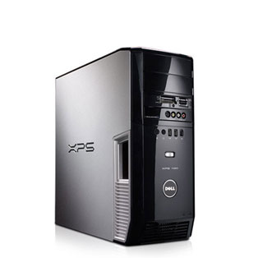 | Dell XPS 420 or better

- Processor: 2.0 GHz or faster
- RAM: 2 GB or more (3 GB if running Windows VISTA)
- Video Card – 128 MB onboard memory (256 MB recommended for low vision on Vista operating system)
- Hard Drive: 120 GB or more
- Optical Drive: CD-RW & DVD-RW
- Operating System: Windows XP-Pro or Windows Vista
- Application: Microsoft Office Small Business (Not Works)
- Connectivity: Network Card10/100 Ethernet
- Speakers: External speakers with volume control and headphone jacks
- Headphones: Should have an in-line volume control
- Card Reader: Capable of reading compact flash (CF) and secure digital (SD) cards for integration with a BrailleNote or PacMate

Monitor:
- 18-inch Flat panel monitor or larger. However, larger is not always better. A student with a significant field loss will probably not benefit from a 22-inch wide screen monitor. A student with only an acuity loss may benefit by having the larger monitor. A good compromise is the 18-inch monitor.
- Video card with at least 128 MB of onboard memory. If you have a low vision student running Zoomtext (Aisquared) or Magic (Freedomscientific) additional onboard memory (256MB) is recommended to avoid a breakup of the screen.
Laser Printer: $250.00
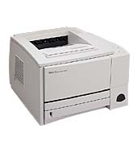 | HP 1022 Laser Printer $200.00  HP 2200 Laser Printer (discontinued infrared printer)  www.hp.com  Other sources for laser printers www.lexmark.com, www.xerox.com  Monochrome Laser Printer  - Speed 10-15 pagers per minute  - Connectivity: Parallel, USB, Bluetooth and Infrared if available.  - Dots per Inch: 600 x 600

Inkjet Printer: $125.00
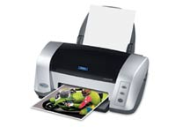 | Epson C88+  www.epson.com  Other sources for inkjet printers www.hp.com, www.canon.com  Color inkjet printer  - Speed: Up to 22 pages per minute  - Dots per Inch: 5760x1440  - Connectivity: USB

Infrared Adapter: $75.00
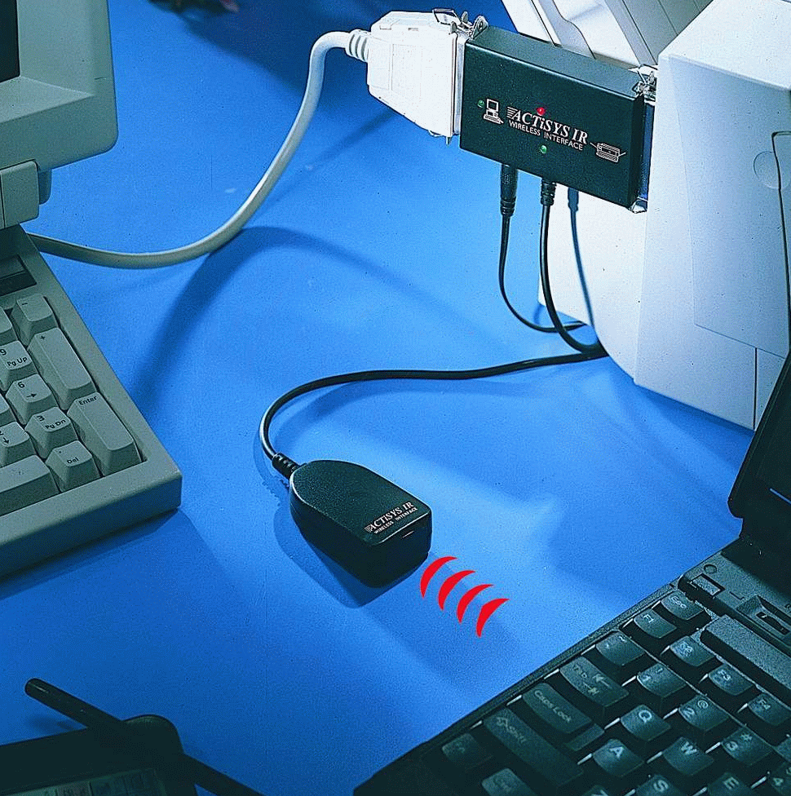 | IR100M Parallel Printer Adapter – This adapter can be connected to a parallel port on a printer and used with infrared ports on note-takers.  www.actisys.com

Bluetooth Adapter: $100.00
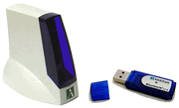 | Ambicom Wireless Bluetooth Printer Kit Model WBP-KIT – Wireless Bluetooth printing  www.actisys.com
Embosser: $4100.00
Specifications from: www.brailler.com/juli3.htm. Other sources for embossers www.indexbraille.com, www.viewplus.com, www.americanthermoform.com, www.sighted.com

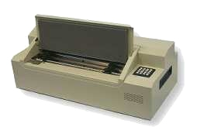 | Juliet Pro 60

Classroom (high production) Embosser
- Speed: 60 characters per second interpoint, 40 cps single side
- Paper: Standard Braille paper (8 ½ x 11, 11 ½ x 11) tractor feed
- Connectivity: Parallel and serial

Scanner: $75.00
Specifications downloaded from www.canon.com. Other sources for scanners www.hp.com and www.microtek.com

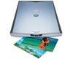 | CanoScan LiDE 60,70, and 90

Flatbed color scanner
- Maximum Size: 8 ½ x 11
- Interface: USB
- Resolution: 1200 dots per inch
- Software: Scansoft Omnipage SE

Braille Translation Software: $600.00

Duxbury Braille Translation Software 10.6
www.duxburysystems.com
Braille 2000
www.braille2000.com
Braille Translation Software
- Translates text, MS Word and HTML into grade I or II braille
- Translates foreign language text into foreign language braille
- Translates Scientific Notebook documents into Nemeth braille.

Math Editor: $150.00
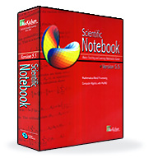 | Scientific Notebook – Math editor to create math documents for conversion into Nemeth Braille code. Used with Duxbury Braille translation software.  www.mackichan.com
Music Braille Translators: $1000.00
Goodfeel version 3 – Transciption software to convert printed music notation to braille. www.dancingdots.com
Music optical character recognition:
Sharp Eye 2
www.dancingdots.com

Music Publishing Software: $325.00
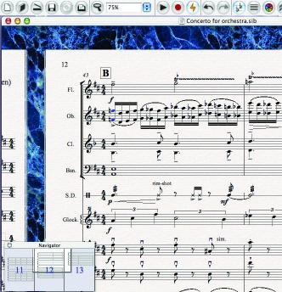 | Sibelius Speaking 3 – Transciption software to convert printed music notation to braille. www.dancingdots.com  Sonar 6.0 (Cake Talking 6.2 JAWS scripts for Sonar)  www.dancingdots.com
Optical Character Recognition Software: $200.00 Upgrade
FOR SIGHTED TEACHERS AND TRANSCRIBERS
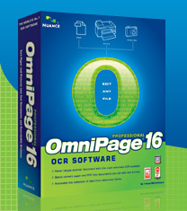 | Omnipage Pro 16 Optical Character Recognition Software  www.nuance.com  Optical Character Recognition Software (OCR) for a sighted user.  - Manual zoning with the mouse  - Auto scan into MS Word document  - Upgrade from Omnipage SE from scanner purchase

Optical Character Recognition Scanning & Reading Software: $1000.00
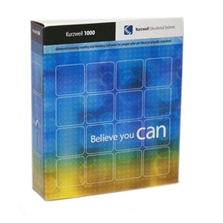 | Kurzweil 1000 version 11 scanning and reading software  For blind students and staff  www.kurzweiledu.com
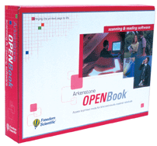 | OpenBook 8.0 scanning and reading software  For blind students and staff  www.freedomscientific.com
Optical Character Recognition Software (OCR) for a blind user.
- Scan and Read documents • Built-in voice
- Built-in dictionary

Kurzweil 3000 version 10 scanning and reading software
for struggling readers and learning disabilities

www.kurzweiledu.com
Wynn 5.0 scanning and reading software
for struggling readers and learning disabilities

www.freedomscientific.com
Optical Character Recognition Software (OCR) for a struggling readers.
- Scan and Read documents • Built-in voice
- Built-in dictionary • Various tools for learning disabilities

Screen Reader with Braille Support: $1100.00 + 200.00 Software Maintenance Agreement

JAWS Source: www.freedomscientific.com.
Other screen reader sources HAL: www.yourdolphin.com
WindowEyes: www.gwmicro.com
System Access: www.serotek.com
VoiceOver: www.apple.com
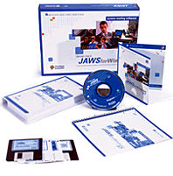 | JAWS screen reading software for the blind  (Professional version required for Windows XP Professional, Windows 2000 or NT)
Screen reader for Windows XP, 98, ME
- Speech synthesizer (Eloquence)
- Refreshable Braille display support
- Multiple language support
- Internet Explorer support

Screen Magnification: $600.00 screen magnification with speech,
$395.00 screen magnification only
Source: www.aisquared.com.
Other sources MAGIC: www.freedomscientific.com
LUNAR: www.yourdolphin.com
BIGGY PLUS www.rjcooper.com (pointer/cursor enhancement only)

Zoomtext Screen Magnification software for low vision students.
Screen Magnification
- 2-36 x magnification
- Screen reading capability
- Document reader

Screen Reader & Magnification with Braille Support
JAWS with MAGIC: www.freedomscientific.com
Supernova: www.yourdolphin.com
Braille Note Taking Device: $6,000.00+ 32-cell, 4,000.00+ 18-cell

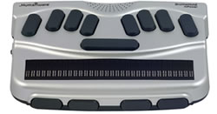 | BrailleNote mPower Keysoft 7.5 32-cell Braille note taking device  GPS Attachment extra  www.humanware.com
- 32-cell or 18-cell displays ● Windows CE ● Built-in modem and card slot
- Infrared printer port

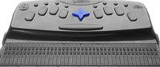 | PacMate Omni 40-cell Braille note taking device  GPS Attachment extra  www.freedomscientific.com
- 40-cell or 20-cell displays ● Windows Mobile 6.0 ●Built-in modem and card slot ● Infrared printer port

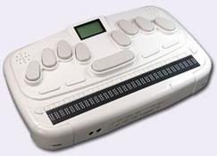 | Braille Sense 32-cell Braille note taking device  www.gwmicro.com
- 32-cell display ● Windows CE ● Built-in LCD Display

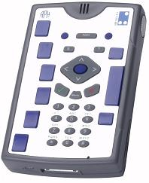 | Braille+ Mobile Manager Braille note taker  www.aph.com

Accessible GPS: $1,800
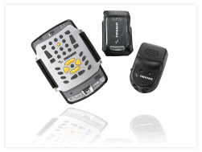 | STAND-ALONE  Trekker 3.0 speech output GPS orientation aide with limited PDA application access  SOFTWARE / HARDWARE ADD-ONS  BrailleNote GPS 4.2 (BrailleNote)  www.humanware.com  StreetTalk 2.0 (PACMate)  www.freedomscientific.com
Closed Circuit TV (CCTV): $2800.00

Closed circuit TV’s are available from many vendors and should be selected after viewing in person.
DESKTOP CCTV: $2800.00

Merlin 17” LCD – Color desktop CCTV www.enhancedvision.com
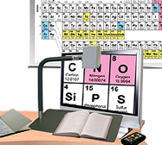 | DISTANCE CCTV: $2200.00  ONYX Swing Arm – Semi-portable CCTV with the ability to flip up and view distant objects.  www.freedomscientific.com  Distance CCTV’s are available as all-in-one options or separate camera and monitor. Physical settings should be considered when choosing the style.
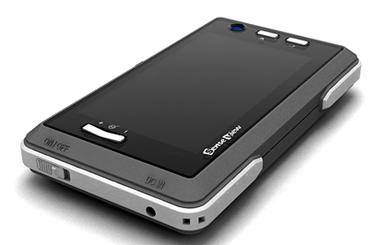 | HAND-HELD CCTV: $900.00  Senseview - Portable hand-held CCTV with built-in screen www.gwmicro.com  Some hand-held CCTV’s are equipped with a distance viewing camera. This as well as viewing area should be taken into consideration when determining an appropriate tool.

Color Closed Circuit TV
- Color display • Auto focus • 2x to 60x magnification
www.clarityusa.com www.optelec.com www.ovac.com www.telesensory.com www.visiontechnology.com www.humanware.com
www.freedomscientific.com www.enhancedvision.com www.gwmicro.com
www.freedomvision.com

Each vendor listed above carries all three classes of CCTV. Contact the vendor to see a demonstration of each of their products.

To see a more complete list of CCTV vendors go to www.nyise.org/blind.htm and select Low Vision Resources.
Braille Displays: $3500.00

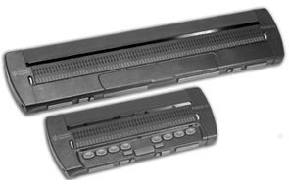 | BRAILLE DISPLAYS  Braille displays are available in a variety of sizes and should be selected after considering student needs.  Refreshable Braille is an electromechanical device and needs occasional cleaning, adjustment, and repair. A product maintenance agreement should accompany the purchase.  Focus 40/80 – Windows Braille display www.freedomscientific.com  Other Sources of Braille Displays  www.humanware.com www.handytech.us  www.gwmicro.com www.sighted.com
Braille displays support a student’s literary Braille reading. A Braille display connected to a computer with a screen reader will increase a student’s Braille reading ability as well as facilitate increased comprehension.

Braille Learning: $350.00 (requires tablet)

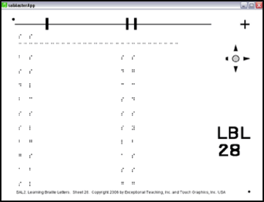 | BRAILLE LEARNING  Learning Braille through the use of a touch tablet can facilitate an organized approach to learning Braille as well as independent learning.  SAL2 – Braille Teaching Curriculum  (Used with the Talking Tactile Tablet)  www.exceptionalteaching.com  www.touchgraphics.com

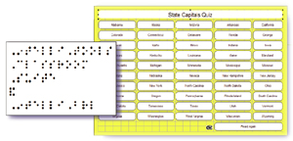 | IntelliBraille - Braille Teaching Curriculum  (Used with the Intellitools tablet / Classroom Suite)  www.intellitools.com
If a tablet is purchased to facilitate Braille learning, be sure to check out other possibilities and curriculum used with the tablet to determine if you can make further use of it.
Accessible Calculators: $250.00

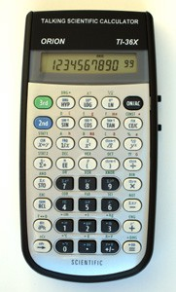 | HAND-HELD CALCULATORS:  Orion TI-36X Talking Scientific Calculator – Handheld talking scientific calculator.  www.orbitresearch.com
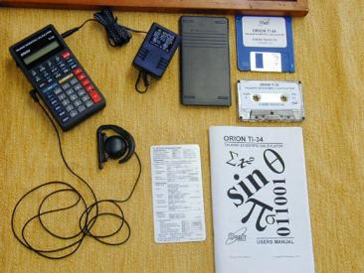 | Orion Talking TI-34 Calculator – Handheld talking scientific calculator.  (Discontinued)  This product may be available for purchase on the internet
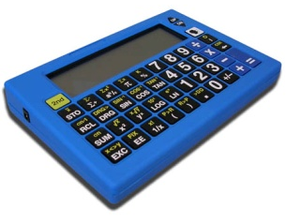 | SciPlus 300 - Talking Scientific Calculator  www.sightenhancement.com
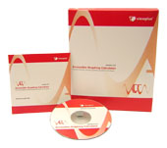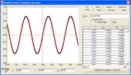 | SOFTWARE CALCULATORS:  Audible Graphing Calculator – Talking graphing calculator for algebra and above.  www.viewplus.com

Each calculator will have a variety of features that may or may not suit the needs of a student in particular math classes. Calculators should be purchased with current and future courses in mind.

Digital Talking Book Players: $400.00

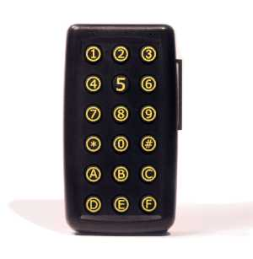 | BookPort – Portable Audio Book Reader (Reads MP3, text, Word and BRF files): www.aph.org  Available through Federal Quota Funds
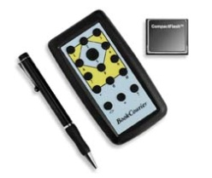 | Book Courier - Portable Audio Book Reader (Reads MP3, text, Word and BRF files):  www.bookcourier.com
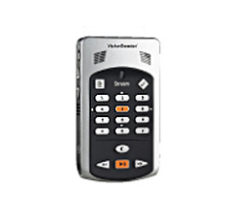 | Victor Reader Stream – Digital DAISY player (Audio Books): www.humanware.com
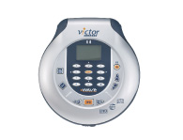 | Victor Reader Wave – Digital DAISY player (Audio Books): www.humanware.com  Victor Reader Classic X and Classic X + also available
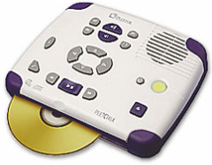 | PlexTalk PTN 1 – Daisy Player  www.irti.net
 | SOFTWARE
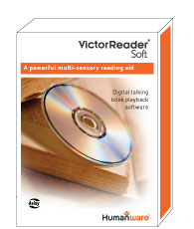 | Victor Soft – Digital DAISY player for your computer (Play DAISY Audio Books on your computer)  www.humanware.org  Other Sources for DAISY Reader software  www.freedomscientific.com (FSreader)  www.yourdolphin.com (EasyReader)
Keyboarding Programs: $80

TypeAbility – Talking Typing Tutor
www.yesaccessible.com
Talking Typer – Talking Typing Tutor
www.aph.org

Touch Tablets: $700.00

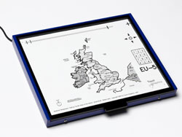 | Talking Tactile Tablet – Talking touch tablet, used with development software to create talking maps, diagrams and pictures.  www.touchgraphics.com/ttt.htm
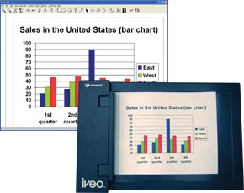 | IVEO – Speaking Tactile Diagrams: used with development software to create talking maps, diagrams and pictures.  www.viewplus.com
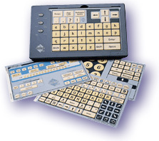 | IntelliTools keyboard – Adaptive programmable keyboard for physically disabled students (adapted for the visually impaired with tactile markers)  www.intellitools.com

Touch tablets offer an opportunity for educational teams to create individualized lesson plans that a student can interact with and learn from. These tablets also offer pre-made curricula.

Combining touch tablets with tactile graphics provides a student the opportunity to add voice labels to their own artwork and/or creations that are found online or pre-made.

Tactile Graphics Production: $1300.00 (PIAF)

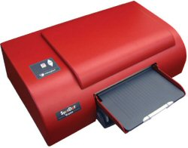 | Emprint Braille Printer/Embosser – Color tactile graphic Braille embosser with interlined Braille with print.  www.viewplus.com
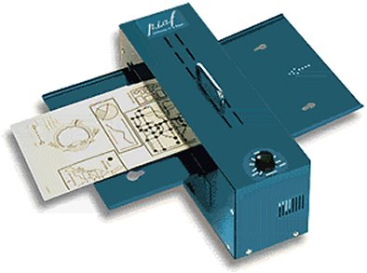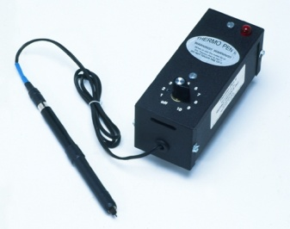 | P.I.A.F. Pictures in a Flash – Quick and easy development of tactile graphics using heat sensitive paper.  www.quantech.com.au  www.humanware.com  Other sources:  Swell-Form Graphics II Machine  www.americanthermoform.com  Tactile Image Enhancer, Thermo Pen  www.brailler.com
QuickTac 4.0 and TGD-Pro – QuickTac is a free download that can be used to create simple tactile graphics that can be produced on most embossers.

TGD-Pro combines QuickTac with the ability to import pictures collected from the internet, clip art, etc.

www.duxburysystems.com

The Braille Authority of North America (BANA) guidelines for tactile graphics can be viewed at www.tactilegraphics.org.

The International Council on English Braille (ICEB), Tactile Graphics Project can be viewed at http://www.iceb.org/icetac.html.

Information about the Tactile Graphics Image Library can be found at http://www.aph.org/tgil/index.html.
Manual Braille Writers: $690

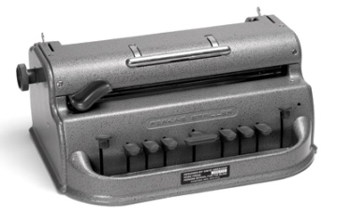 | Standard (Mechanical) Perkins Braille Writer  www.perkins.org  Available through Federal Quota
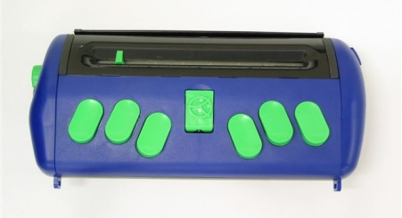 | Jot-a-Dot – Portable Braille writer www.humanware.com  www.jotadot.com
Electronic Braille Writer: $2,750

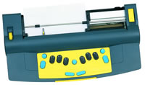 | Mountbatten Braille Writer – Electronic Braille Writer  www.humanware.com  www.mountbattenbrailler.com
Electronic Book Access
Source | Fee | Content Available | How do I sign-up?
Public Library | Free | Books (all varieties) | Contact your local public library.
Web Braille  www.loc.gov/nls/braille | Free if visually impaired | Books, Magazines Braille Music, | Fill out form at https://www.nlstalkingbooks.org/ or call 1-888-657-7323 to connect to a local library, more contact information available at http://www.loc.gov/nls/contact.html
BookShare  www.bookshare.org | Ind. or Group Account | Books and Periodicals | Register via website, provide proof of disability, and submit payment
Texas School for the Blind and Visually Impaired  http://www.tsbvi.edu/braille/index.htm | Free if visually impaired | Books and other Braille Materials | Complete form at referenced url and obtain a password to download books.
Project Gutenberg  www.gutenberg.net or http://www.promo.net/pg/ (has quick search author and title edit boxes on home page) | Free | Books, speeches, videos, music (recorded and sheet), pictures | Begin searching or browsing at website, no sign-up necessary.
ManyBooks.net  www.manybooks.net | Free | Books | Begin searching or browsing at website, no sign-up necessary.
The Online Books Page  http://onlinebooks.library.upenn.edu/lists.html | Free | Books | Begin searching or browsing at website, no sign-up necessary.
Louis APH Data Base  http://sun1.aph.org/louis/ | Fee, either $25 quota per book or fee based on non-APH item | Textbooks & Books | Fill out Agreement to Use the APH File Repository at http://sun1.aph.org/louis/reposagree.html
Clearinghouse for Specialized Media and Technology (CSMT)  https://csmt.cde.ca.gov | Free if TVI or transcriber | Textbooks, Audio Books, etc. | Fill out Member Registration Form at https://csmt.cde.ca.gov/Newacct.aspx
Recording for the Blind & Dyslexic  http://www.rfbd.org | Ind. or Group Account | Textbooks, Audio Books | Provide documented proof of visual impairment, http://www.rfbd.org/certification.htm
Low Vision Classics  www.classicbookshelf.com | Free | Books | Begin searching or browsing at website, no sign-up necessary.
Please reference ‘Electronic Book Access Handout’ from the Technology page on the California School for the Blind webpage
www.csb-cde.ca.gov
Gaming Resources
APH Games  http://www.aph.org/tech/index.html  Hark the Sound Version 3.4  wwwx.cs.unc.edu/~gb/wp/research/hark-the-sound/ (Google search ‘Hark the Sound’)  Braille Bug  http://www.afb.org/braillebug  RJ Cooper Games  www.rjcooper.com  PCSGames  www.pcsgames.net  The Game Accessibility Project  www.game-accessibility.com  Audyssey  www.audyssey.org  AudioGames  www.audiogames.net  Kitchens Inc.  www.kitchensinc.net  The Zone BBS  www.zonebbs.com  BSC Games  www.bscgames.com  Spoonbill Software  www.omninet.net.au/~irhumph/blindgamers.htm  Azabat Games  www.azabat.co.uk  Gaming Galaxy!  tman.net.ms/galaxy/  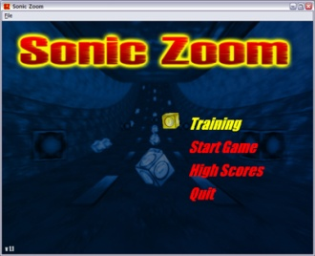 | VIP Gameszone  www.vipgameszone.com  GMA Games  www.gmagames.com  L-Works  www.l-works.net  USA Games  www.usagames.us  Draconis Entertainment  www.draconisentertainmetn.com  The Accessible Friends Network  http://www.tafn.org.uk/games.htm  7-128 Software  www.7128.com  Bavisoft  www.bavisoft.com  Games for the Blind.com  www.gamesfortheblind.com  Danz Games  www.danzgames.com  Blind Cool Tech  www.blindcooltech.com  Dreamtech Interactive  www.geocities.com/kenwdowney  Klango Games  www.klangogames.com  Blind Adrenaline Simulations  www.blindadrenaline.com  SoundRTS  http://jlp.free.fr/soundrts  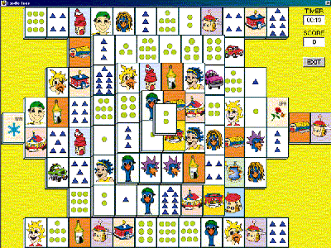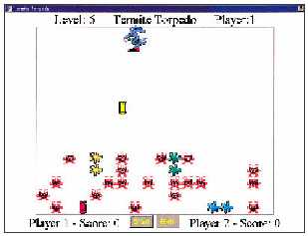  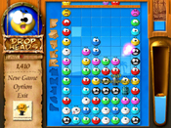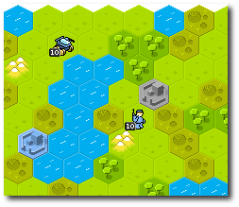
The use of games improves computer knowledge, keyboarding skills, and problem solving ability. (Some of the above listed game sites have adult content in addition to appropriate children’s games).
The above listed items are only suggestions. Each classroom is unique. Equipment should be purchased based on the needs of each individual student. However, just as the modern office is now built around the computer, so is the modern VI classroom. Students must have access to the Internet for research, current events and communication. In order to use the computer successfully, the visually impaired student will probably use either a screen reader or a screen magnification program. Worksheets can be accessed using a CCTV or optical character recognition software. Work is produced on a word processor either on the computer or on a braille note taker. The work must then be printed for the sighted teacher.

A teacher or transcriber must prepare materials in Braille or large print for the student. This must be done in a timely manner; materials three days late are almost useless to a student. The use of optical character recognition and translation software in the hands of a certified braille transcriber make the production of braille and large print much more timely and efficient.

In every case, technology has enhanced the learning process for the visually impaired student. Book readers, access software, talking calculators, scanners and printers are essential in order to allow a visually impaired student to compete successfully with their sighted peer.

All product names are registered trademarks of their respective owners. The information in this handout has been carefully checked and is believed to be accurate. However technology changes rapidly and products can be sold to other companies. Please check with the company’s web site to verify the accuracy of each product’s specifications.

Well Stocked VI Classroom, February 26, 2008

