Step by Step Tutorials for Microsoft Internet Explorer 8 Accessibility Options

Table of Contents

Microsoft Internet Explorer 8 Accessibility Features Overview 2

Select text and move around a Web page with the keyboard 3

Zoom in on a Web page 6

Change text size on Web pages 7

Choose colors used on Web pages 9

Choose the font style and size used on Web pages and documents 11

Choose accessibility settings for Web pages 13

Format Web pages using a custom style sheet 15

Choose advanced settings 17

Find text on a Web page 20

Simplify common tasks 22

# Microsoft Internet Explorer 8 Accessibility Features Overview

Make computers easier and more comfortable to use with accessibility features and utilities built right into Internet Explorer 8.

* **Select text and move around a Web page with the keyboard**
* **Zoom in on a Web page**
* **Change text size on Web pages**
* **Choose colors used on Web pages**
* **Choose the font style and size used on Web pages and documents**
* **Choose accessibility settings for Web pages**
* **Format Web pages using a custom style sheet**
* **Choose advanced settings**
* **Find text on a Web page**
* **Simplify common tasks**

## Select text and move around a Web page with the keyboard

Rather than using a mouse to select text and move around within a Web page, you can use standard navigation keys on your keyboard—HOME, END, PAGE UP, PAGE DOWN, and the arrow keys. This feature is called Caret Browsing and is named after the caret—or cursor. This makes it easier to select, copy, and paste text to another document—without a mouse. With Caret Browsing on, move up, down, left and right on the Web page my pressing and holding the arrow keys. To select text, just move the cursor to the beginning of the text, hold down the SHIFT key and move the arrow keys until the text you want is selected. With text selected, you can copy (CTRL+C), and paste (CTRL+V), in a separate document. See below for steps to **Enable Caret Browsing for New Windows and Tabs.**

|  |  |  |
| --- | --- | --- |
|  | **Mouse actions** | **Keyboard actions** |
| **1** | On the **Start** menu:   * Select **Internet Explorer 8**. | Display the **Start** menu by pressing the Windows logo key Windows logo key.   * Select **Internet Explorer 8** by using the arrow keys, then ENTER. |
| **2** | To turn on Caret Browsing:   * Select the **Page** button to open the menu. * Select **Caret Browsing**. | To turn on Caret Browsing:   * Press **F7**. |

**Screen shot of Caret Browsing dialog box when F7 is pressed**:

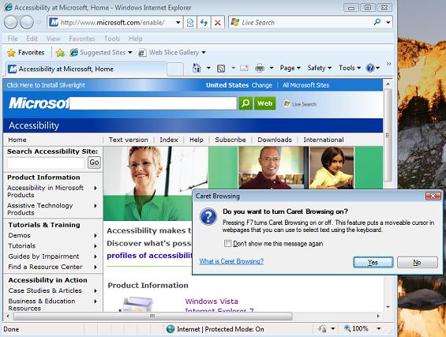

**Enable Caret Browsing for New Windows and Tabs**

|  |  |  |
| --- | --- | --- |
|  | **Mouse actions** | **Keyboard actions** |
| **1** | In **Internet Explorer 8**:   * Select the **Tools** menu. * Select **Internet Options**. | In **Internet Explorer 8**:   * Select the **Tools** menu by pressing ALT+T. * Select **Internet Options** by pressing O. |
| **2** | In the **Internet Options** dialog box:   * Select the **Advanced** tab. | In the **Internet Options** dialog box:   * Select the **Advanced** tab by pressing CTRL+TAB. |
| **3** | On the **Advanced** tab, under **Accessibility**:   * Select **Enable Caret Browsing for new windows and tabs**. | On the **Advanced** tab, under **Accessibility**:   * Select **Enable Caret Browsing for new windows and tabs**, by pressing the arrow keys to move to the option, then, * Press ENTER. |

**Screen shot of Internet Options dialog box, Advanced tab, Accessibility settings**:

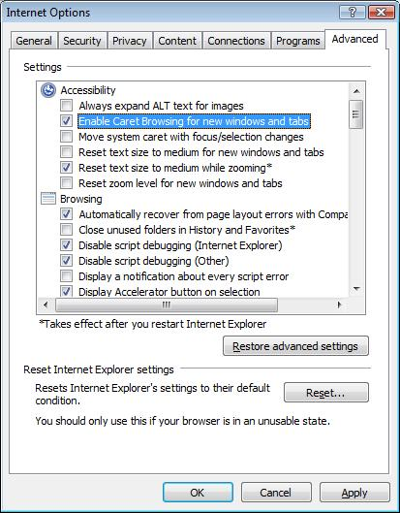

## Zoom in on a Web page

With Microsoft Internet Explorer 8 you can make Web pages easier to read by magnifying the page (zooming in). If you zoom in, everything on the Web page will be magnified (including text, images, and controls). Zooming will change the magnification of the Web site, regardless of the Web site's formatting. **See also Change text size on Web pages.**

|  |  |  |
| --- | --- | --- |
|  | **Mouse actions** | **Keyboard actions** |
| **1** | On the **Start** menu:   * Select **Internet Explorer 8**. | Display the **Start** menu by pressing the Windows logo key Windows logo key.   * Select **Internet Explorer 8** by using the arrow keys, then ENTER. |
| **2** | **To zoom in or out on a Web page:**   * Click the **Magnifying glass icon** at the bottom right corner of the Internet Explorer window. Or, select the arrow to open the list of options and select one. | **To zoom in or out on a Web page:**   * Press CTRL + PLUS SIGN (+) to zoom in, or CTRL + HYPHEN (-) to zoom out. |

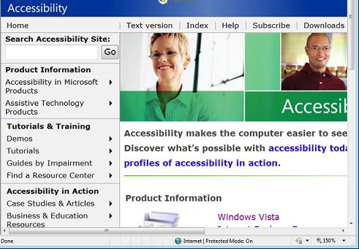

## Change text size on Web pages

With Microsoft Internet Explorer 8 you can make Web pages easier to see by changing the size of text used on Web pages. If you change the text size, graphics and controls will remain in their original size but the text size will change. If the text size was explicitly set by the person who created the Web page you must override it. See **Choose accessibility settings for Web pages**.

|  |  |  |
| --- | --- | --- |
|  | **Mouse actions** | **Keyboard actions** |
| **1** | On the **Start** menu:   * Select **Internet Explorer 8**. | Display the **Start** menu by pressing the Windows logo key Windows logo key.   * Select **Internet Explorer 8** by using the arrow keys, then ENTER. |
| **2** | **To change the text size on a Web page**:   * Select the **Page** menu. * Point to **Text Size**. * Select your choice of **Largest, Larger, Medium, Smaller, Smallest** text sizes. | **To change the text size on a Web page:**   * Select the **Page** menu, by pressing ALT+P. * Select **Text Size** by pressing X. * Select your choice of **Largest, Larger, Medium, Smaller, Smallest** text sizes by pressing the arrow keys, then ENTER. |

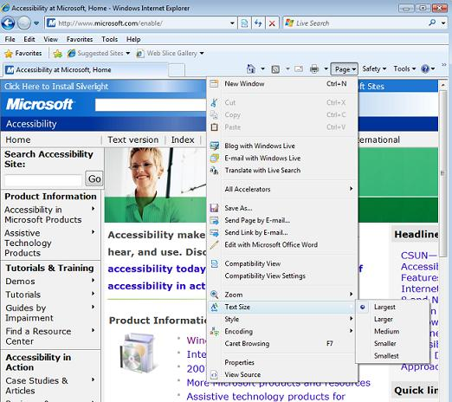

## Choose colors used on Web pages

To make Web pages easier to see, you can change the text, background, link and hover colors in Internet Explorer 8.

|  |  |  |
| --- | --- | --- |
|  | **Mouse actions** | **Keyboard actions** |
| **1** | On the **Start** menu:   * Select **Internet Explorer 8**. | Display the **Start** menu by pressing the Windows logo key Windows logo key.   * Select **Internet Explorer 8** by using the arrow keys, then ENTER. |
| **2** | In Internet Explorer 8:   * Select the **Tools** menu. * Select **Internet Options**. | In Internet Explorer 8:   * Select the **Tools** menu, by pressing ALT+O. * Select **Internet Options** by pressing O. |
| **3** | On the **General** tab, select:   * The **Colors** button. | On the **General** tab:   * Select the **Colors** button by pressing ALT+O. |
| **4** | Under **Colors**:   * Remove the check mark from the **Use Windows colors** check box. * Choose a text color by selecting the color box next to **Text** and then choosing from the available colors. * Choose a background color by selecting the color box next to **Background** and then choosing from the available colors. * Choose a visited link color by selecting the color box next to **Visited** and then choosing from the available colors. * Choose an unvisited link color by selecting the color box next to **Unvisited** and then choosing from the available colors. | Under **Colors**:   * Remove the check mark from **Use Windows colors** by pressing ALT+W. * Choose a text color by selecting the color box next to **Text** by pressing ALT+T, and then choosing from the available colors by pressing the arrow keys, then ENTER. * Choose a background color by selecting the color box next to **Background** by pressing ALT+B, and then choosing from the available colors by pressing the arrow keys, then ENTER. * Choose a visited link color by selecting the color box next to **Visited** by pressing ALT+I, and then choosing from the available colors by pressing the arrow keys, then ENTER. * Choose an unvisited link color by selecting the color box next to **Unvisited** by pressing ALT+N, and then choosing from the available colors by pressing the arrow keys, then ENTER. * Choose a hover color by selecting the color box next to **Hover** by pressing ALT+O, and then choosing from the available colors by pressing the arrow keys, then ENTER. |
| **5** | **To use a color for links you hover over with the mouse**,   * Select the **Use hover color** check box, and then select the color box next to **Hover** and then choose from the available colors. | **To use a color for links you hover over with the mouse**,   * Select the **Use hover color** check box by pressing ALT+H, and then select the color box next to **Hover** by pressing ALT+O, and then choose from the available colors by pressing the arrow keys, then ENTER. |

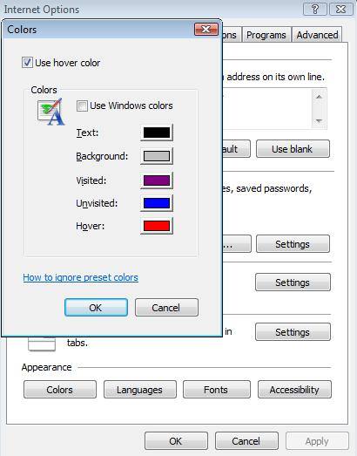

## Choose the font style and size used on Web pages and documents

You can choose the fonts used on Web pages and documents to make them more legible.

|  |  |  |
| --- | --- | --- |
|  | **Mouse actions** | **Keyboard actions** |
| **1** | On the **Start** menu:   * Select **Internet Explorer 8**. | Display the **Start** menu by pressing the Windows logo key Windows logo key.   * Select **Internet Explorer 8** by using the arrow keys, then ENTER. |
| **2** | In Internet Explorer 8:   * Select the **Tools** menu. * Select **Internet Options**. | In Internet Explorer 8:   * Select the **Tools** menu, by pressing ALT+O. * Select **Internet Options** by pressing O. |
| **3** | On the **General** tab:   * Select the **Fonts** button. | On the **General** tab:   * Select the **Fonts** button by pressing ALT+N. |
| **4** | Under **Webpage font**:   * Select the font you want to use from the drop-down list. | Under **Webpage font**:   * Select the font you want to use from the drop-down list by pressing ALT+W, then the arrow keys. |
| **5** | Under **Plain text font**:   * Select the font you want to use from the list. * Select **OK**. | Under **Plain text font**:   * Select the font you want to use from the list by pressing ALT+P, then the arrow keys. * Select **OK** by pressing TAB+ENTER. |

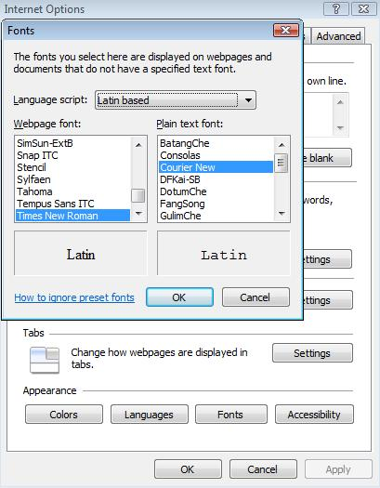

## Choose accessibility settings for Web pages

You can choose to set Internet Explorer to ignore colors, font styles, and font sizes specified on Web pages to make the pages easier to see. You can also choose to format documents using your own style sheet.

|  |  |  |
| --- | --- | --- |
|  | **Mouse actions** | **Keyboard actions** |
| **1** | On the **Start** menu:   * Select **Internet Explorer 8**. | Display the **Start** menu by pressing the Windows logo key Windows logo key.   * Select **Internet Explorer 8** by using the arrow keys, then ENTER. |
| **2** | In Internet Explorer 8:   * Select the **Tools** menu. * Select **Internet Options**. | In Internet Explorer 8:   * Select the **Tools** menu, by pressing ALT+O. * Select **Internet Options** by pressing O. |
| **3** | On the **General** tab:   * Select the **Accessibility** button. | On the **General** tab:   * Select the **Accessibility** button by pressing ALT+E. |
| **4** | Under **Formatting**, select:   * **Ignore colors specified on webpages** if you want your browser to ignore colors specified on Web pages. * **Ignore font styles specified on webpages** if you want your browser to ignore font styles specified on Web pages. * **Ignore font sizes specified on webpages** if you want ignore font sizes specified on Web pages. | Under **Formatting**, select:   * **Ignore colors specified on webpages** if you want your browser to ignore colors specified on Web pages, by pressing ALT+C. * **Ignore font styles specified on webpages** if you want your browser to ignore font styles specified on Web pages, by pressing ALT+S. * **Ignore font sizes specified on webpages** if you want your browser to ignore font sizes specified on Web pages, by pressing ALT+Z. |
| **5** | To format Web pages using your own style sheet, under **User style sheet**, select:   * **Format documents using my style sheet**. * **Style sheet**, then type the name of your style sheet, or navigate to it by selecting the **Browse** button. | To format Web pages using your own style sheet, under **User style sheet**, select:   * **Format documents using my style sheet** by pressing ALT+D. * **Style sheet**, by pressing ALT+T, then type the name of your style sheet, or navigate to it by selecting the **Browse** button by pressing ALT+B. |

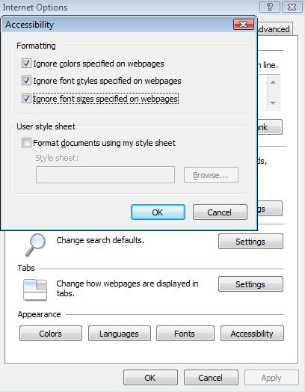

## Format Web pages using a custom style sheet

You can choose to set your browser to format documents using your own style sheet.

|  |  |  |
| --- | --- | --- |
|  | **Mouse actions** | **Keyboard actions** |
| **1** | On the **Start** menu:   * Select **Internet Explorer 8**. | Display the **Start** menu by pressing the Windows logo key Windows logo key.   * Select **Internet Explorer 8** by using the arrow keys, then ENTER. |
| **2** | In Internet Explorer 8:   * Select the **Tools** menu. * Select **Internet Options**. | In Internet Explorer 8:   * Select the **Tools** menu, by pressing ALT+O. * Select **Internet Options** by pressing O. |
| **3** | On the **General** tab:   * Select the **Accessibility** button. | On the **General** tab:   * Select the **Accessibility** button by pressing ALT+E. |
| **4** | Under **User style sheet**, select:   * **Format documents using my style sheet**. * **Style sheet**, then type the name of your style sheet, or navigate to it by selecting the **Browse** button. * Get a custom style sheet at [www.microsoft.com/enable/training/ie5/css.aspx](http://www.microsoft.com/enable/training/ie5/css.aspx) | Under **User style sheet**, select:   * **Format documents using my style sheet** by pressing ALT+D. * **Style sheet**, by pressing ALT+T, then type the name of your style sheet, or navigate to it by selecting the **Browse** button by pressing ALT+B. * Get a custom style sheet at [www.microsoft.com/enable/training/ie5/css.aspx](http://www.microsoft.com/enable/training/ie5/css.aspx) |

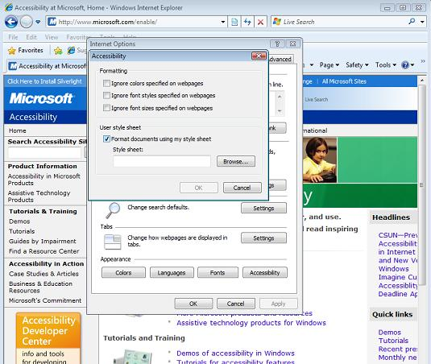

## 

## Choose advanced settings

To make Web pages easier to see and work with, you can change several accessibility, browsing, multimedia and printing settings in Internet Options.

|  |  |  |
| --- | --- | --- |
|  | **Mouse actions** | **Keyboard actions** |
| **1** | On the **Start** menu:   * Select **Internet Explorer 8**. | Display the **Start** menu by pressing the Windows logo key Windows logo key.   * Select **Internet Explorer 8** by using the arrow keys, then ENTER. |
| **2** | In Internet Explorer 8:   * Select the **Tools** menu. * Select **Internet Options**. | In Internet Explorer 8:   * Select the **Tools** menu, by pressing ALT+O. * Select **Internet Options** by pressing O. |
| **3** | In **Internet Options**:   * Select the **Advanced** tab. | In **Internet Options**:   * Select the **Advanced** tab by pressing CTRL+TAB. |
| **4** | Under **Accessibility**, select from these options:   * **Always expand ALT text for images**. * **Enable Caret Browsing for new windows and tabs**. * **Move system caret with focus/selection changes**. * **Reset text size to medium for new windows and tabs**. * **Reset text size to medium while zooming (takes effect after you restart Internet Explorer)**. * **Reset zoom level for new windows and tabs**. | Under **Accessibility**, select from these options by using the arrow keys to move up and down, and the SPACEBAR to insert or remove the checkmark:   * **Always expand ALT text for images**. * **Enable Caret Browsing for new windows and tabs.** * **Move system caret with focus/selection changes**. * **Reset text size to medium for new windows and tabs**. * **Reset text size to medium while zooming (takes effect after you restart Internet Explorer)**. * **Reset zoom level for new windows and tabs**. |
| **5** | Under **Browsing**, select from these options:   * **Display Accelerator button on selection.** * **Underline links either Always, when you Hover over them, or Never**. * **Use inline AutoComplete (outside of Internet Explorer)**. * **Use smooth scrolling**. | Under **Browsing**, select from these options by using the arrow keys to move up and down, and the SPACEBAR to insert or remove the checkmark:   * **Display Accelerator button on selection. Underline links either always, when you hover over them, or never**. * **Use inline AutoComplete (outside of Internet Explorer)**. * **Use smooth scrolling**. |
| **6** | Under **Multimedia**, select from these options:   * **Always use ClearType for HTML (takes effect after you restart Internet Explorer)**. * **Enable automatic image resizing**. * **Play animations in webpages (takes effect after you restart Internet Explorer)**. * **Play sounds in webpages**. * **Show image download placeholders**. * **Show pictures**. * **Smart image dithering**. | Under **Multimedia**, select from these options by using the arrow keys to move up and down, and the SPACEBAR to insert or remove the checkmark:   * **Always use ClearType for HTML (takes effect after you restart Internet Explorer)**. * **Enable automatic image resizing**. * **Play animations in webpages (takes effect after you restart Internet Explorer)**. * **Play sounds in webpages**. * **Show image download placeholders**. * **Show pictures**. * **Smart image dithering**. |
| **7** | Under **Printing**, turn on or turn off:   * **Print background colors and images**. | Under **Printing**, select by using the arrow keys to move up and down, and the SPACEBAR to insert or remove the checkmark:   * **Print background colors and images**. |

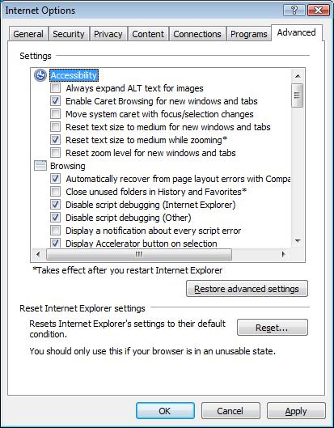

## Find text on a Web page

With Internet Explorer 8 you can search within Web pages more effectively. Earlier versions of Internet Explorer allowed you to find words or phrases in a Web page but Internet Explorer 8 provides these improvements:

* The text box into which you type the words you want to find now appears on the tab row and not as a separate dialog box. This enables you to stay on the Web page and doesn't block parts of the page.
* As you type words into the text box, the matching words are highlighted on the Web page, making it easy to quickly scroll the page and see all the instances of the words you're searching for. In addition, you can still click the Next and Previous buttons to move around the page just as you did in previous versions of Internet Explorer. This tutorial shows you how to find information on a Web page.

|  |  |  |
| --- | --- | --- |
|  | **Mouse actions** | **Keyboard actions** |
| **1** | On the **Start** menu:   * Select **Internet Explorer 8**. | Display the **Start** menu by pressing the Windows logo key Windows logo key.   * Select **Internet Explorer 8** by using the arrow keys, then ENTER. |
| **2** | * Select the **Edit** menu. * Select **Find on this Page**. | * Select the **Edit** menu by pressing ALT+E. * Select **Find on this Page** by pressing F. |
| **3** | * Type the word or phrase you want to find on the page in the **Find** box on the Tab row.   The number of matches found will appear next to the **Options** button, and the page will automatically scroll to the first occurrence of the word or phrase.   * To go to the next or previous instance of the word or phrase, click the **Next** or **Previous** button. | * Type the word or phrase you want to find on the page in the **Find** box on the Tab row.   The number of matches found will appear next to the **Options** button, and the page will automatically scroll to the first occurrence of the word or phrase.   * To go to the next instance of the word or phrase, press ENTER; and, to go to the previous occurrence of the word or phrase, press SHIFT+ENTER. |

**Screen shot of words highlighted on Web page by Find on Page command:**

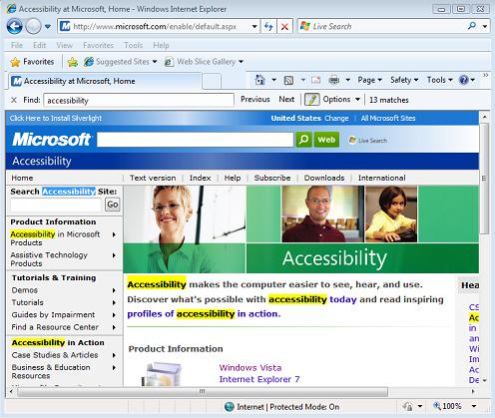

## Simplify common tasks

You can use Accelerators with text that you select on a Web page to perform such tasks as copying, pasting, printing, opening a street address in a mapping Web site, or looking up the dictionary definition of a word—saving time and keystrokes. You can also choose the Web services or Web sites that Accelerators use to handle different tasks. Internet Explorer 8 comes with a selection of Accelerators included by default, but you can add or remove them as you like. Find out more about Accelerators in Internet Explorer Help. Type "accelerators" in the Search box to explore topics.

|  |  |  |
| --- | --- | --- |
|  | **Mouse actions** | **Keyboard actions** |
| **1** | On the **Start** menu:   * Select **Internet Explorer 8**. | Display the **Start** menu by pressing the Windows logo key Windows logo key.   * Select **Internet Explorer 8** by using the arrow keys, then ENTER. |
| **2** | To select text to use with Accelerators:   * Place the cursor in front of the text you want to select. * Click the LEFT mouse button and hold. * Drag to the end of the text you want to select. * Let go of the mouse button   The Accelerator button will appear.   * Select the button to open the Accelerator list. * Select the Accelerator you want to use.   **Note:** For Copy, Print and other commands, press the RIGHT mouse button. | To select text to use with Accelerators:   * Use the arrow keys to move the cursor in front of the text you want to select. * Hold down the SHIFT key. * Press the arrow keys to highlight text to the end of the selection. * Release the SHIFT key.   The Accelerator button will appear.   * Press SHIFT+F10 to open the Accelerator list. * Select the Accelerator you want to use. |

**Screen shot of Accelerator button**:

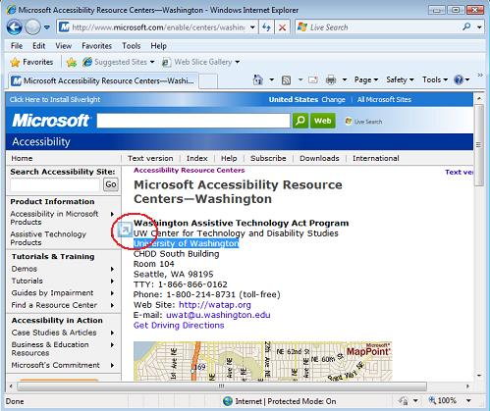

**Screen shot of Accelerator list after button is selected**:

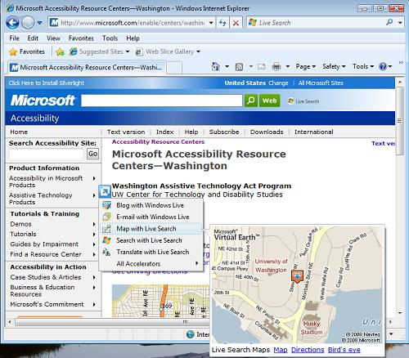

**Screen shot of Accelerator list when SHIFT+F10 is pressed**:

