Walk through of Returning Student Housing Selection

Step 1: Please go to the Housing page on the VSU website and click Housing Portal in the grey task bar. Log into the Housing Portal.

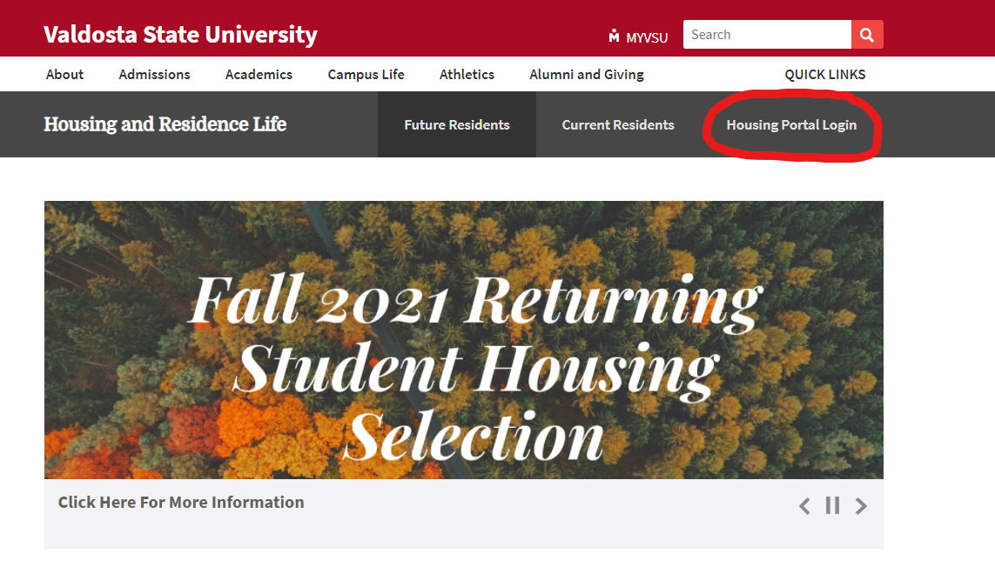

Step 2: If you are not already logged into your MyVSU, you will be directed to that log in there first and then you will automatically be sent back to the Housing Portal. Click on APPLICATION in the red task bar or from the drop-down menu.

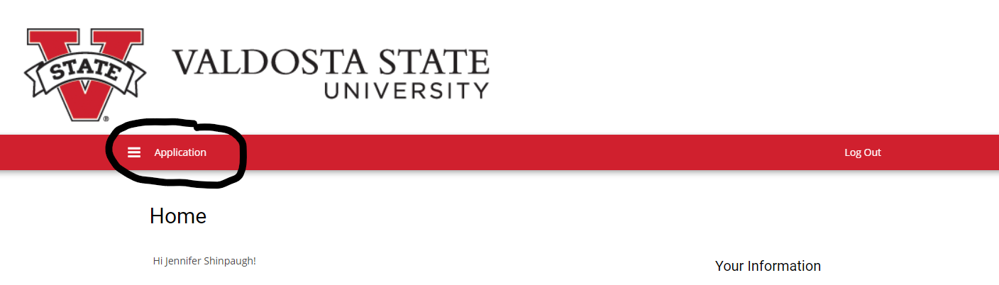

Step 3: Select the Term you are applying for. At this time, the only application available is for Academic Year 2021-2022. Summer will open later in March.

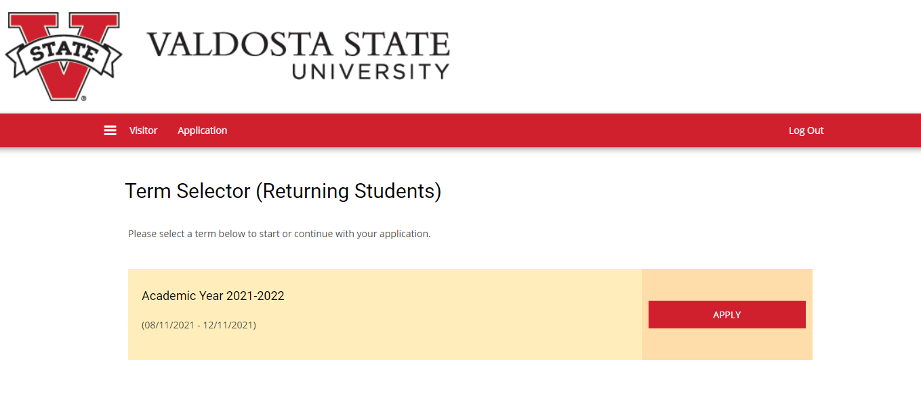

Step 4: Confirm your personal details. If anything is incorrect, please contact the Registrar’s Office at registrar@valdosta.edu.

Step 5: Housing Accommodations. If you require special housing accommodations due to a disability, your situation must be reviewed by the Access Office. If you are already approved, you do not need to click yes. Please select either yes or no from the drop-down menu.

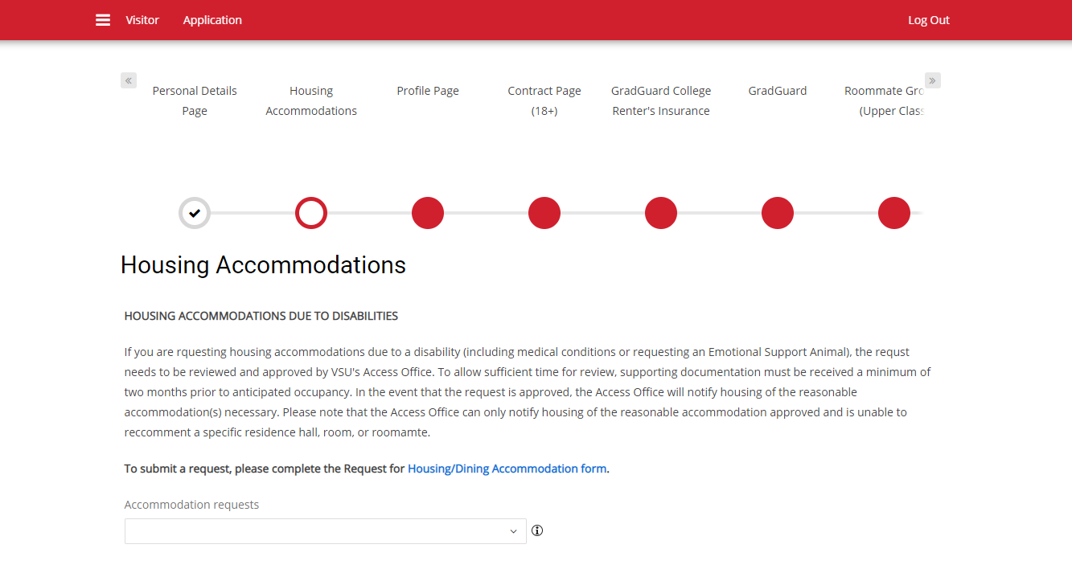

Step 6: Enter profile information. This information is what the system uses to show you roommate suggestions. As a reminder, matched roommate groups will select before students without a roommate, so we can get as many roommate pairs together as possible.

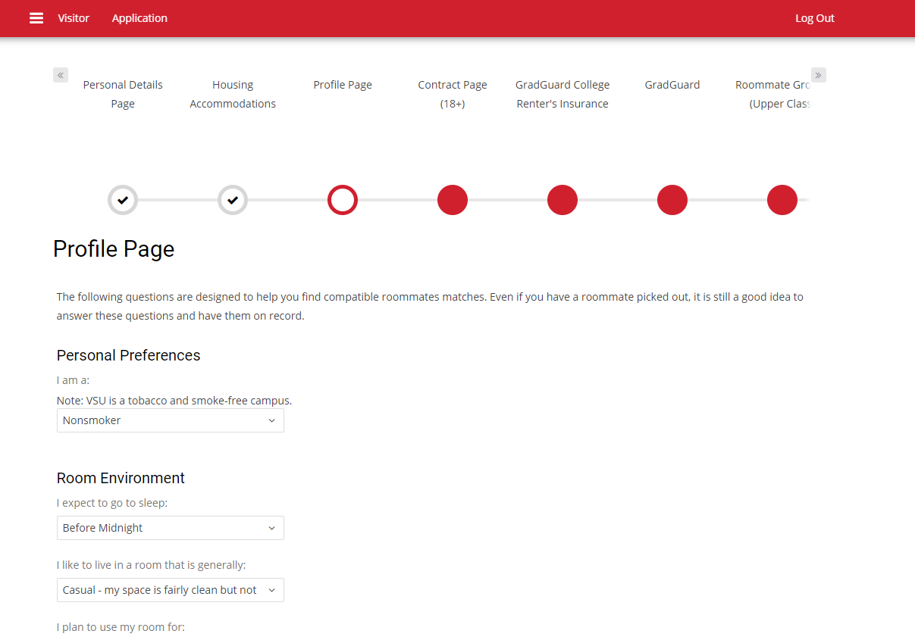

Step 6B: Roommate Search Process. You are automatically opted into being displayed in roommate search results. Do not unclick this box…if you do, nobody will be able to match with you as a roommate. You can enter more information about yourself as well.

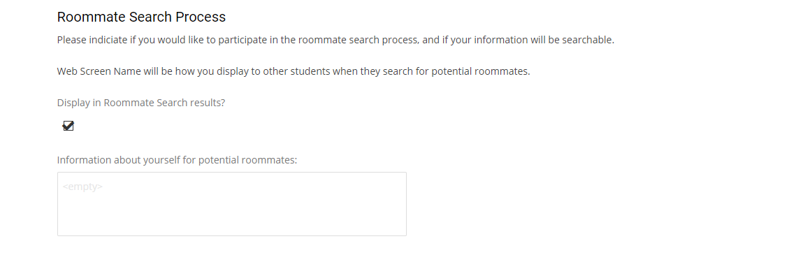

Step 7: Sign the contract. Yes, you will sign the contract prior to selecting your room. This will NOT lock you into the contract. You will be locked into a contract after you select a space during your timeslot in March. If you are under 18, a parent will need to sign the contract for you and you will need to upload JUST the signature page before proceeding. Do not skip this step or your application will be incomplete and you cannot return to that page.

Step 8: GradGuard Renters Insurance. This is an optional service you can sign up for. It will take you to their website to complete the process and you can either sign up, ask for more information, or decline.

Step 9: Roommate Groups. Here is where you will request or search for roommates. Reminder, only groups of 2 or 4 can be verified. Group leader is automatically set to the 1st person who requests a roommate but that can be changed. You can search for other students who have applied by name or you can see who it suggests based on your submitted profile from Step 6. You can come back to this page to finish if you are waiting on someone else to complete the application. Just remember that your application is not complete until you complete this step.

