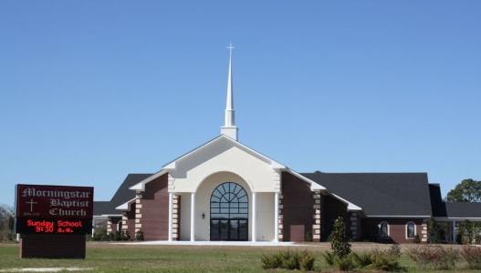
Morning Star Baptist Church Tutorial Program

1051 Howell Road Phone: 229.247.8881 or 229.242.7926

Valdosta, GA 31601 Email: msmbc@bellsouth.net
Website: www.morningstarvaldosta.org
DR. WILLIAM C. MORGAN, Pastor/Teacher
Sis. Deanna Brooks, Tutorial Coordinator
Sis. Jaclyn Lyons, Assistant Coordinator
Sis. Talena Hicks, Secretary
Dear Student Teachers,
I am writing you to consider joining me as a volunteer at the Morning Star Missionary Baptist Church tutoring/mentoring program; this program help match adults to work one-on-one with 1st through 12th grade students. I have been a volunteer with this program for the last 2 years. The goal here at Morning Star Missionary Baptist Church is to help students stay in school and prepare to graduate with a plan for their next step-college, trade school, armed forces, etc.-and eventually move into the workforce.
Valdosta State University has joined us in helping our future leaders strive for academic excellence, so we encourage you all to volunteer twice a week to the tutorial program. The hours of operation will be every Tuesday and Wednesday from 5:15-6:30p.m. starting September 20, 2016; a small snack will be provided afterwards. The program operates throughout the school year. We will also have a sign in sheet for all participants and at the end of the semester a formal letter will be written on your behalf explaining in detail total hours volunteered. I personally encourage you to become a volunteer. There are many youth who need someone in their life to help them succeed. Last year there were many students who came consistently to the program every week in hope that they would eventually be paired with a tutor/mentor. YOU CAN BE THAT TUTOR/MENTOR! If you would like more information on volunteering, please call 229-548-2678, or call Morning Star Baptist Church at 229-247-8881 located on 1051 Howell Rd. You can also e-mail me at ddbrooks@valdosta.edu or deanna.marshall75@gmail.com. My volunteer experience has made a positive impact on my life.
Sincerely,
Mrs. Deanna Brooks, M.Ed.

