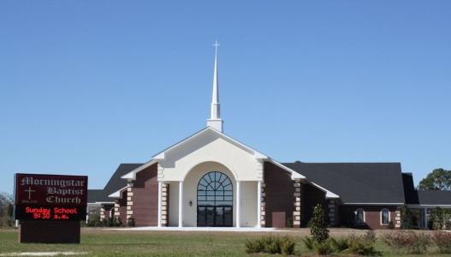
Morning Star Baptist Church Tutorial Program

1051 Howell Road Phone: 229.247.8881 or 229.242.7926

Valdosta, GA 31601 Email: msmbc@bellsouth.net
Website: www.morningstarvaldosta.org
DR. WILLIAM C. MORGAN, Pastor/Teacher
Sis. Deanna Brooks, Tutorial Coordinator
Sis. Jaclyn Lyons, Assistant Coordinator
Sis. Talena Hicks, Secretary
Dear Volunteer Tutor,
Thank you so much for accepting joining me and many others as a volunteer at the Morning Star Missionary Baptist Church tutoring/mentoring program; this program help match adults to work one-on-one with 1st through 12th grade students. We must have your basic information on file as well as a waiver to relinquish Morning Star Missionary Baptist Church of any liability. Please fill out the form completely and ensure you sign and date. The hours of operation will be every Tuesday and Wednesday from 5:00-6:30p.m. starting September 20, 2016; a small snack will be provided afterwards. The program operates throughout the school year. We will also have a sign in sheet which all tutors must sign in and at the end of the semester a formal letter will be written on your behalf explaining in detail total hours volunteered. You can also e-mail me at ddbrooks@valdosta.edu or deanna.marshall75@gmail.com if you have any questions.
ACCIDENT WAIVER AND RELEASE OF LIABILITY FORM
I HEREBY ASSUME ALL OF THE RISKS OF PARTICIPATING IN ANY/ALL ACTIVITIES ASSOCIATED WITH Morning Star Missionary Baptist Church, including by way of example and not limitation, any risks that may arise from negligence or carelessness on the part of the persons or entities being released, from dangerous or defective equipment or property owned, maintained, or controlled by them, or because of their possible liability without fault.
I certify that I am physically fit, have sufficiently prepared or trained for participation in this activity, and have not been advised to not participate by a qualified medical professional. I certify that there are no health-related reasons or problems which preclude my participation in this activity.
I acknowledge that this Accident Waiver and Release of Liability Form will be used by the event holders, sponsors, and organizers of the activity in which I may participate, and that it will govern my actions and responsibilities at said activity.
In consideration of my application and permitting me to participate in this activity, I hereby take action for myself, my executors, administrators, heirs, next of kin, successors, and assigns as follows:
(A) I WAIVE, RELEASE, AND DISCHARGE from any and all liability, including but not limited to, liability arising from the negligence or fault of the entities or persons released, for my death, disability, personal injury, property damage, property theft, or actions of any kind which may hereafter occur to me including my traveling to and from this activity, THE FOLLOWING ENTITIES OR PERSONS: The Morning Star Baptist Church, staff and/or their directors, officers, employees, volunteers, representatives, and agents, and the activity holders, sponsors, and volunteers;
(B) INDEMNIFY, HOLD HARMLESS, AND PROMISE NOT TO SUE the entities or persons mentioned in this paragraph from any and all liabilities or claims made as a result of participation in this activity, whether caused by the negligence of release or otherwise.
I acknowledge that MSMBC and their directors, officers, volunteers, representatives, and agents are NOT responsible for the errors, omissions, acts, or failures to act of any party or entity conducting a specific activity on their behalf.
I hereby consent to receive medical treatment which may be deemed advisable in the event of injury, accident, and/or illness during this activity.
I understand while participating in the MSMBC tutorial program, I may be photographed. I agree to allow my photo, video, or film likeness to be used for any legitimate purpose by the activity holders, producers, sponsors, organizers, and assigns.
The Accident Waiver and Release of Liability Form shall be construed broadly to provide a release and waiver to the maximum extent permissible under applicable law.
I CERTIFY THAT I HAVE READ THIS DOCUMENT AND I FULLY UNDERSTAND ITS CONTENT. I AM AWARE THAT THIS IS A RELEASE OF LIABILITY AND A CONTRACT AND I SIGN IT OF MY OWN FREE WILL.
________________________________ ___________ __________________________________ ______
Participant’s Signature Date Participant’s Name Age
(Please print legibly.)
________________________________ ______________________________
Phone/email Address
(If under 18 years old, Parent or Guardian must also sign.)

