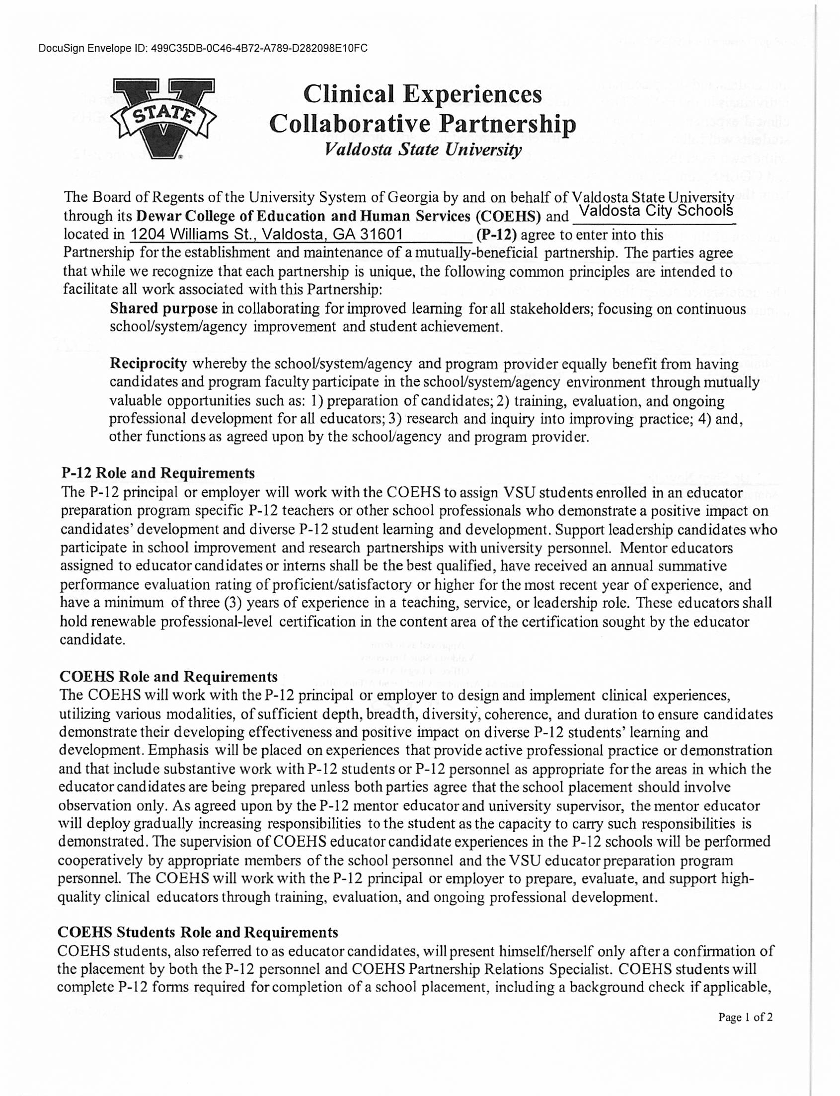

DocuSign Envelope ID: 533564E4-03A9-45C4-B0FE-7C534BD949E1

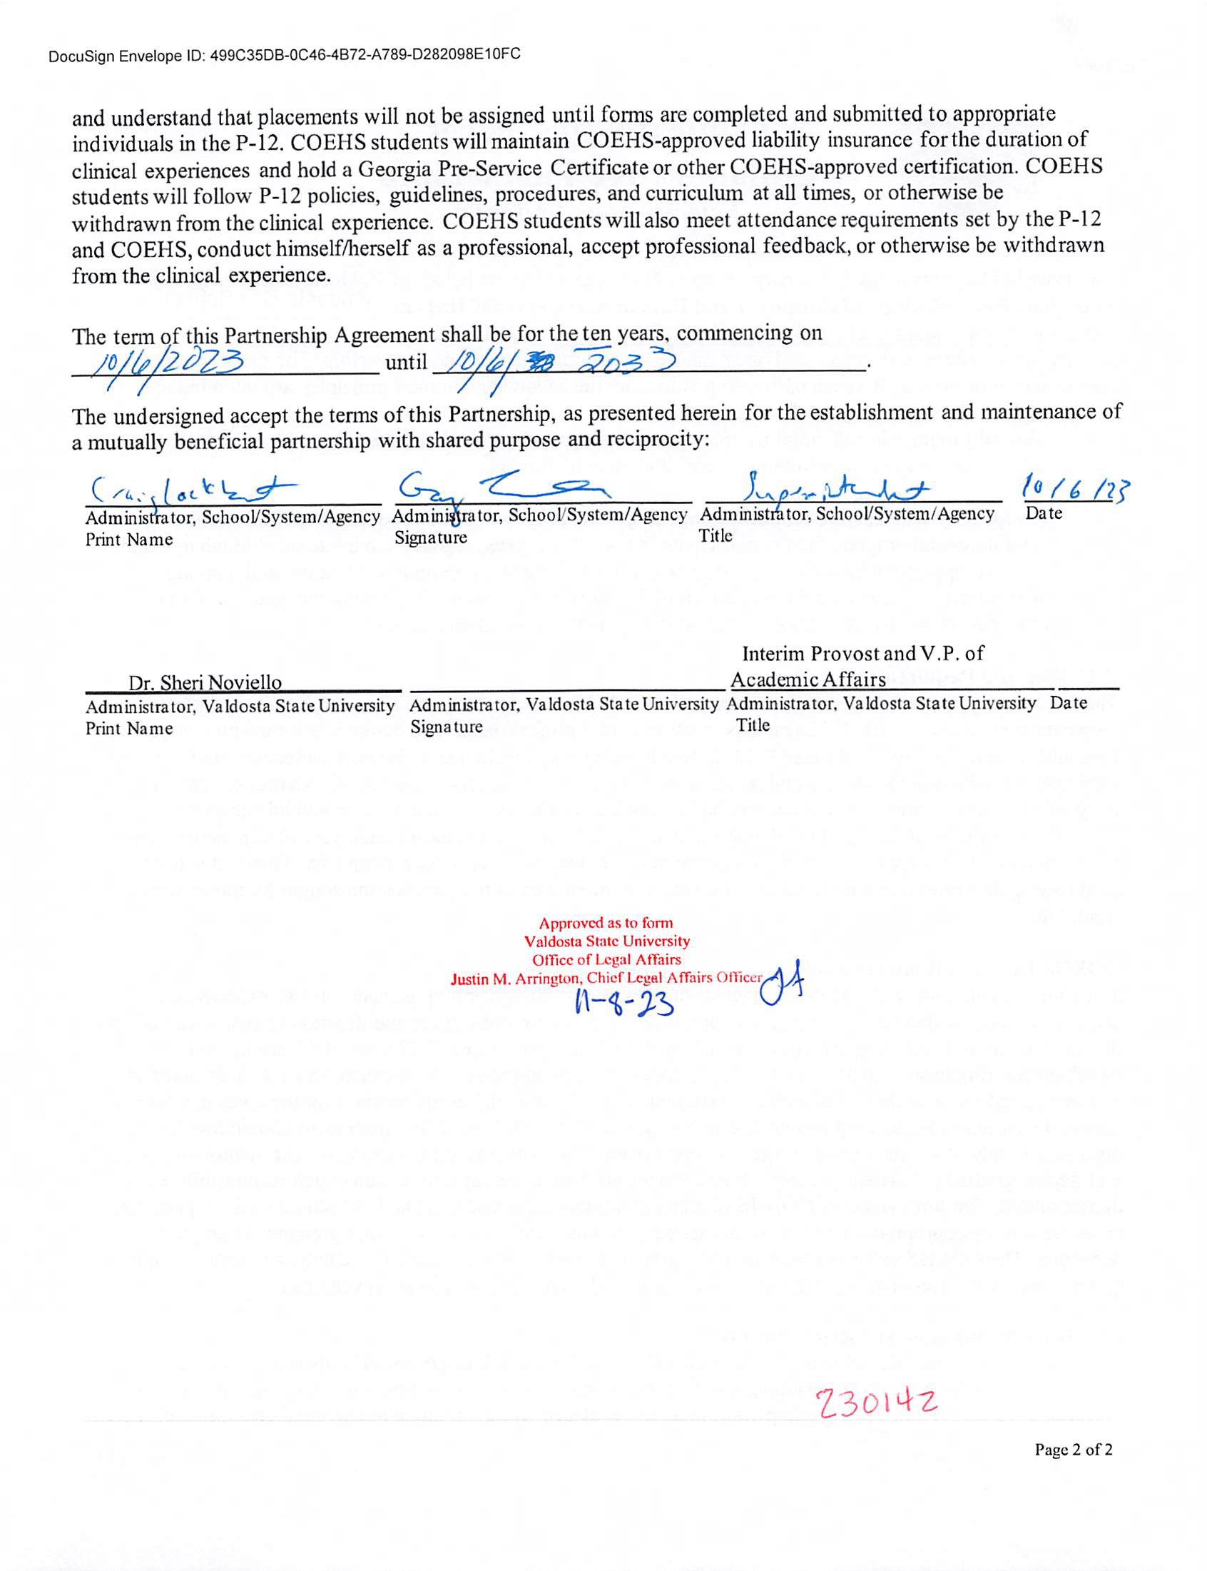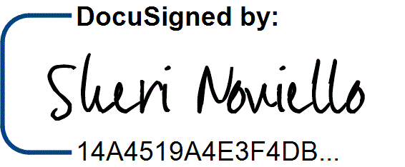

DocuSign Envelope ID: 533564E4-03A9-45C4-B0FE-7C534BD949E1

11/10/2023 | 7:05