American Sign Language/Interpreting
Qualified interpreters provide a critical link in the education system for teachers, as well as deaf and hard of hearing students. This four year degree program is designed to provide students with interpreting and transliteration skills, in depth knowledge of the field, and an understanding of the interpreter's role within the school system. This program provides students with field labs, practicum experiences, and internships within local public school settings. In addition, at the conclusion of the program, students will qualify to take state and national evaluations for interpreter proficiency.
Students who successfully complete the program in American Sign Language/ Interpreting at Valdosta State University will earn a Bachelor of Science degree. Completion of the program requires passing of the written portion of the Educational Interpreter Performance Assessment (EIPA) or the National Interpreter Certification (NIC).
American Sign Language/Interpreting
The American Sign Language program is housed in the Department of Middle, Secondary, Reading and Deaf Education within the James L. and Dorothy H. Dewar College of Education at Valdosta State University. Students can enroll in the program as traditional/on campus residents, or complete coursework through distance learning/video conferencing technology. The Department offers undergraduate programs in ASL/Interpreting, Deaf Education, Middles Grades Education, Reading and master's degree preparation in Special Education: Deaf and Hard of Hearing.

Educational Interpreters: Providing a Vital Link By Equalizing and Enhancing Education

American Sign Language/Interpreting
Undergraduate
American Sign Language/
Interpreting
Program
FIRST FALL (16 hours)
ASLS 3170 4 hours
DEAF 3110 3 hours
SPEC 3000 3 hours
INTP 3010 3 hours
ELECTIVE 3 hours
SECOND FALL (13 hours)
INTP 4010 3 hours
INTP 4020 4 hours
INTP 4030 3 hours
INTP 4040 3 hours
FIRST SPRING (16 hours)
ASLS 3140 3 hours
DEAF 3120 3 hours
ASLS 3180 4 hours
DEAF 3130 3 hours
INTP 3150 3 hours
SECOND SPRING (15 hours)
For Additional information contact:
Dr. Nanci A. Scheetz
Department of Middle Grades, Secondary, Reading & Deaf Education
1500 N. Patterson St.
Valdosta, GA 31698
Phone: 229-219-1322
Fax: 229-333-5963
Email: nascheet@valdosta.edu
INTP 4050 3 hours
INTP 4060 3 hours
INTP 4070 3 hours
INTP 4080...................................................................... 6 hours
American Sign
Language/
Interpreting
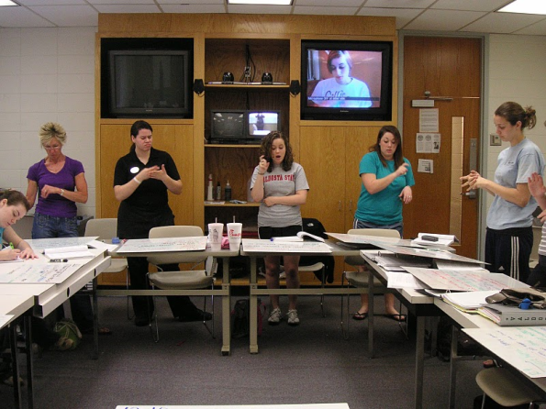
Program

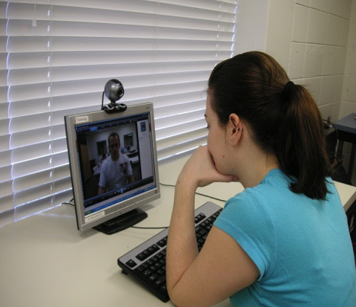

VALDOSTA STATE
UNIVERSITY

 |  |  | American Sign Language/Interpreting |  | American Sign Language/Interpreting
 | Course Description |  |  |  |  |  |  | American Sign Language/ Interpreting  Program
ASLS 3170 American Sign Language III  Prerequisite: ASLS 2120  The third in a series of courses based on American Sign Language concepts and principles. This course is designed to increase recognition and recall skills in dialogue communication. American Sign Language idioms are also included as well a deeper understanding of the grammar, syntax complexities within the language.  ASLS 3180 American Sign Language IV  Prerequisite: ASLS 3170  This is the fourth in a series of courses based on American Sign Language concepts and principles. This class is an advanced course in American Sign Language for students who have completed previous coursework in ASL. Emphasis is placed on the production of non-voiced, conversational, spontaneous signed sentences. Continued attention is given to the development of recognition as well as recall skills. Sociolinguistics with specific reference to syntax, and role of non-manual markers and idioms are explored as well as the interplay between language and overview within the Deaf community.  DEAF 3110 Orientation to Deafness  An over⁻view of the field of deafness. Topics include psychosocial aspects of deafness, educational settings, modes of communication, technology, vocational opportunities, moral development, and needs of the multi- handicapped deaf and hard of hearing population.  DEAF 3120 Psychosocial Aspects of Deafness  An introduction to the study of deafness and how it impacts on both the psychological and the social development of the individual. The focus of this class is toward a general understanding of deafness as a psychosocial variable that is influential in shaping the life experiences and functioning of individuals who are deaf and/or hard of hearing. Incorporates further study of the significance of deafness by examining interactions between and among those who are and those who are not deaf.  DEAF 3130 Overview of Language Learning in Deaf Children An overview of language development in deaf children from infancy through young adulthood. The course includes and examination of the various theories of language development and assessment instruments used to evaluate this population. Emphasis is placed on interpreter flexibility in using the different modes of communication as they relate to the various stages of language development.  SPEC 3000 Serving Student Diverse Needs  Prerequisite: Appropriate 2999 course. Introduction to major issues in the field of special education. Emphasis is placed on understanding the characteristics and etiologies of individuals with diverse needs and on identifying the qualities of home, school and community environments that support these individuals in achieving their potential. Public school observation/participation in programs for students with disabilities is required. |  |  | ASLS 3140 Linguistics of American Sign Language Prerequisite: ASLS 3170  An overview of structural linguistics, sociolinguistics, and pragmatics. Linguistic theories will be applied to both spoken English and ASL, with other examples being drawn from various languages. Special attention will be paid to phonological (including the application of phonological rules), morphological, lexical, syntactical, and discourse structures of ASL, as well as language variation and language change.  INTP 3010 Topics for Educational Interpreting Prerequisite: ASLS 2120  An overview of the field of interpreting. This course examines the role of the educational interpreter and provides an in-depth analysis and application of the Code of Ethics. Settings and situations which emphasize the role of the interpreter within the academic environment are examined.  INTP 3150 English–ASL Translation  Prerequisites: INTP 2999, DEAF3110, ASLS3170. A skills-oriented course designed to provide students with practice translating English to ASL and ASL to English. The primary focus of the class will be on the process of translation, i.e., analysis, transfer and reformulation of the source text in the target language when there is substantial time to consider language form and function, cultural parallelism, and pragmatic aspects of the translation. Students will engage in practice of meaning analysis, written transcription, and signed and spoken translation.  INTP 4010 Consecutive English/American Sign Language Interpreting  Prerequisites: ASLS 3180, INTP 3010, & ASLS 3140  A skills class designed to provide students with the opportunity to develop and enhance their interpreting skills. The course emphasizes techniques for interpreting spoken instructional and non-instructional activities into ASL.  INTP 4020 Consecutive American Sign Language / English Interpreting  Prerequisites: ASLS 3180, INTP 3010, & ASLS3140  A study of the principles and problems relating to interpreting a signed message from the deaf individual into its spoken English equivalent. Emphasis is placed on word choice, register, inflection, clarity, tone, and intent of the message.  INTP 4030 Consecutive Transliterating: English to a Manually Coded English Sign System  Prerequisites: INTP 3010, ASLS 3180, & ASLS3140  A skills course focusing on transliterating skills. Emphasis is placed on techniques for transliterating instructional/ non-instructional classes and activities found in the public school system. Particular attention is given to the use of English sign systems as they relate to subject matter-that requires an English-based sign system. |  | INTP 4040 Practicum for Educational Interpreters Prerequisites: INTP 3010, ASLS 3180, & ASLS 3140  Provides advanced students with structured observation of professional interpreters and an opportunity to acquire additional knowledge about the profession of interpreting.  INTP 4050 Simultaneous English/ American Sign Language Interpreting I  Prerequisites: INTP 3010, INTP 4010,  INTP 4020, INTP 4030, & INTP 4040  An extension of INTP 4010. This course is designed to strengthen the skills of advanced level students so that they are able to interpret accurately a spoken message into ASL.  INTP 4060 Simultaneously American Sign Language/ English Interpreting  Prerequisites: INTP 3010, INTP 4010,  INTP 4020, INTP 4030, & 1NTP 4040  A continuation of INTP 4030. This course is designed to strengthen the skills of advanced-level students preparing them to interpret accurately information presented in ASL into appropriate spoken English. Emphasis continues to be placed on word choice, register, inflection, clarity, tone, and intent of message.  INTP 4070 Simultaneous Transliterating: English to an English Sign System  Prerequisites: INTP 3010, INTP 4010,  INTP 4020, INTP 4030, & INTP 4040  A continuation of INTP 4040. This course is designed to give students additional opportunities to enhance their transliterating skills. Emphasis is placed on techniques for transliterating instructional and non-instructional activities found in the public school system. Continued attention is given to increasing fluency and sign choice equivalencies that best match the spoken message.  INTP 4080 Educational Interpreting Internship INTP 3010, INTP 4010, INTP 4020, INTP 4030, & INTP 4040  An opportunity for students to work in a school system and apply their interpreting skills in the educational setting. Sites for internships are selected where mentors are available to further promote student growth and development. Students become familiar with the duties and responsibilities that interpreters have in the classroom.
VALDOSTA STATE
UNIVERSITY
 |  |  |  |  |  | 