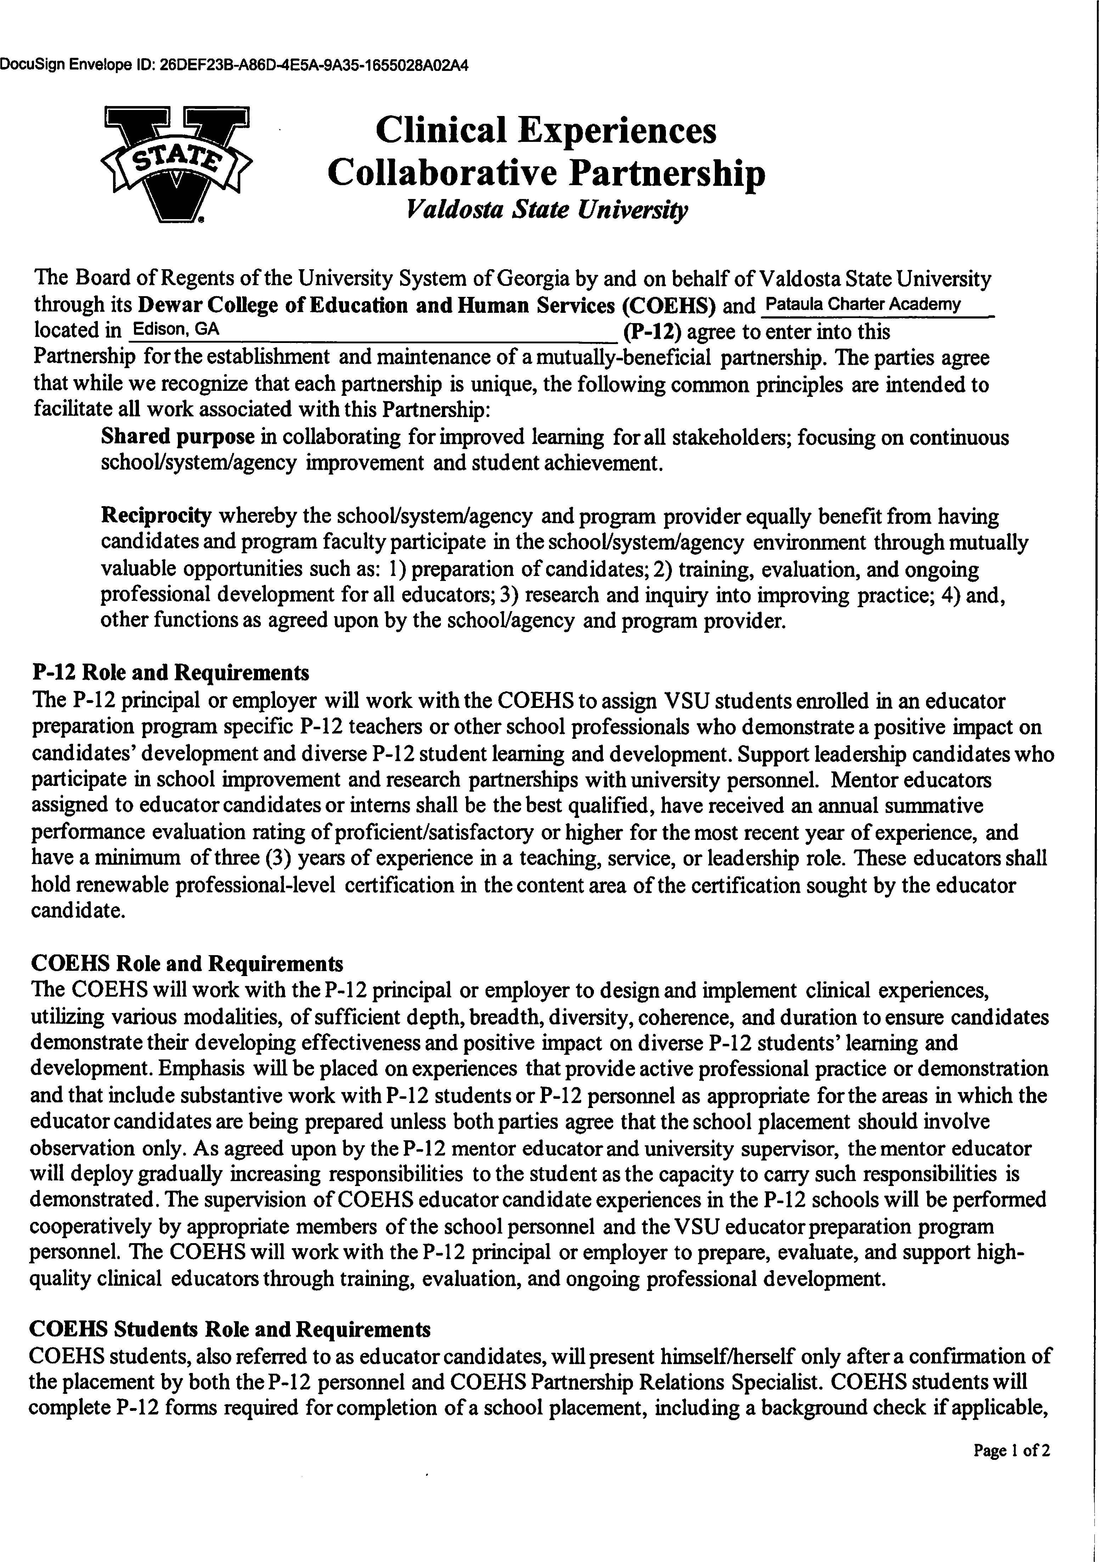

DocuSign Envelope ID: 85A9E380-E627-4AE5-BA28-4122C5AC45F3

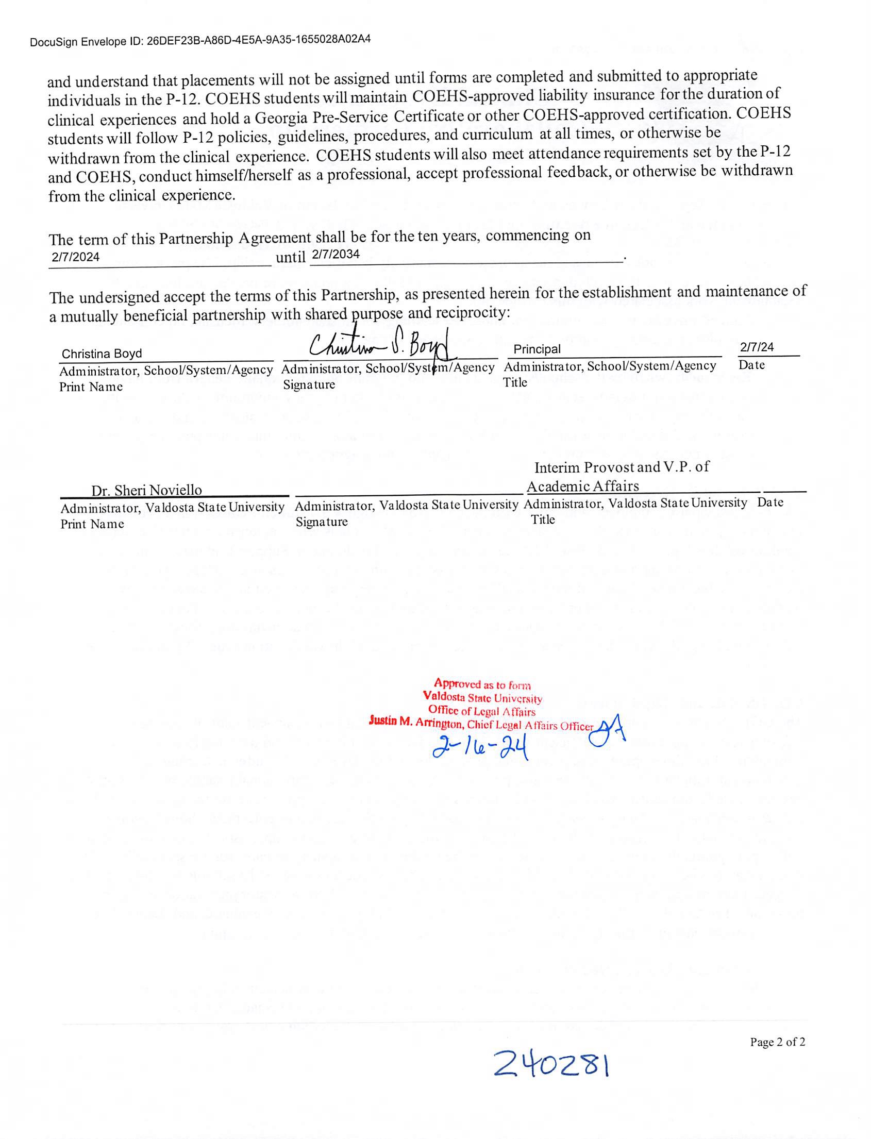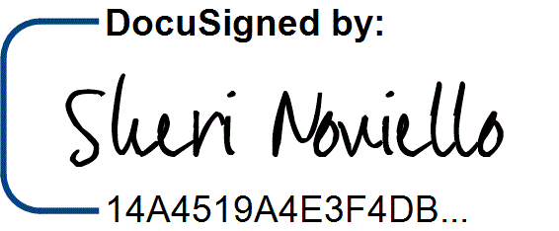

DocuSign Envelope ID: 85A9E380-E627-4AE5-BA28-4122C5AC45F3

2/21/2024 | 4:24 AM