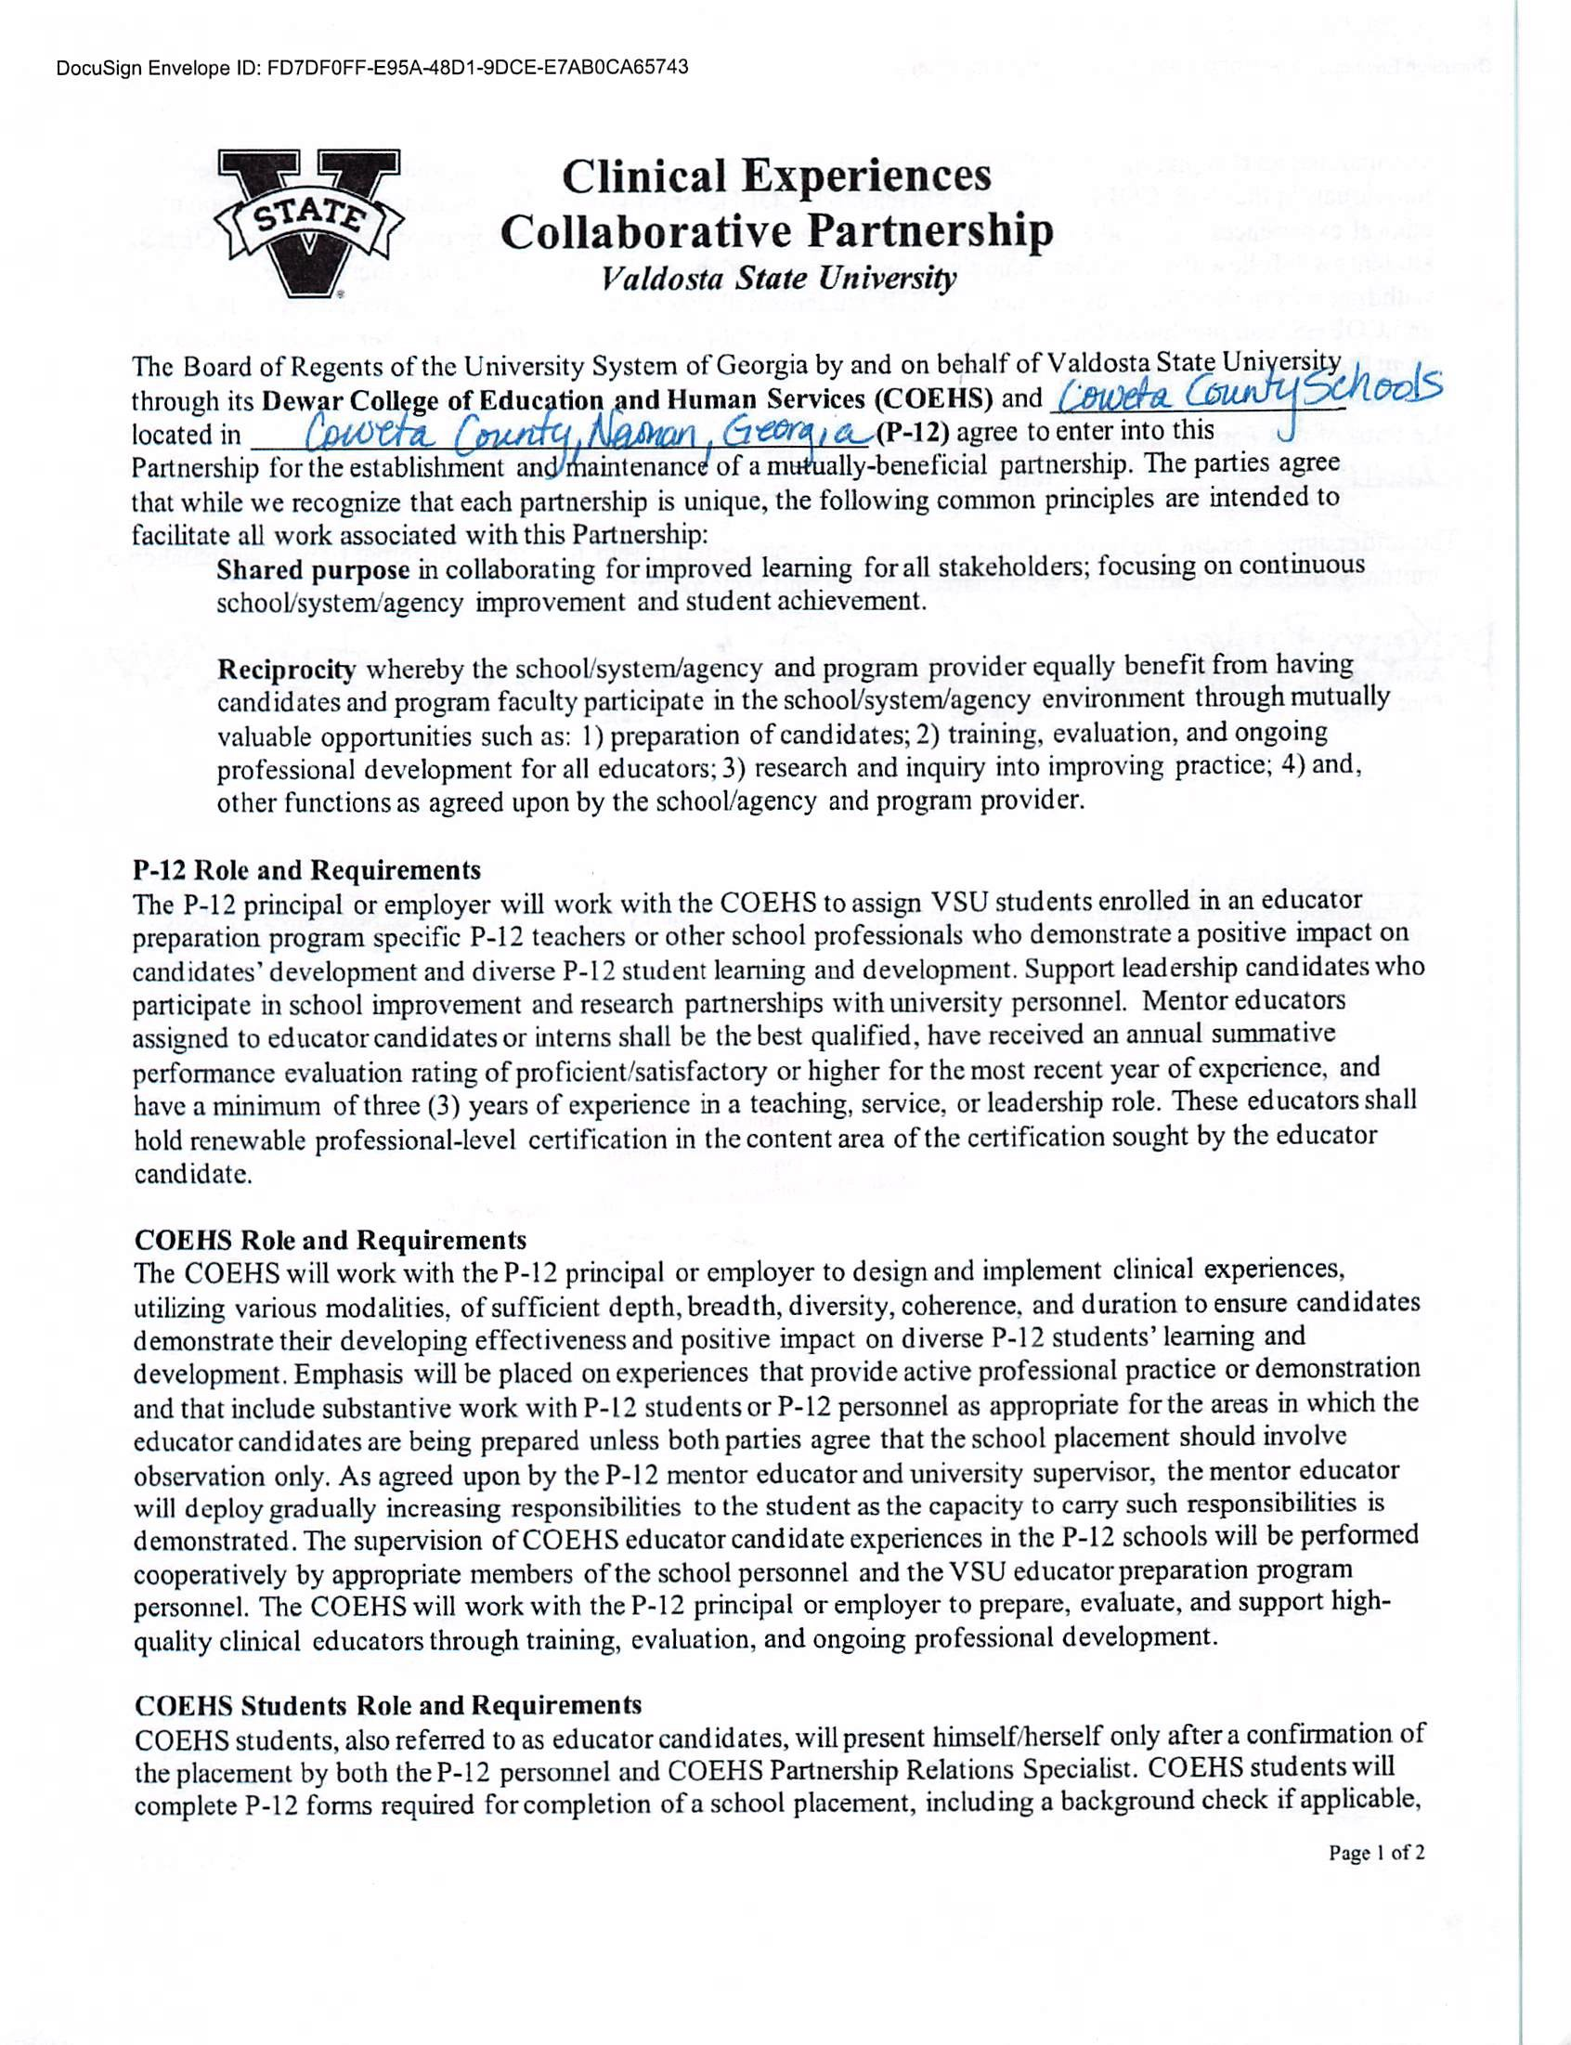

DocuSign Envelope ID: E2888FFE-2D1A-4F3D-BADC-D8DD01BD643D

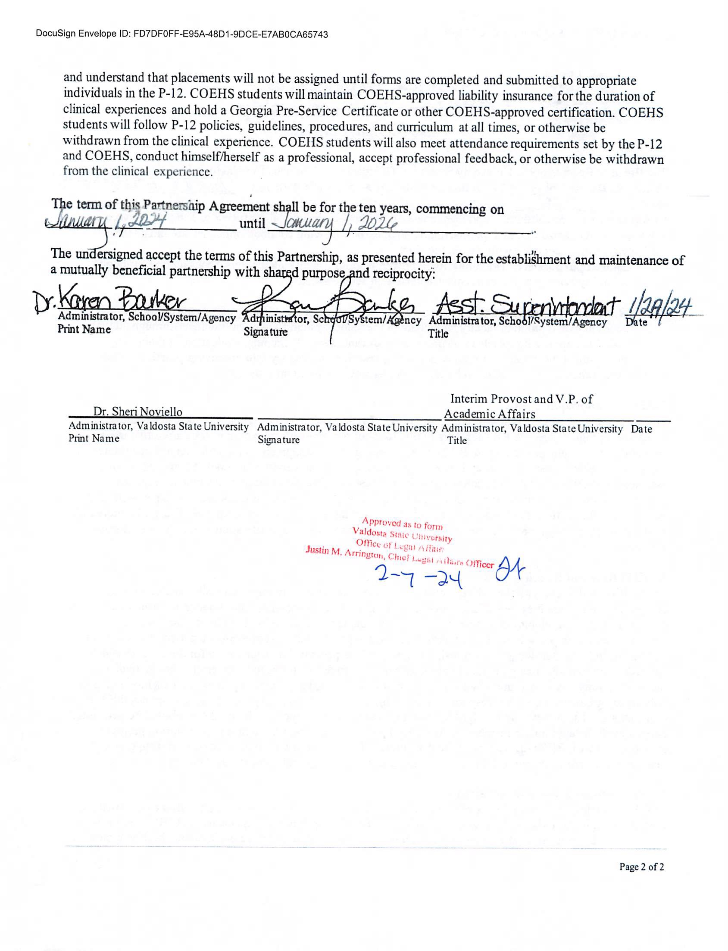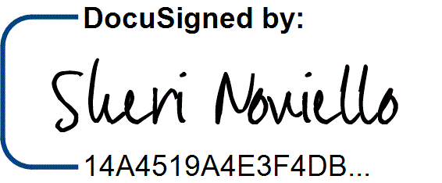

DocuSign Envelope ID: E2888FFE-2D1A-4F3D-BADC-D8DD01BD643D

2/8/2024 | 8:03 AM