COEHS Pre-Tenure, Tenure, and Promotion Electronic Submission Policies

Overview
The COEHS utilizes Microsoft OneDrive to submit/review pre-tenure, tenure, promotion and post-tenure reviews.

Each faculty member with an upcoming pre-tenure, tenure, promotion, and post-tenure reviews will have an OneDrive folder and corresponding sub-folders created by the COEHS dean’s office. Individual faculty will upload their documents in PDF format.

On July 1st folders will be available for faculty who are submitting their dossiers for pretenure, tenure, promotion, and post-tenure review.

Review letter writers will upload their letters as they are written. When a letter writer uploads to his or her letter a copy should also be sent to the candidate.

This document supplements the COEHS Performance Guidelines and the COEHS Pre-Tenure, Tenure, and Promotion Electronic Submission Instructions. The COEHS Tenure and Promotion Resources page provides a number of useful tenure and promotion resources.

Permissions and Access to One Drive Folder
The COEHS Dean’s office is responsible for adjusting permissions to each candidate’s folder and will have access to faculty folders throughout the personnel review process. The access start and end dates in the table below are based upon the recommended completion dates published by the University.

The COEHS Dean’s office will request the Departmental and University P&T committee members’ names prior to the access start dates. Review letters should be uploaded into the folder prior to the access end date. If there are any issues, contact the COEHS Dean’s office.

Access dates can be modified by the COEHS Dean’s office as needed due to changes in University policy or under extenuating circumstances. If an access end date falls on a holiday, the access to the OneDrive will end at close of business on the next business day.

Faculty candidates may request access for others to review their materials by sending the request via email to the COEHS Associate Dean. Access for these candidate-requested reviewers will terminate on the faculty access end date (4th Wednesday in August, see chart below) or any earlier date, as directed by the candidate.

Faculty candidates will have restricted view for Folder A, no access to Folder B, and editorial access to Folders C-H. Note that Folder B contains review letters of the personnel action under consideration, and while the candidate cannot access those files through the electronic submission folder in OneDrive, reviewers at each stage will be sharing their review letter with the candidate via email or in hard copy, at the discretion of the letter writer.

Those reviewers who also have the responsibility to upload review letters will have permission to upload their letters to Folder B and restricted view of all other folders.

Those participants who are serving as reviewers but will not be uploading reviews letters will have restricted view of all folders.

Restricted view means an individual can view pages and documents but cannot edit, alter, download, upload, or share files.

Faculty candidates will not be able to modify their files after the access end date. Files that are not in the OneDrive at the access end date will not be considered. If changes to the files are requested, the department head, the chair of the college personnel committee, or their designee will upload additional documents.

Deadlines to upload files will follow the University policy. All access end times are at 11:59 Eastern Standard Time on the proscribed access end date.

Pre-Tenure File Access
 | Access Start Date | Access End Date (11:59 pm EST )
Faculty Member | July 1 | 4th Wednesday in August
Department Committee | 4th Wednesday in August | Determined by the  Department Committee and the Department Head. The Department Head communicates this access end date to the Dean’s Office.
Department Head | July 1 | 1st Wednesday in October
Dean | 1st Wednesday in October | 4th Friday in November
*

 | Access Start Date | Access End Date (11:59 pm EST )
Faculty Member | July 1 | 4th Wednesday in August
Department Committee | 4th Wednesday in August | 2nd Wednesday in September
Department Head | July 1 | 1st Wednesday in October
College Committee | 1st Wednesday in October | 4th Wednesday in October
Dean | 4th Wednesday in October | 4th Friday in November
Academic Affairs | 4th Friday in November | 2nd Wednesday in December
University Committee | 2nd Wednesday in December | 1st Monday in February
Provost and VPAA | 1st Monday in February | 1st Monday in March
President | 1st Monday in March | 3rd Monday in March
Tenure and Promotion File Access *

Uploading Responsibility
Individual faculty members are responsible for uploading all files, with exception of the documents in three areas:
- Folder A. Policies:
  - The Dean’s office will populate this folder with relevant policies • Folder B. Review Letters for Current Action:
  - Recommendation letters from personnel committees (department and college) will be uploaded by the chair of the personnel committee.
  - The recommendation letter from the department head will be uploaded by the department head.
  - The recommendation letter from the Dean will be uploaded by the Dean.
  - The University Committee (UTPC), the Provost, and the President will have the ability to upload letters; however, they may request assistance from the COEHS office to provide access to a designee to upload the letters or the Dean’s office will upload letters into the appropriate location.
  - When letter writers through the Dean’s level upload their letters, she or he should also send a copy to the candidate. How letters are shared after the Dean’s review is at the discretion of the letter writer.
- Folder D. Section II Annual Evaluations, item 1: The COEHS Dean’s office will populate the COEHS Performance Guidelines.

The candidate should not change the names of folders or sub-folders.

The candidate uploads all PDFs using the naming conventions as specified. Specifications for uploading and naming PDF documents that are placed in each Folder (A – H) are located in Appendix A at the end of this document and in COEHS Electronic Submission Instructions for Pre-Tenure, Tenure, and Promotion.

All instructions should be used as appropriate to the current personnel action. For instance, pre-tenure candidates will not have previous tenure letters to upload (for example, as in Folder D section 5).

Tips for creating files, naming files, file organization, uploading, and saving files:
- Faculty candidates should save all files on a local computer and backup all files prior to uploading files to the OneDrive folders.
- Candidates should not upload unnecessarily large documents.
- Total file size (total of ALL files combined) should be kept under 5 GB maximum.
- Files/documents should be saved as a PDF file format whenever possible and must be viewable without specialized software (such as Avid, AutoDesk/AutoCAD, iRender, Adobe Photoshop, Illustrator, InDesign, Lightwave, Auralia, Pyware, Finale, Audacity, etc.).
- The following characters are not supported in folder or file names: ~ # % & * : < > ? /
\ { | }
- The following names are not allowed for folders or files: .lock, CON, PRN, AUX, NUL, COM0 - COM9, LPT0 - LPT9, _vti_, desktop.ini, any filename starting with ~$.
- Hyperlinks to media files (audio/image/video), direct URL links to websites, YouTube/Vimeo websites or media channels, etc., should be saved within a PDF document.

Accessing OneDrive Folders
A direct link to your One Drive folder will be shared via email.

You can also access OneDrive folder(s) to upload materials by signing into your MyVSU account on the VSU home page. A visual guide is included in Appendix B.

- Click on the Email link in the red band on the top of the page.
- Click the 9 dots box (App launcher) in the upper left corner above the new message button.
- Click OneDrive.
- Click Shared (on the left panel).
- Click Shared with you (one of two horizontal tabs).
- Locate your folder. It will be your last name and the name of your action: LastNameFirstInitialPromotionToAssociateAndTenure.

Appendix A:
COEHS Pre-Tenure, Tenure, and Promotion Electronic Submission Instructions
Folder A. Policies:
  - All Documents in this folder will be pre-loaded by the Deans office.

Folder B. Review Letters & Cover Sheet(s) for Current Action:
These are the review letters and the coversheet(s) for this action. No letters or cover sheets will exist on the day the candidate uploads his or her dossier.
- Access to this folder will evolve from department level to Provost level as the process progresses through the stages of review.
- Letter writers: when you upload your letter to this folder you should also send a copy via email or in hard copy to the candidate.
- Letter writers: Remember to sign the coversheets. You will need to download the cover sheet(s), sign, and then upload the signed copy. Please delete the version that does not have your signature and re-name the newly signed and uploaded copy as described below.
Cover Sheet:
- Candidate: If you are submitting two cover sheets (i.e., one for promotion and one for tenure) please combine both documents into one PDF file.
- This PDF document should be titled: 1COEHSLastNameFirstInitialCoverSheet.pdf
- Example: 1COEHSGonzalesMCoverSheet.pdf PDF 2. CV:
Review Letters: please use these naming conventions:
- 2 DepartmentCommitteeLetter.pdf
- 3 DepartmentHeadLetter.pdf
- 4 COEHSCommitteeLetter.pdf
- 5 COEHSDeansLetter.pdf
- 6 UTPCCommiteeLetter.pdf (or another name at the discretion of the letter writer)
- 7 ProvostLetter.pdf (or another name at the discretion of the letter writer)
- 8 PresidentsLetter.pdf (or another name at the discretion of the letter writer)
Folder C. Section I Vita:
PDF 1. CV:
- Your CV should be in reverse chronological order.
- The PDF should be titled: 1LastNameFirstInitialCV.pdf
- Example: 1GonzalesMCV.pdf
Folder D. Section II Annual Evaluations:
- This section draws from previous evaluations and personnel actions.
- When there is more than one of each document, compile the PDF in chronological order.
PDF 1. COEHS Performance Guidelines:
- The Deans office will place the Performance Guidelines here
PDF 2. Previous Annual Faculty Evaluations:
- Compile all Annual Faculty Evaluations in one PDF document in chronological order.
- This PDF document should be titled: 2PreviousAnnualFacultyEvaluations.pdf

PDF 3. Summary of Accomplishment of Annual Goals and Recommended Areas for Improvement:
- Summarize accomplishment of annual goals and status of any recommended areas for improvement in one PDF document.
- This PDF document should be titled: 3SummarizeAccomplishmentsAreasFor Improvement.pdf
PDF 4. Previous Pre-Tenure Letters:
- Compile all pre-tenure letters in one PDF document in chronological order.
- This PDF document should be titled: 4PreTenureLetters.pdf

PDF 5. Previous Department Tenure and Promotion Letters:
- Compile all Department Tenure and Promotion Letters into one PDF document in chronological order.
- This PDF should be titled: 5DeptTenurePromotionLetters.pdf

PDF 6. Previous COEHS Tenure and Promotion Letters
- Compile all COEHS Tenure and Promotion Letters into one PDF document in chronological order.
- This PDF should be titled: 6COEHSTenurePromotionLetters.pdf

Folder E. Section III Teaching and Advising:
- The candidate populates all sub-folders in this section as described below.

Sub-folder 1. Teaching:
- This sub-folder will include five PDF documents (areas A –E, as described in the COEHS Performance Guidelines).
- Each area should provide the information as detailed in the COEHS Performance Guidelines.

PDF A. Teaching Load Reassigned Time
- The candidate will copy and paste the area A instructions listed in the COEHS Performance Guidelines into a document. Following those instructions, the candidate should fill in his or her response.
- This PDF should be titled: ATeachingLoadReassignedTime.pdf

PDF B. SOI Summaries and Narrative
- The candidate will copy and paste the area B instructions listed in the COEHS Performance Guidelines into a document. Following those instructions, the candidate should fill in his or her response.
- This PDF should be titled: BSOISummariesAndNarrative.pdf

PDF C. Evidence Syllabi COEHS Format
- This item is now optional. If you chose to include evidence that your syllabi are in COEHS format, use only one syllabus as your example.
- The candidate will copy and paste the area C instructions listed in the COEHS Performance Guidelines into a document. Following those instructions, the candidate should fill in his or her response.
- This PDF should be titled: CEvidenceSyllabiCOEHSFormat.pdf

PDF D. Evidence Data Informed Teaching
- The candidate will copy and paste the area D instructions listed in the COEHS Performance Guidelines into a document. Following those instructions, the candidate should fill in his or her response.
- This PDF should be titled: DEvidenceDataInformedTeaching.pdf

PDF E. Evidence Effective Teaching
- The candidate will copy and paste the area E instructions listed in the COEHS Performance Guidelines into a document. Following those instructions, the candidate should fill in his or her response.
- This PDF should be titled: EEvidenceEffectiveTeaching.pdf

Sub-folder 2. Advising:
- This sub-folder will include three PDF documents: areas A –C, as described in the COEHS Performance Guidelines.
- Each area should provide the information as detailed in the COEHS Performance Guidelines.

PDF A. Summaries Of SOA:
- The candidate will copy and paste the area A instructions listed in the COEHS Performance Guidelines into a document. Following those instructions, the candidate should fill in his or her response.
- This PDF should be titled: ASummariesOfSOA.pdf PDF B. Orientation Participation:
- The candidate will copy and paste the area B instructions listed in the COEHS Performance Guidelines into a document. Following those instructions, the candidate should fill in his or her response.
- This PDF should be titled: BOrientationParticipation.pdf

PDF C. Evidence of Effective Advising:
- The candidate will copy and paste the area C instructions listed in the COEHS Performance Guidelines into a document. Following those instructions, the candidate should fill in his or her response.
- This PDF should be titled: CEvidenceOfEffectiveAdvising.pdf

Sub-folder 3. Narratives 3-6:
- This sub-folder should include one PDF
- The candidate will copy and paste items 3-6 listed in the COEHS Performance Guidelines into a document. Following each set of instructions, the candidate should fill in his or her response.
- This PDF should be titled: Narratives3-6.pdf

Folder F. Section IV Scholarship and Academic Achievement:
- The candidate populates all folders in this section as described below.

Sub-folder 1. Scholarship and Academic Achievement Narrative:
- Include a narrative about your scholarship and academic achievement in one PDF document.
- If you mention the name a piece of your scholarship in the narrative, link it to the PDF copy in the evidence sub-folder (sub-folder 4. Evidence of Scholarship and Academic Achievement).
    - Note: You will be providing the reviewers evidence for each piece of scholarship listed in your dossier (as described in the instructions for sub-folder 4, below), however, you do not need to mention every piece of scholarship in your narrative.
    - This instruction to link mention of scholarly items is included to assist reviewers.
    - This narrative about your scholarship and academic achievement should be placed in a PDF that is titled: ScholarshipAndAcademicNarrative.pdf

Sub-folder 1A. Articles, External Funded Grants, and Books:
- In this sub-folder candidates should place two PDF documents. The first is a chronological list of your refereed publications. The second is a chronological list of your other publications.
▪ Note: You will be providing the reviewers evidence for each piece of scholarship listed in your dossier (as described in the instructions for sub-folder 4. Evidence of Scholarship and Academic Achievement, below)
- In each of these lists (PDF A Refereed Publications Chronology and PDF B Other Publications Chronology), link the names of each piece of work to the PDF copy in the evidence folder (sub-folder 4. Evidence of Scholarship and Academic Achievement).
- PDF A Refereed Publications Chronology: should be titled:
ARefereedPublicationsChronology.pdf
- PDF B Other Publications Chronology: should be titled: BOtherPublicationsChronology.pdf

Sub-folder 2. Papers, Workshops, and Symposia Presented at Conferences:
- The candidate should place one PDF document in this sub-folder that contains a listing of all papers, workshops, and symposia presented at professional local, state, regional, national, or international venues.
- Link the names of each activity to the PDF copy in the evidence sub-folder (4. Evidence of Scholarship And Academic Achievement).
- PDF A Papers, Workshops, and Symposia Presented at Conferences: should be titled: APapersWorkshopsSymposiaPresented.pdf

Sub-folder 3. Other Scholarly Activity:
- Place one PDF document in this in this sub-folder that contains a listing of all other scholarly activity as described in the COEHS Performance Guidelines.
- When the evaluator opens this PDF, they should see items A-E as they are outlined in the COEHS Performance Guidelines, with your response filled in for each section.
- Link the names of each activity to the PDF copy in the evidence folder (4. Evidence of Scholarship and Academic Achievement).
- This PDF document should be titled: AOtherScholarlyActivity.pdf

Sub-folder 4. Evidence of Scholarship and Academic Achievement:
- This sub-folder should contain all of the evidence for Section IV.
- Each piece of your scholarly work should be in a separate PDF document.
- Work that is peer-reviewed or refereed must include documentation of this status. Documentation of peer-reviewed or refereed status should be combined with the scholarly work in one PDF document with the evidence that is it is peer-reviewed or refereed placed at the beginning of the document.
- These PDF documents should be titled: YearXX(month)KindOfWorkShortenedTitle.pdf.
Use four digits for the year. Use two digits (always including zeros) for the month. Kind of
work will be a descriptor of your choosing. Shortened title is at your discretion. Capitalize the first letter of each word.
        - Example: 201908SymposiaWkforceEvolution.pdf
        - Example: 202006GrantFordFoud.pdf
        - Example: 202011BookChapterYoungAdult.pdf
        - Example: 202103ArticleSwallowingDisorders.pdf

Folder G. Section V Service:
- The candidate populates one sub-folder (1. Evidence of Service Areas 1-3) and uploads two PDFs (described below) in this Folder.
- The two PDFs should be uploaded to Folder G. Section V Service, not to subfolder 1. Evidence of Service Areas 1-3. When the reviewer opens this Folder G she or he should see one sub-folder and two PDFs.

Sub-folder 1. Evidence of Service Areas 1-3:
- This folder should contain all of the evidence for Section V. For instance, committee assignment documentation, copies of meeting minutes, or copies of products developed.
- Each service activity for which you are providing documentation should be placed in a separate PDF document.
- These PDF documents should be titled:
YearXX(month)LevelOfServiceKindOfWorkShortenedTitle.pdf.
        - Use four digits for the year.
        - Use two digits (always including zeros) for the month.
        - Level of Service will be will be a descriptor of your choosing like: VSU, COEHS, Dept., Community, Profession, etc.
        - Kind of Work will be a descriptor of your choosing like Committee, Taskforce, Liaison, etc.. Capitalize the first letter of each new word.
        - Shortened Title is at your discretion.
        - Capitalize the first letter of each word.
        - Example: 201908VSUCommiteeeDiversity.pdf
        - Example: 202006COEHSTaskforceLiteracyCenter.pdf
        - Example: 202011DeptGrantYoungAdult.pdf
        - Example: 202103VSUTaskforceExpLearning.pdf

PDF A Chronological List of Service:
- Create a PDF document that lists all of your service activities in chronological order.
- Link the names of each activity to the evidence which should be in PDF format and located in the evidence folder (1. Evidence of Service Areas 1-3).
- This PDF document should be titled: AChronologicalListOfService.pdf

PDF B 1-3 Service Areas Combined:
- Create one PDF document that that compiles item numbers 1, 2, and 3 from Section V: Service.
- When the evaluator opens this PDF, they should see items 1-3 as they are outlined in the COEHS Performance Guidelines, with your response filled in for each section.
- Link the names of each activity to the PDF copy in the evidence folder (1. Evidence of Service Areas 1-3).
- This PDF document should be titled: B1-3ServiceAreasCombined.pdf

Folder H. Section VI Professional Growth and Development:
- This folder will include one PDF document for areas 1-5, as described in the COEHS Performance Guidelines.
- When the evaluator opens this PDF, they should see items 1-5 as they are outlined in the COEHS Performance Guidelines, with your response filled in for each section.
- This PDF document should be titled: 1-5ProfessionalGrowthDevelopment.pdf

Appendix B:
Accessing OneDrive Folders

- Click on the Email link in the red band on the top of the page.

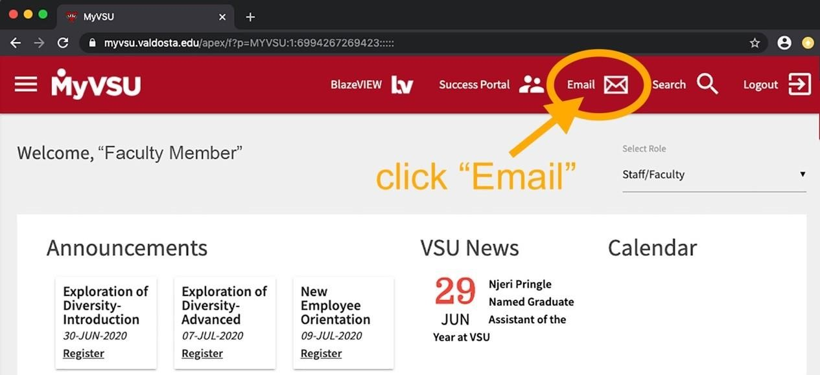

- Click the 9 dots box (App launcher) in the upper left corner above the new message button.

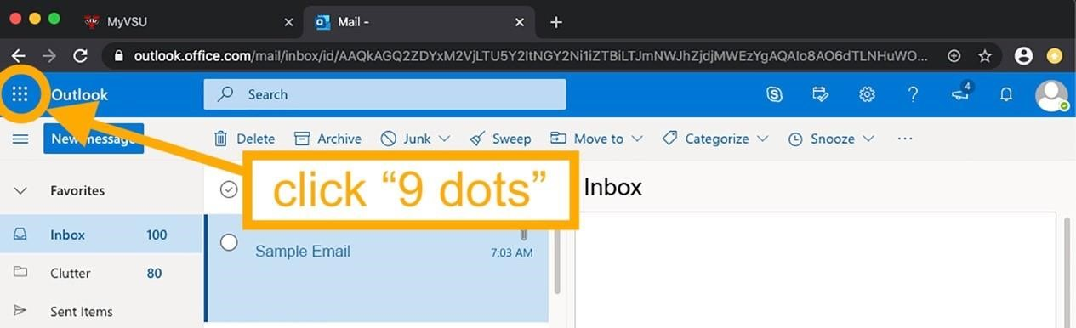

- Click OneDrive

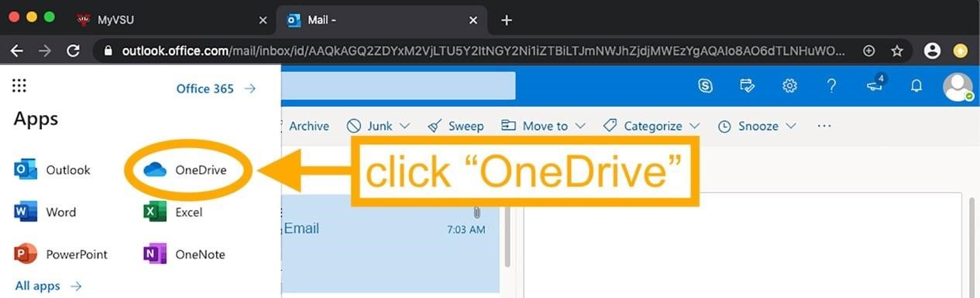

- Click Shared (on the left panel).

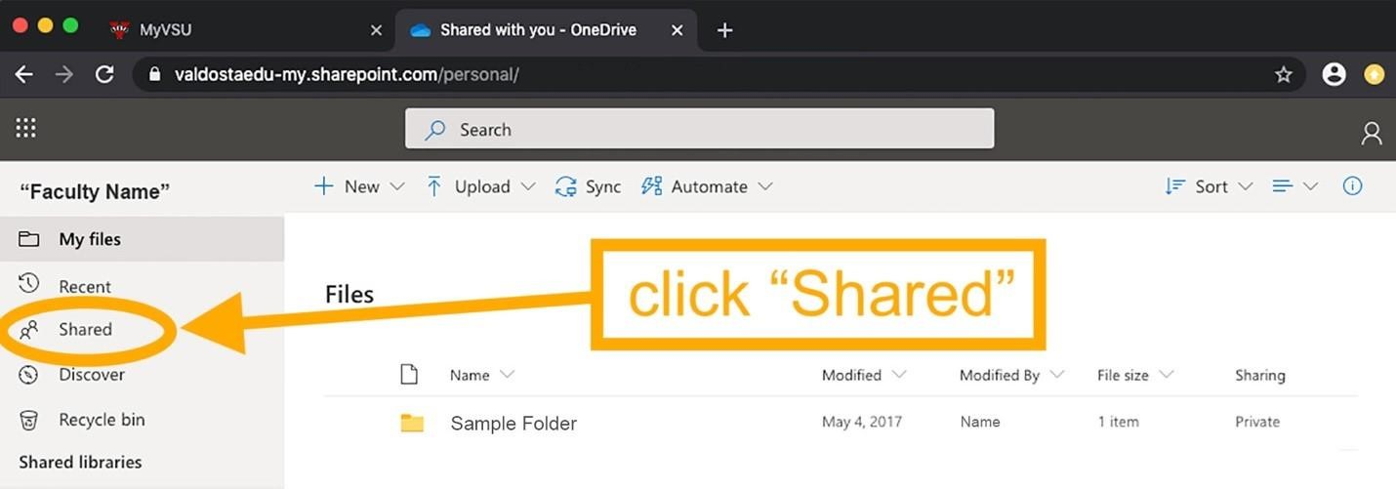

- Click Shared with you (one of two horizontal tabs).
- Locate your folder. It will be your last name, first initial, and the name of your personnel action (e.g., GonzalesMPromotionToAssociateAndTenure)

