Objective:
- Increase skill, craftsmanship, and familiarity with
identifying, achieving, and using intervals (steps) to
create a full value drawing.
- To make a paper airplane that is valuable as a
still life value study.

You must create a drawing that:
- Uses at least 5 tones blended to display a value range from white to black
- Exhibits a full sense of light logic with an accurate treatment of edges, a complete range of value with sensitive transitions rendering accurate effects of
physical light across an object by drawing a still life of a paper airplane with one light source.

Materials: 18 x 24” drawing paper, pencil, charcoal, erasers, paper airplane, clamp lamp.
Process: Start by creating a 5-step value scale. Create 5 value squares that make the best transition between white and black. Compare the squares to one another to determine the best even steps of progressive values. Your scale should be complete to serve as a value reference for you plane drawing. Sketch out some thumbnails to determine your best composition. After choosing your best composition lightly sketch out your plane on paper and, through observation render the value shapes. With the appropriate transitions blend your value shapes to match what you observe within your still life. When finished your drawing must exhibit more than every value from your scale.

You will present one piece of 18" x 24" drawing paper with a full value charcoal representation of a
paper airplane using charcoal, black chalk pastel, white chalk pastel, and eraser. The composition must be well thought out and balanced.

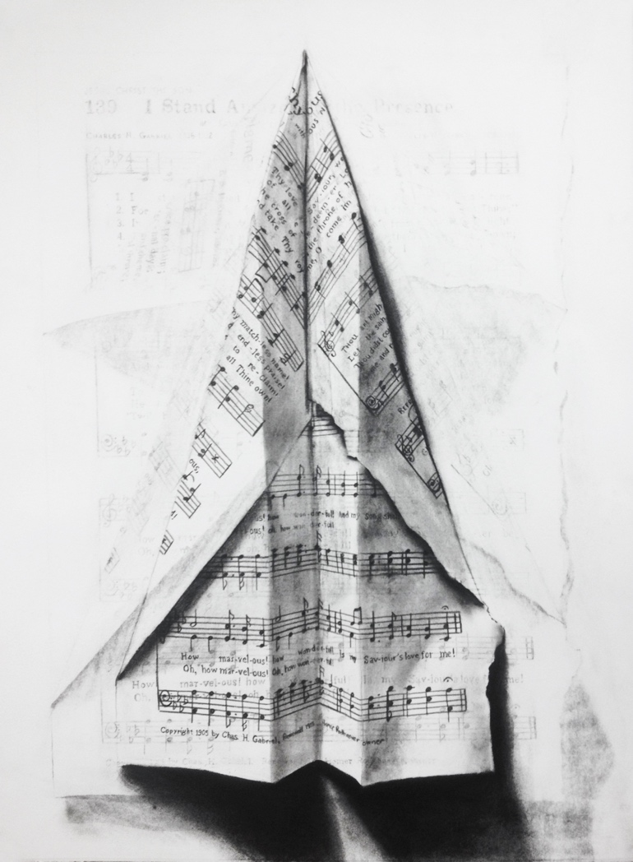

Hymn 139, charcoal on paper, 22 x 30 inches, Craig Hawkins

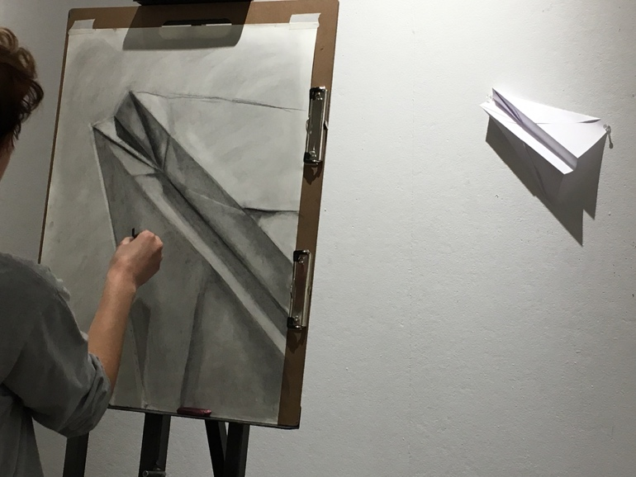

DUE DATE:

