HANDMADE TOOL DRAWINGS

Objective: This assignment will focus on the variety of line quality created through handmade tools. Students will investigate how unconventional drawing tools and impediments can create an expressive line and the performative nature of drawing.

Materials:
Found objects: old toys, garbage, cutlery, etc. anything that can be turned into something to draw with. Be creative!
Aluminum cans (provided)
Scissors
X-acto knife
Brushes
Duct tape
Black India Ink
Sketchbook
18” x 24” sheet of drawing paper

Process:
- In this project you will make your own drawing tools! I will demonstrate how to make a homemade ruling pen using an aluminum can and the variety of marks it can make. You will make minimum 3 different tools that can be used for drawing: at least one should have a performative element (ie. Is it attached to your earring? Elbow? Do you have to move in a strange way to make it work?) and another should have an unconventional end (ie. a stick, fork, etc).
- After creating your drawing tools experiment in your sketchbook to explore the types of marks that can be made. In class students will share their drawing tools and the variety of marks that they make.
- Using your new tools and your 18” x 24” drawing paper you will draw the still life using contour lines, hatching, stippling, and mark making. Start with 3 thumbnail sketches in your sketchbook (just quick tiny sketches that get down the basic information and composition- shouldn’t take you longer that 3 minutes each) to determine an interesting composition. Once a sketch is approved by the instructor you may scale up to your larger paper.
- Using a pencil (lightly! So you can erase the pencil lines later) loosely block in the proportion and location of objects in the still life. Once blocked in, switch to India Ink and your new drawing utensils. Don’t worry if it is messy – be expressive and experimental! Make sure to lookdrawlookdraw and let the utensil intuitively follow the lines of the objects. Alter the thinness and the thickness of the lines based on light and shadow. Use hatching, stippling and mark making to show areas of value through line.
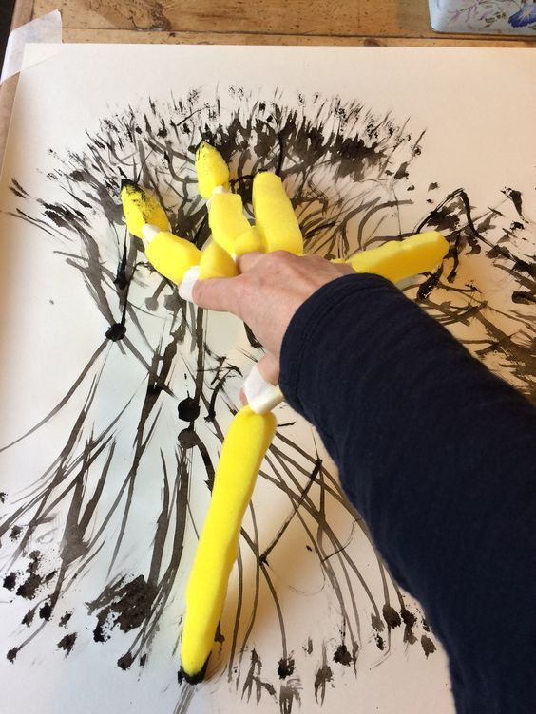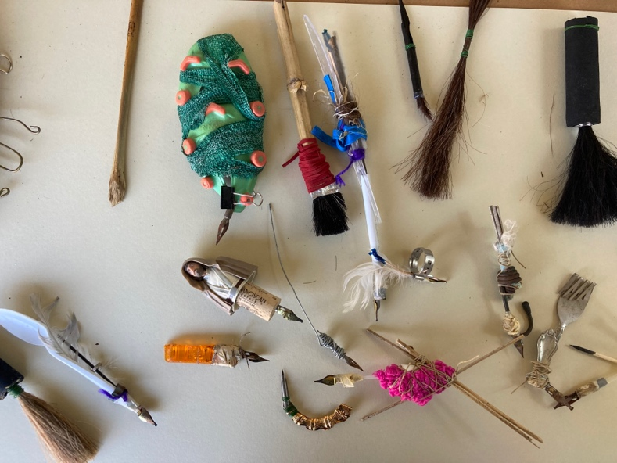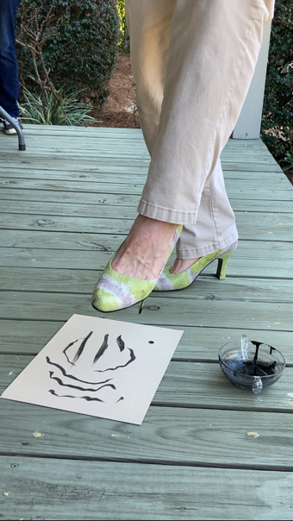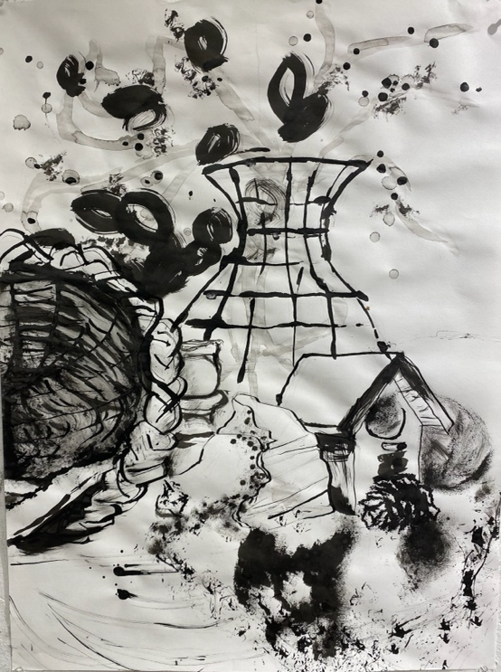
Images of tools and process by Rich Curtis.

