VALDOSTA STATE UNIVERSITY DEPARTMENT OF ART & DESIGN DRAWING I

ART 1010 Drawing I Dr. Selena Nawrocki

Project: Value / Dark and Light on Toned Paper

Drawing Principle:
A toned paper may serve as a middle value when used as a ground with the application of light and dark charcoal, white charcoal pencil, or white conte crayon.

Procedure:
Execute your drawing using charcoal and white conte crayon or white charcoal pencil allowing the paper to serve as the middle value. Try to avoid mixing light and dark values to create intermediate tones. Let the paper serve as the transitional middle value.

Materials:
Middle Value Toned Paper (18” x 24”), Charcoal, White Conte Crayon, White Charcoal Pencil, Blending Tools – Blending Stumps, Q-Tips, Cotton Balls.

Evaluation:
The project will be graded on originality, craftsmanship, pictorial composition, technical achievement, and a professional presentation.

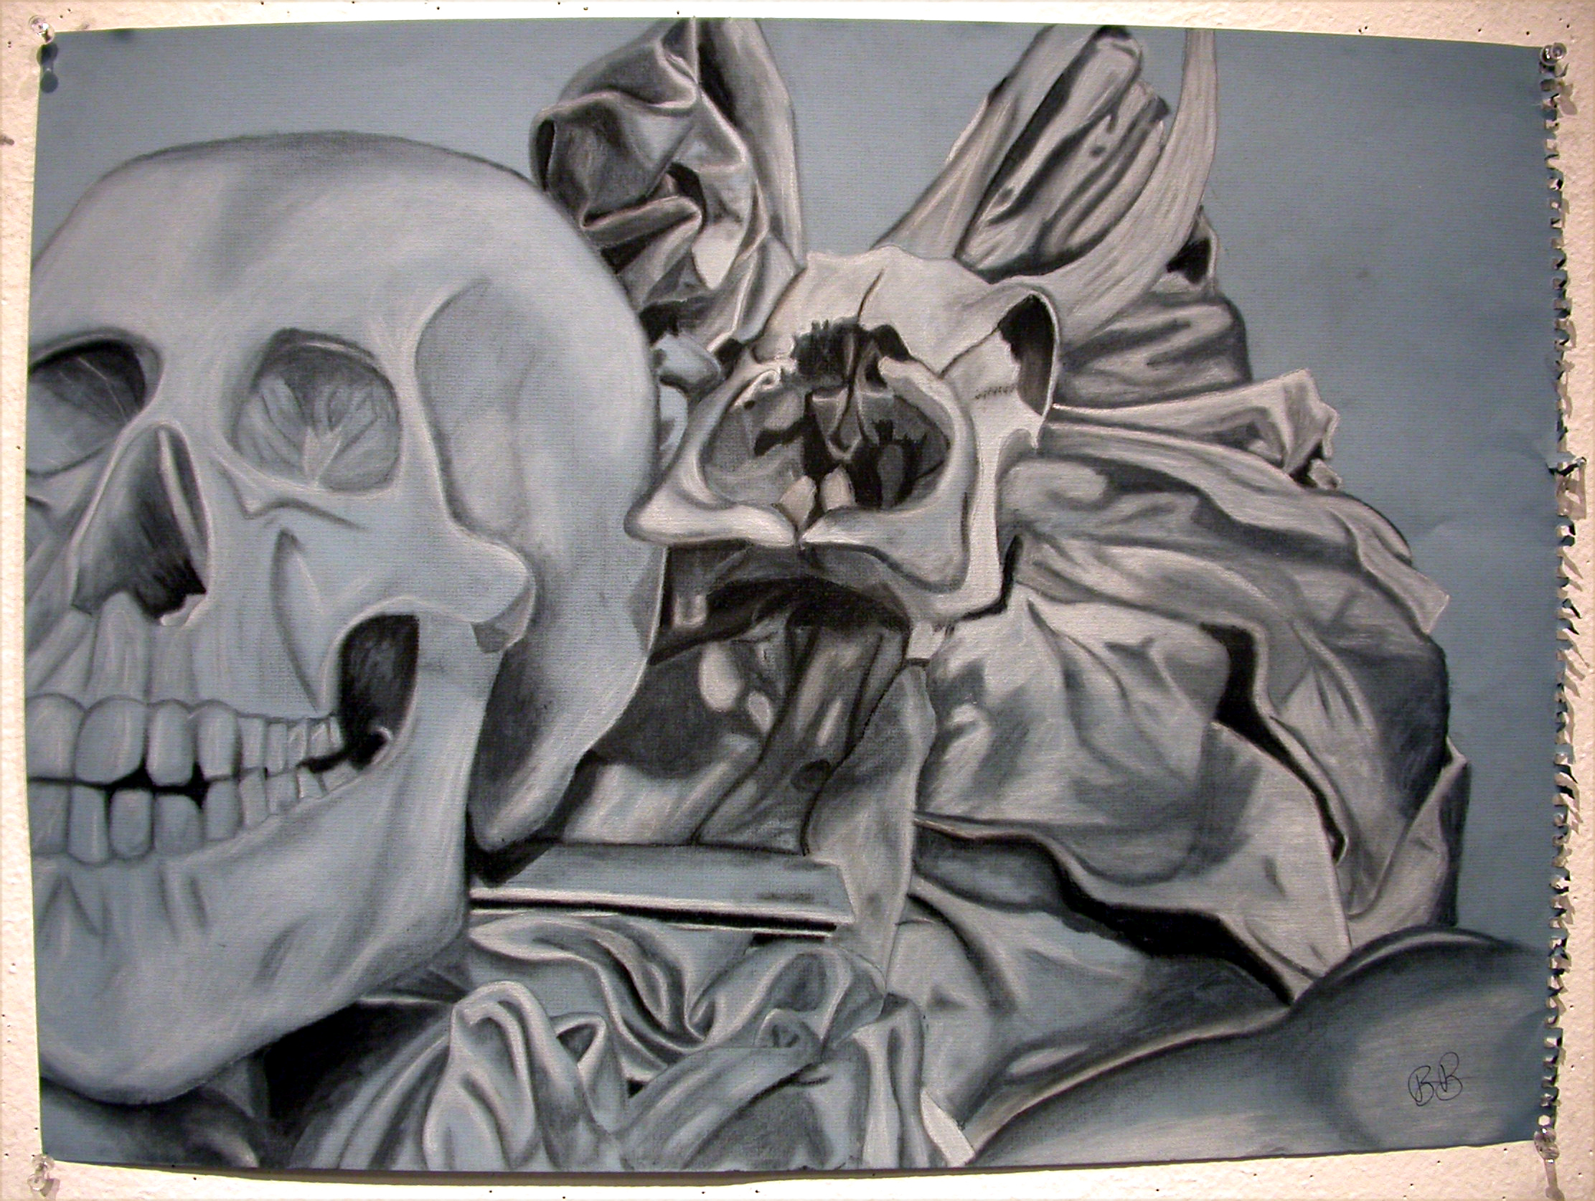
Drawing by student, Rebecca Briggs
VALDOSTA STATE UNIVERSITY DEPARTMENT OF ART & DESIGN DRAWING I

ART 1010 Drawing I Dr. Selena Nawrocki

Project: Value / Dark and Light on Toned Paper

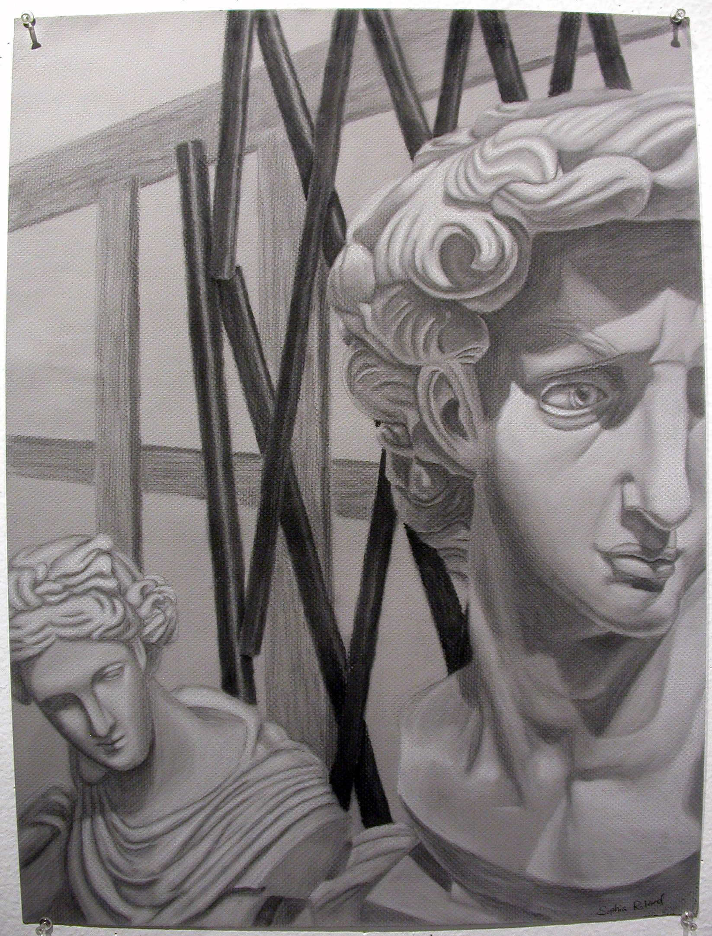
Drawing by student, Sophia Roland

