VALDOSTA STATE UNIVERSITY DEPARTMENT OF ART & DESIGN DRAWING I

ART 1010 Drawing I Dr. Selena Nawrocki

Project: Value / Stipple

Drawing Principle:
Stipple is a technique in which small, distinct dots are applied in patterns to form an image. Tone with emphasis on the gradation of light and shade may be produced by separate strokes or points. Points when grouped in mass will establish values. A full range of tones is determined by varying the proximity of the stipple points.

Procedure:
Construct a value drawing using the stipple technique. A medium to bold tip pen is recommended. Use a full range of values.

Materials:
Strathmore drawing paper (18” x 24”) or Charcoal Paper (18” x 24”), Felt-Tip Pens

Evaluation:
The project will be graded on originality, craftsmanship, technical achievement, pictorial composition, and a professional presentation.

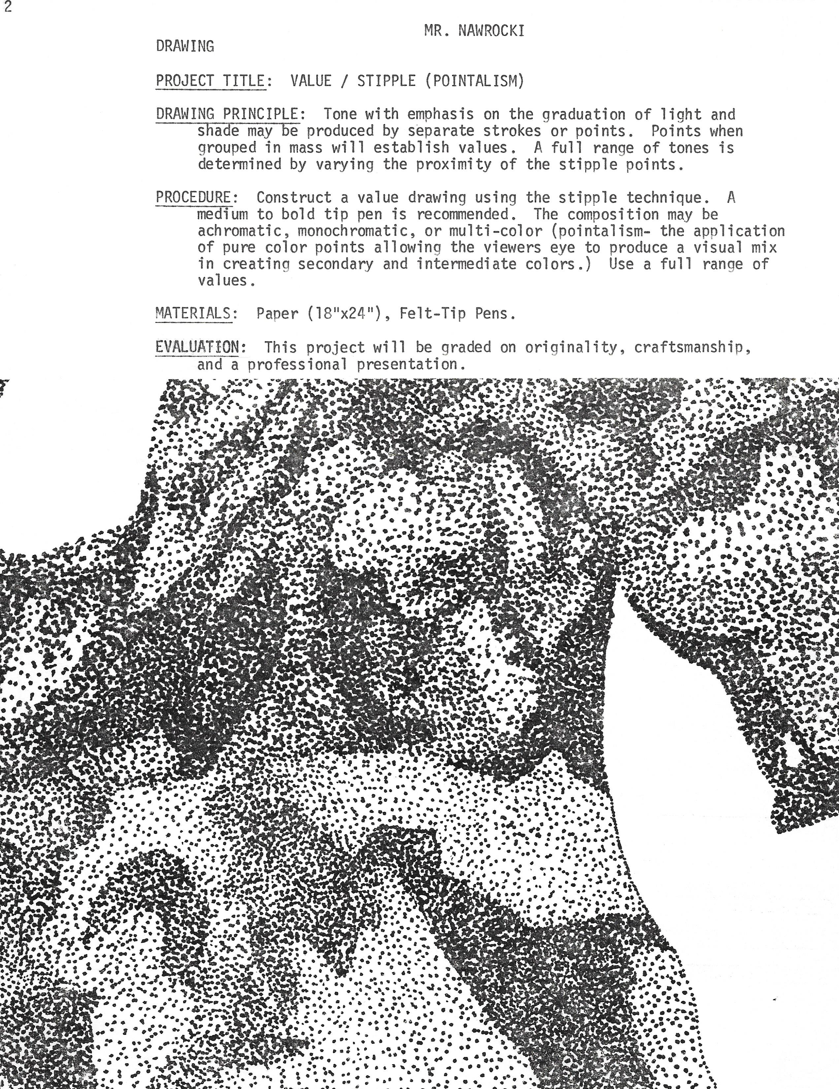

VALDOSTA STATE UNIVERSITY DEPARTMENT OF ART & DESIGN DRAWING I

ART 1010 Drawing I Dr. Selena Nawrocki

Project: Value / Stipple (Pointillism)

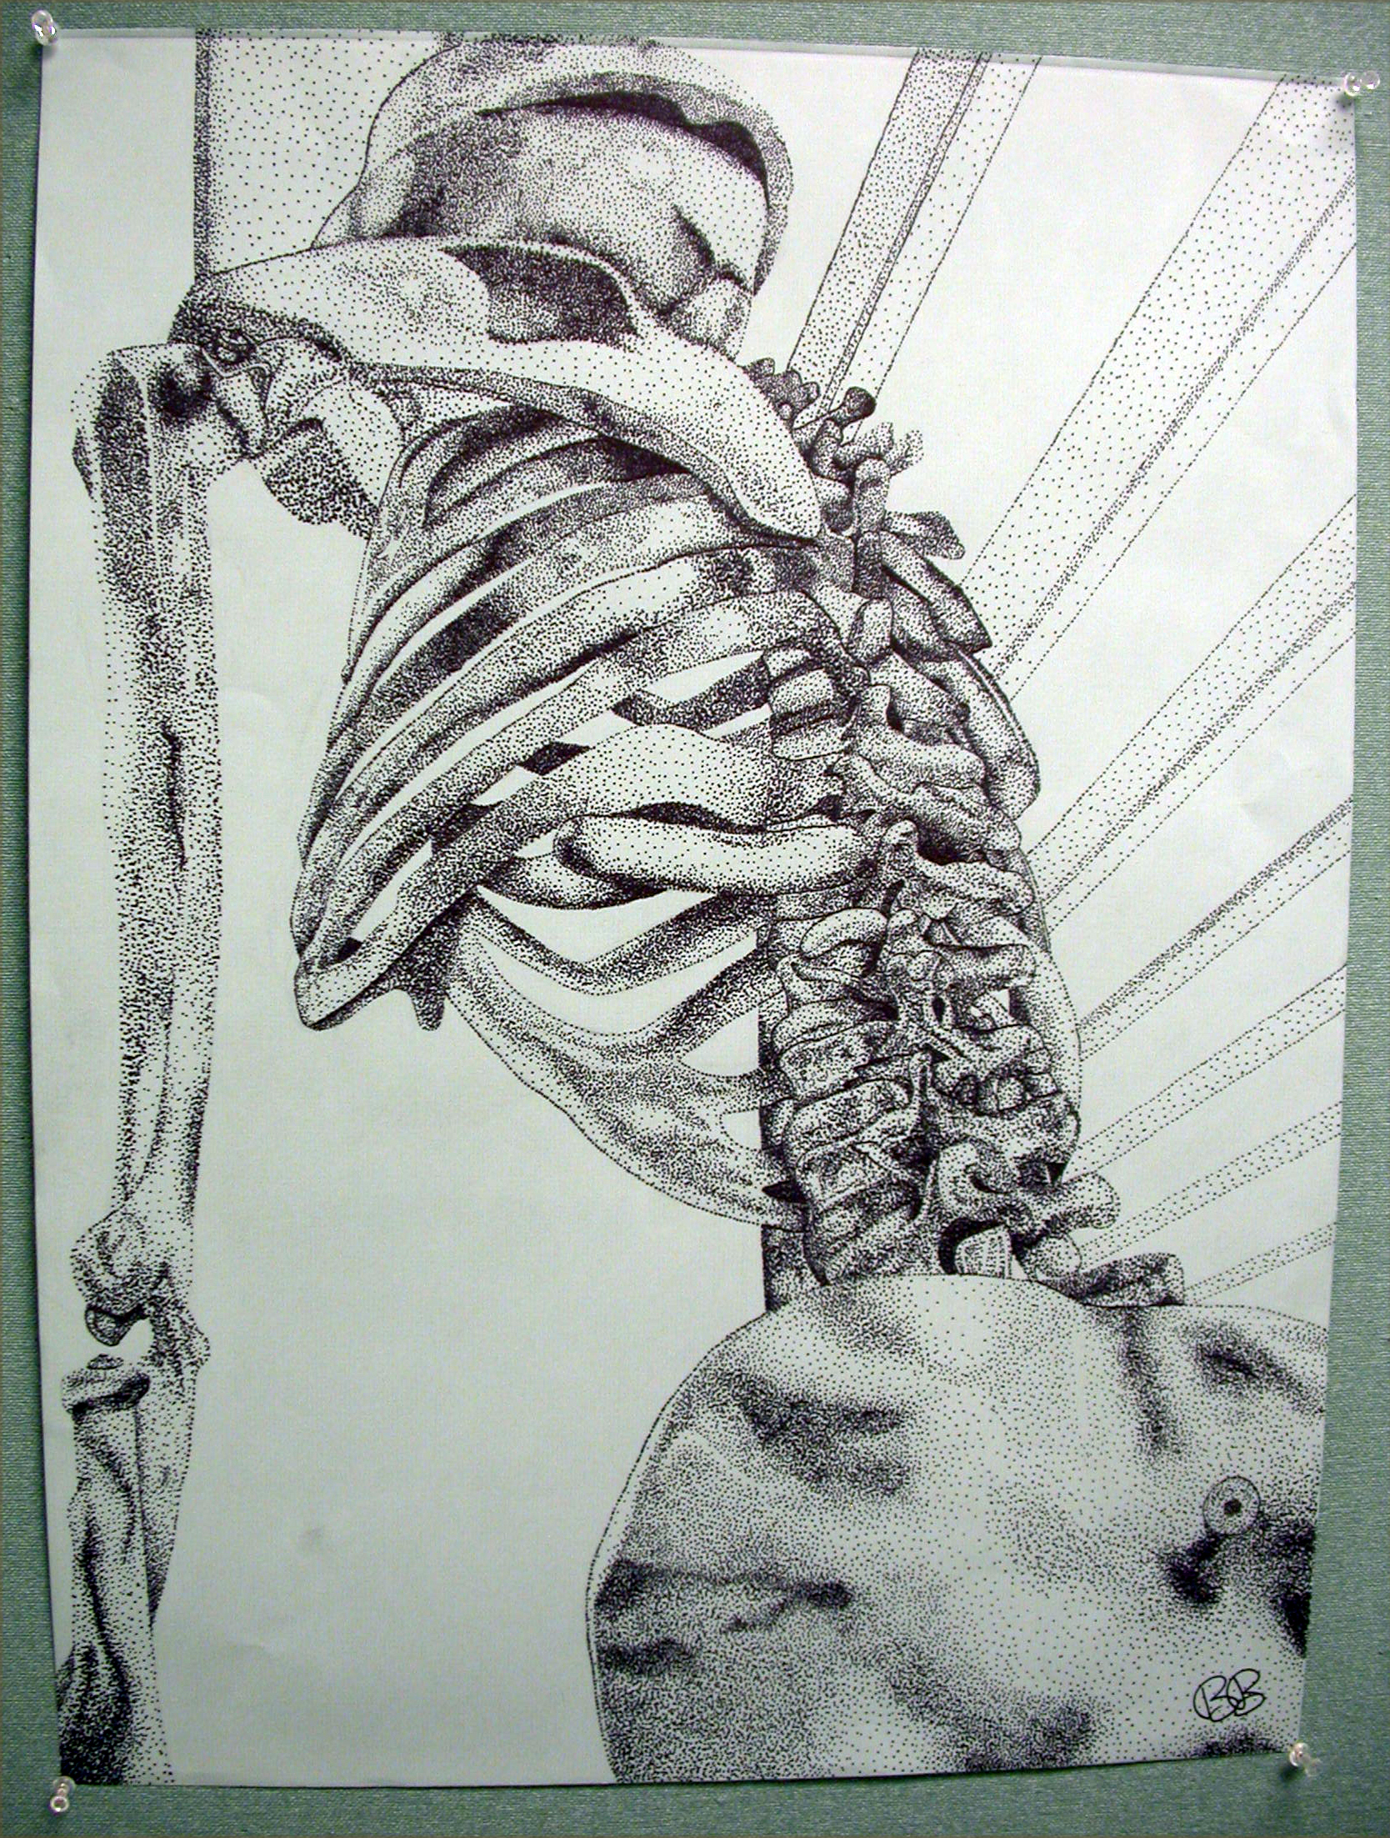
Drawing by student, Rebecca Briggs

VALDOSTA STATE UNIVERSITY DEPARTMENT OF ART & DESIGN DRAWING I

ART 1010 Drawing I Dr. Selena Nawrocki

Project: Value / Stipple (Pointillism)

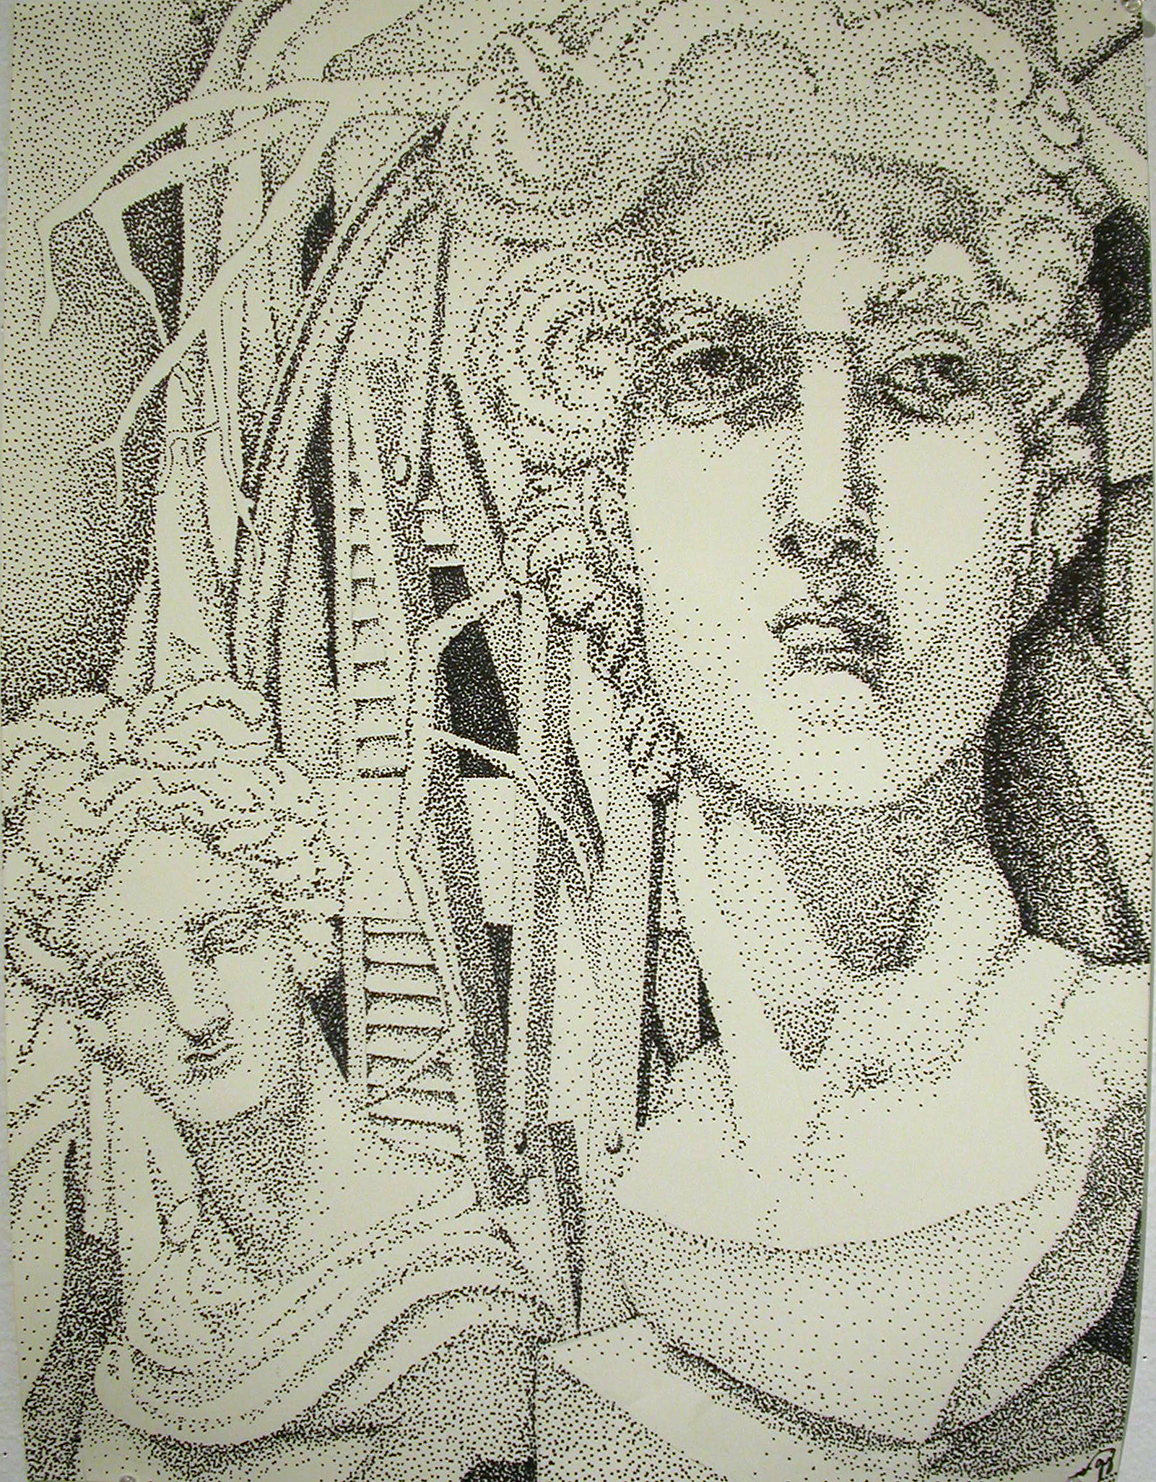
Drawing by student, Taylor Gray

