VALDOSTA STATE UNIVERSITY DEPARTMENT OF ART & DESIGN DRAWING I

ART 1010 Drawing I Dr. Selena Nawrocki

Project: Value / High Contrast with Charcoal (Chiaroscuro)

Drawing Principle:
White under brilliant illumination is the lightest possible value – black in shadow is the darkest tone. In between these values is a full-range of intermediate grays. Chiaroscuro is the use of strong contrasts between light and dark.

Procedure:
Establish a high contrast (black & white) drawing using charcoal. Line may be used to support the tone, but the emphasis should be on value.

Materials:
Strathmore 400 Series or Charcoal drawing paper (18” x 24”), Charcoal, blending stump, chamois cloth, cotton balls, Q-tips

Evaluation:
The project will be graded on originality, pictorial composition, technical achievement, craftsmanship, and a professional presentation.

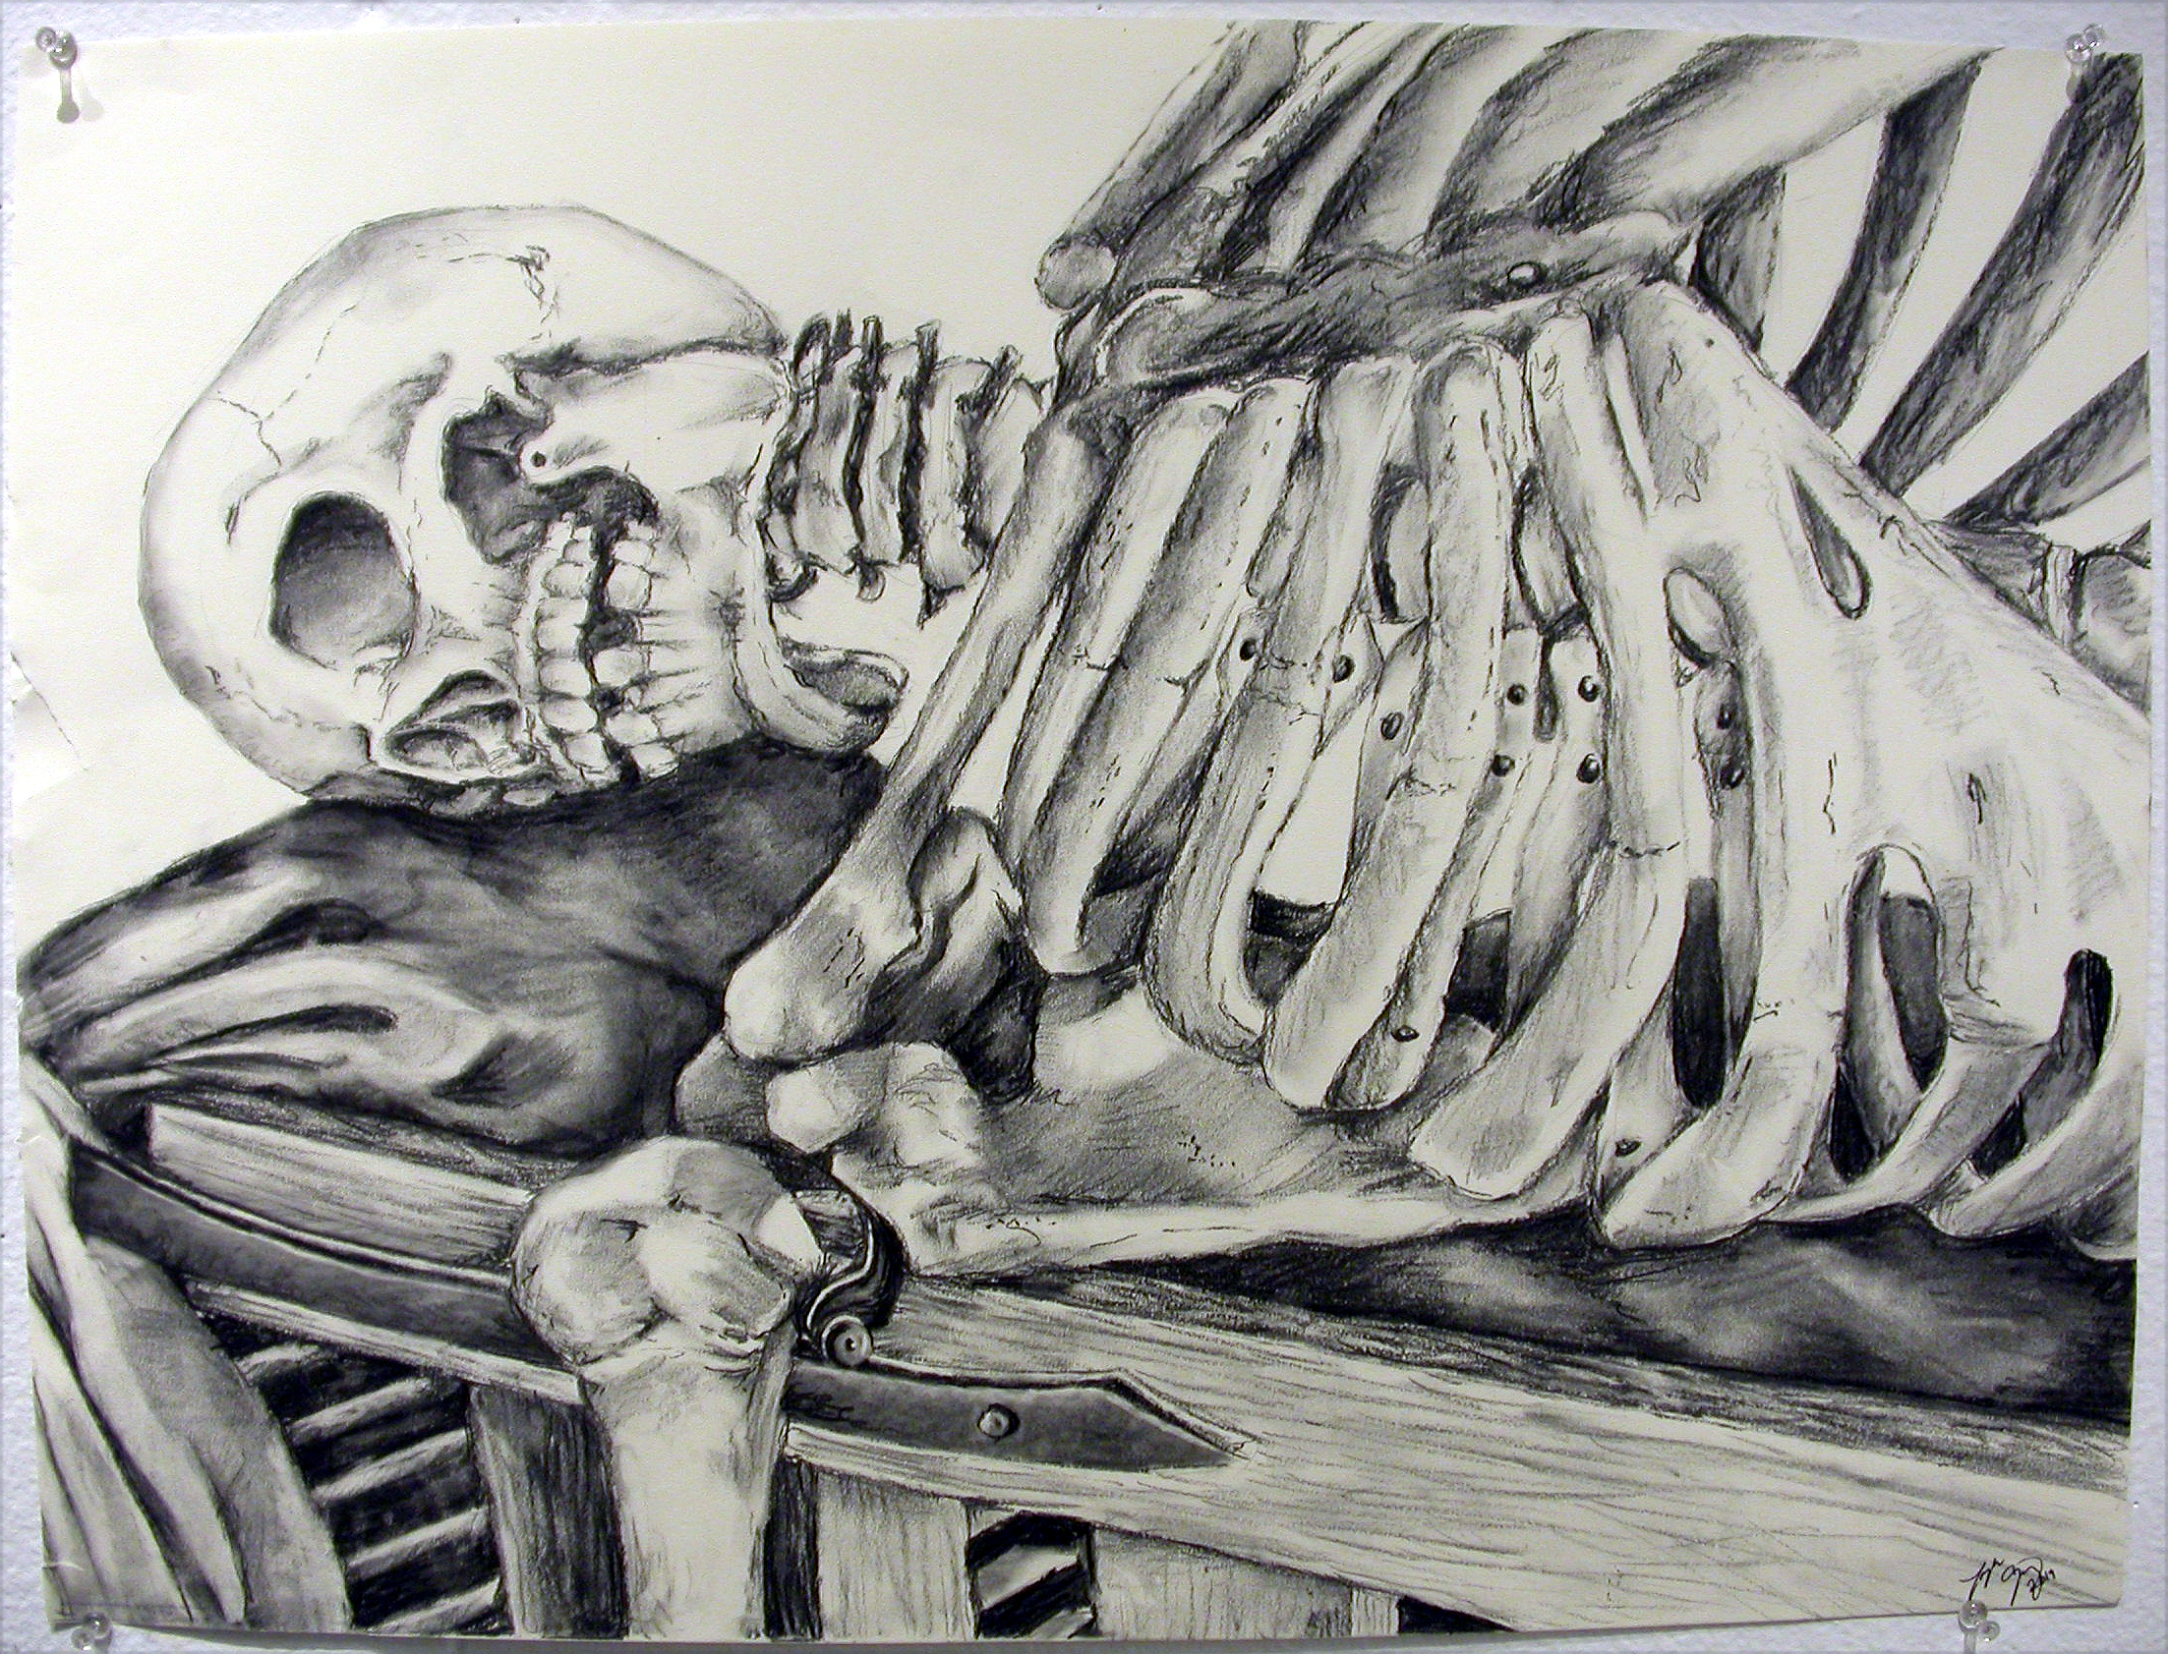
Drawing by student, Taylor Gray

VALDOSTA STATE UNIVERSITY DEPARTMENT OF ART & DESIGN DRAWING I

ART 1010 Drawing I Dr. Selena Nawrocki

Project: Value / High Contrast with Charcoal (Chiaroscuro)

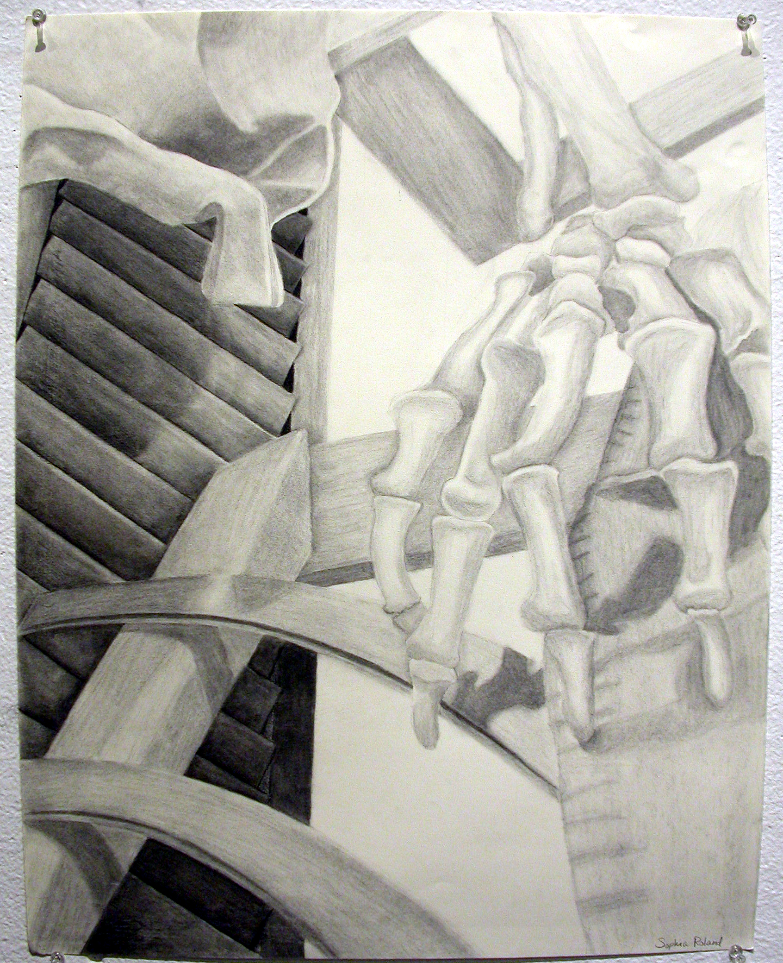
Drawing by student, Sophia Roland

