VALDOSTA STATE UNIVERSITY DEPARTMENT OF ART & DESIGN DRAWING I

ART 1010 Drawing I Dr. Selena Nawrocki

Project: Value / Graphite

Drawing Principle:
Graphite pencils are available in a variety of grades: 6B is the softest, possessing the highest graphite content; 9H, the hardest contains the greatest proportion of clay.
- Soft Pencils (6B to B) are well suited for contour drawings or other types of free notations. The soft lead lends itself to hatching and other forms of value expression.
- Hard Pencils (H to 9H) are well adapted to a style of drawing in which light shading supplements line to convey a full sense of form.

Procedure:
Produce a value drawing using graphite pencils. Line may be used to support the tone.

Materials:
Strathmore Drawing Paper 400 Series (18” x 24”), Graphite tools (Ebony Pencil), Kneaded Eraser, Workable Spray Fixative

Evaluation:
The project will be graded on originality, craftsmanship, pictorial composition, technical achievement, and a professional presentation.

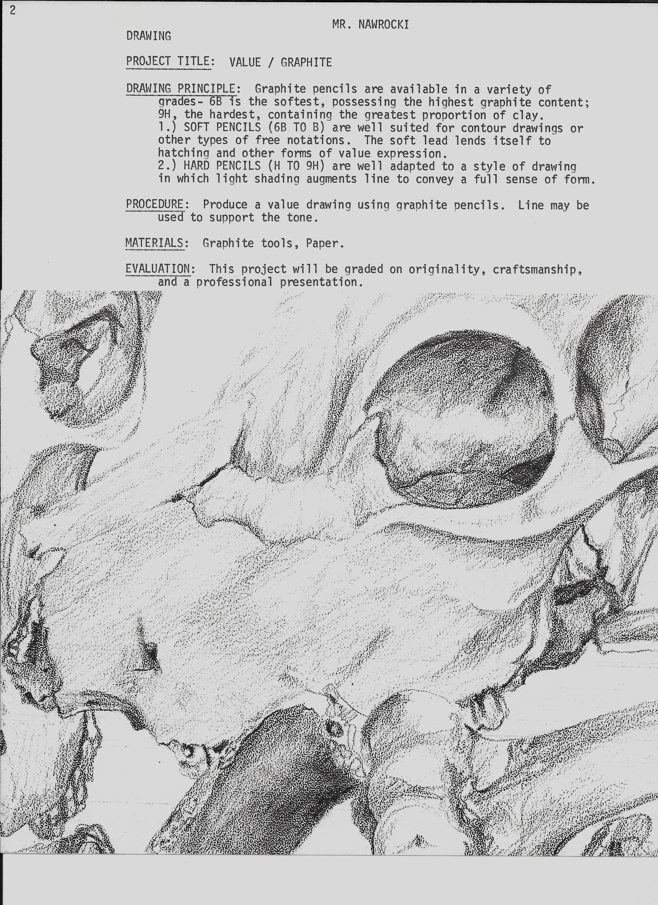
VALDOSTA STATE UNIVERSITY DEPARTMENT OF ART & DESIGN DRAWING I

ART 1010 Drawing I Dr. Selena Nawrocki

Project: Value / Graphite

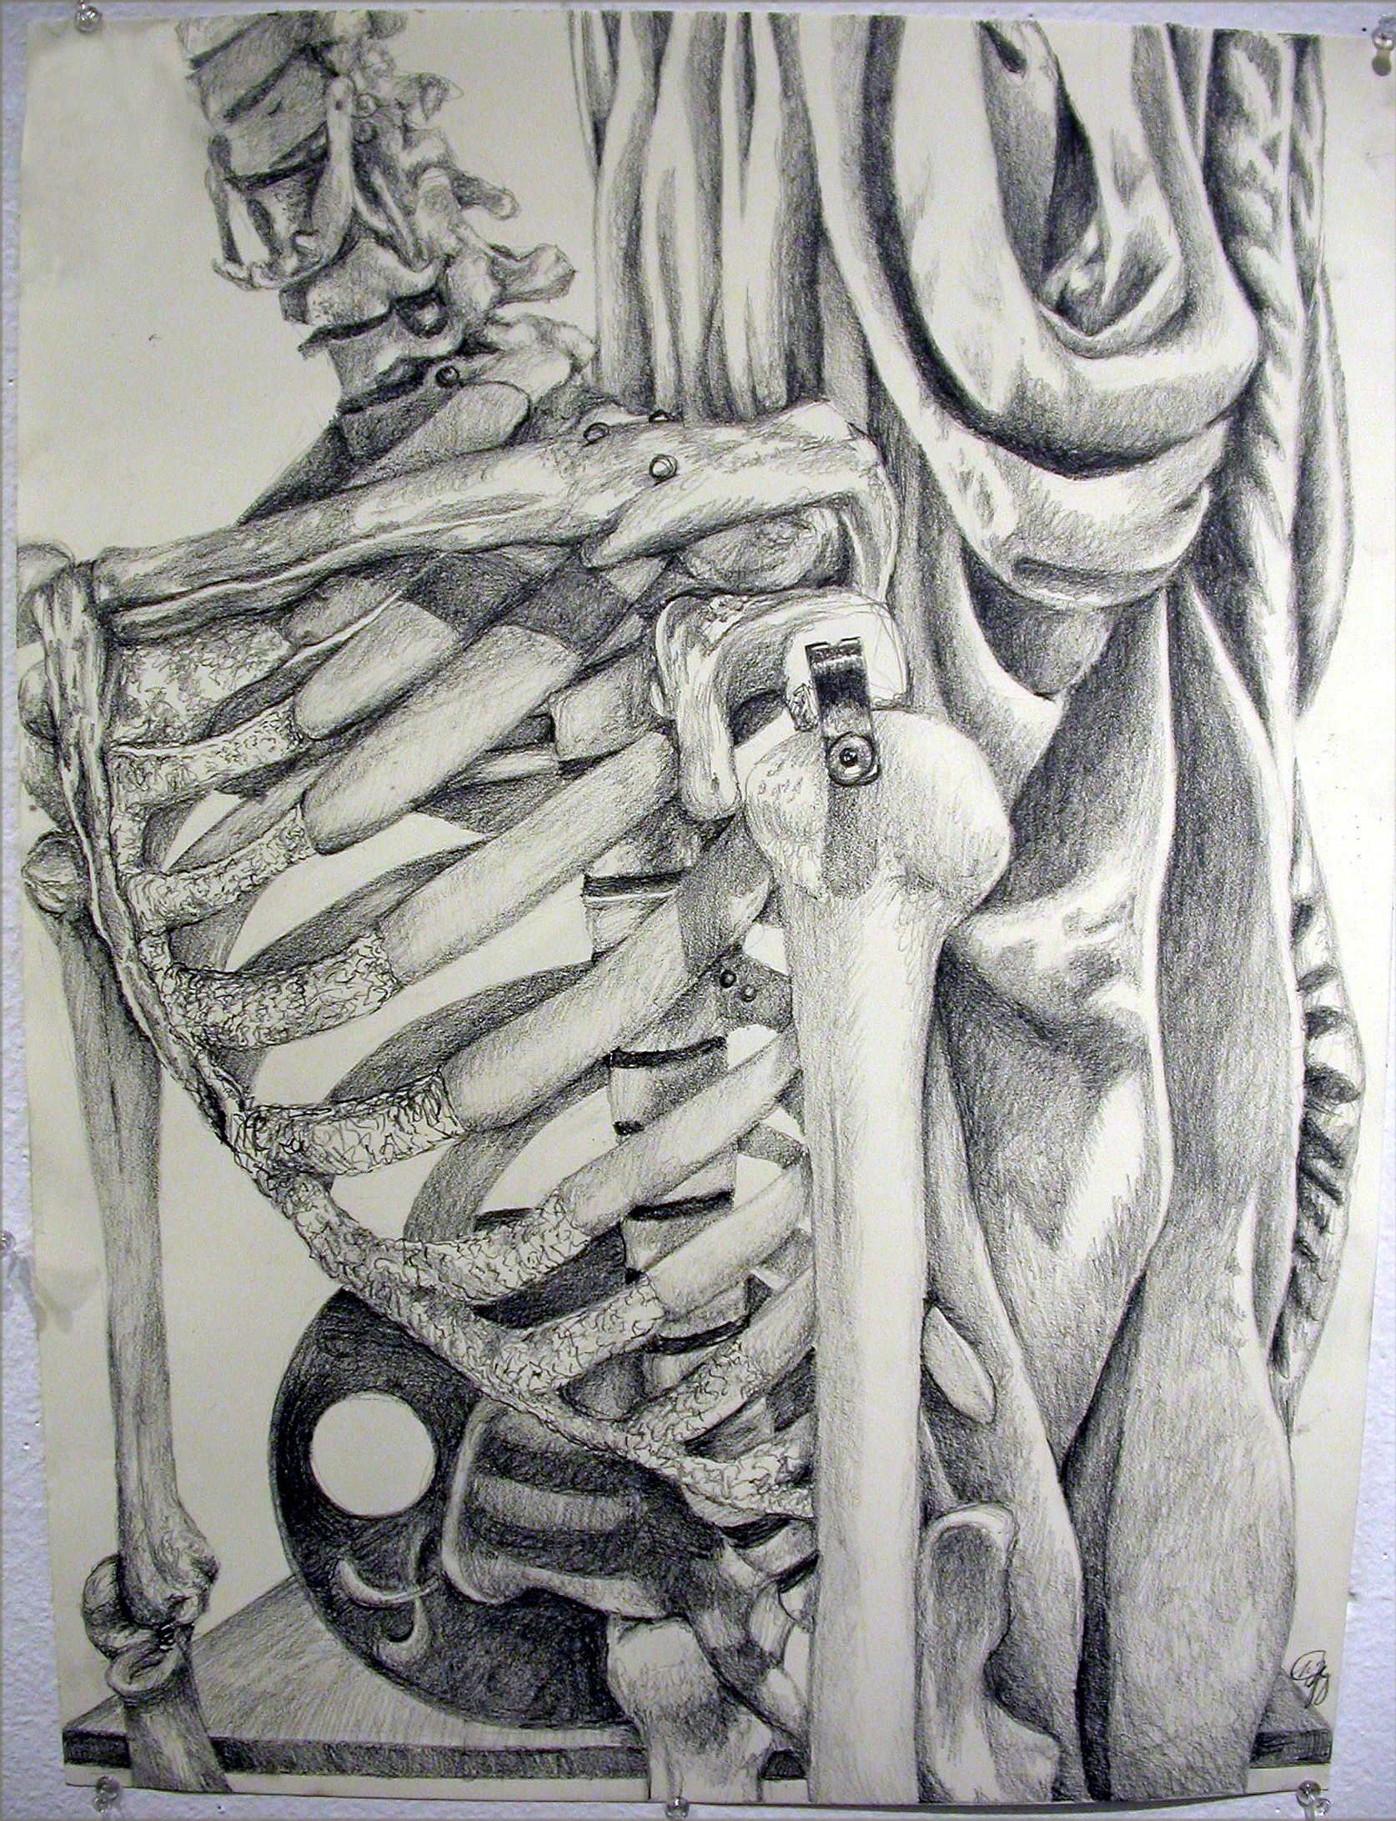Drawing by student, Taylor Gray
VALDOSTA STATE UNIVERSITY DEPARTMENT OF ART & DESIGN DRAWING I

ART 1010 Drawing I Dr. Selena Nawrocki

Project: Value / Graphite

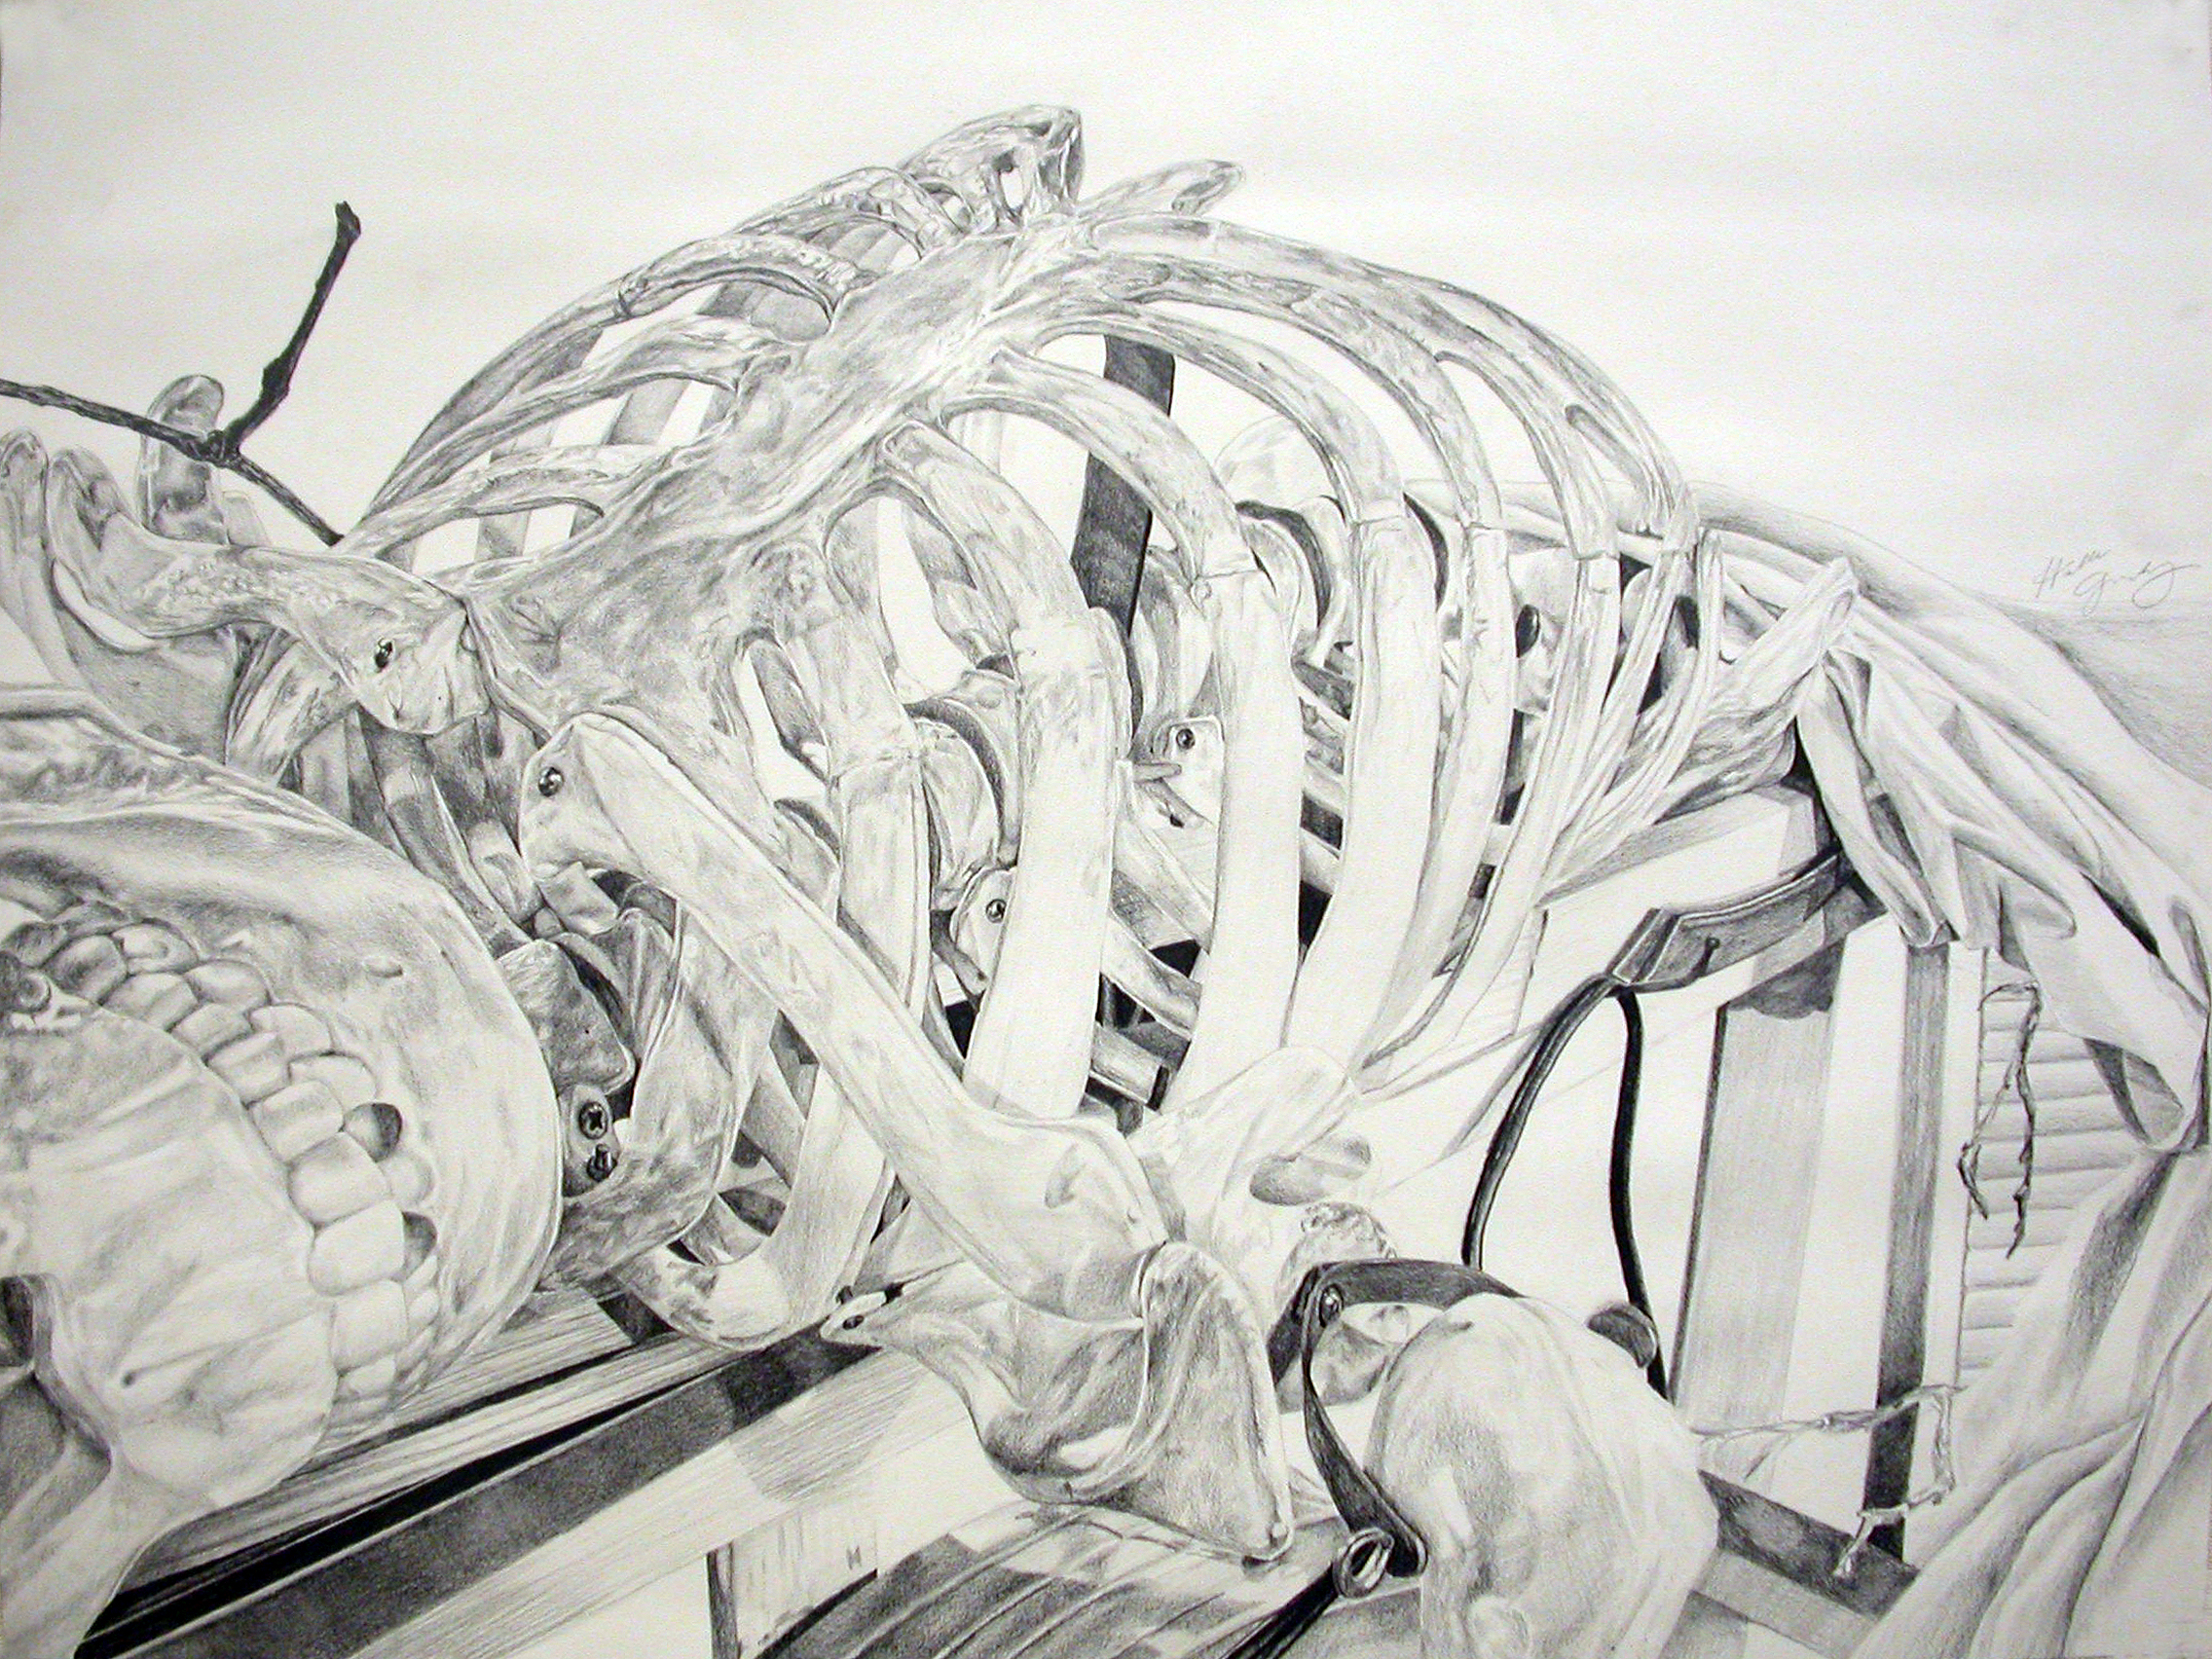Drawing by student, Halle Gandy (Honorable Mention Award – VSU Student Competition)

The 5 Elements of Shading
In order to draw realistically, you must first understand how lighting affects form. There are five elements of shading essential to depicting an object’s form realistically. Without a solid foundation of these elements, everything you draw will look flat. Your subject will look three-dimensional only when the effects of light and shadow are properly placed. Each of the five elements of shading can be seen on the sphere below.
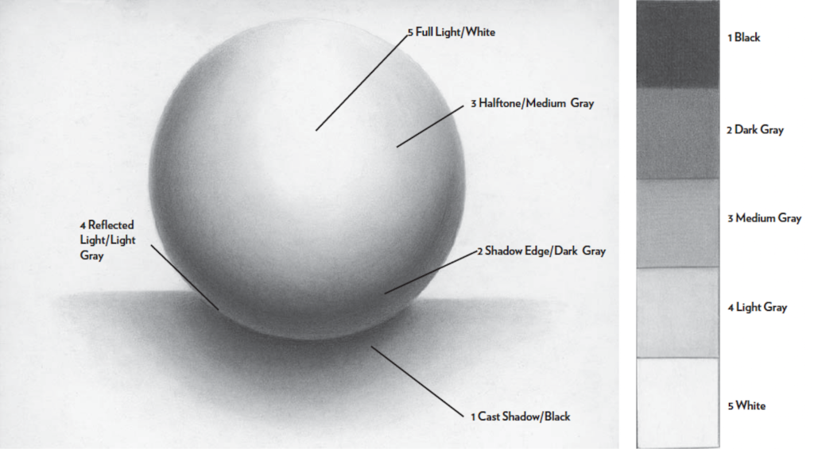
1. Cast Shadow
This is the shadow the object you are drawing casts onto a surrounding surface. It is often the darkest part of your drawing because this is where the light is completely blocked. It should be drawn in as close to black as possible. As it comes out from the object, it will start to appear lighter. It is No. 1 on the value scale.

2. Shadow Edge
This is also referred to as a turning shadow. It is not the edge of the object, but rather the shadow on the object that shows it’s a rounded surface. This is a dark gray tone that corresponds with No. 2 on the value scale. You will find this shadow where an object has protruded and the surface recedes to the other side.

3. Halftone
This is the true color of your object, unaffected by the light. It has no shadow and is No. 3 on the value scale.

4. Reflected Light
Look at the sphere above, and you’ll see a subtle rim of light along the edge of the shadow side. This is the light bouncing up from the surface and coming from behind. It is the element most often left out of a drawing. Yet without it separating the shadow edge and cast shadow, your object will look flat. Be sure to study your reference for the reflected light — it is always seen on the edges, rims or lip of an object. While it is lighter than the shadows, it is still seen on the darker side of the object. It should never be left too white, or it will not look realistic. It is a light gray and corresponds with No. 4 on the value scale.

5. Full Light
This is the part of your subject that receives the most light. It’s No. 5 on the value scale, where the tones fade gently into the white of the paper.

