VALDOSTA STATE UNIVERSITY DEPARTMENT OF ART & DESIGN DRAWING I

ART 1010 Drawing I Dr. Selena Nawrocki

Project: Illusionistic Drawing / Perspective

Drawing Principle:
- Linear Perspective – the illusion of three-dimensions on a two-dimensional plane was developed during the 15th century by Filippo Brunelleschi. It is a scientific method of determining the correct placement of forms in space and the degree to which such forms appear to diminish in size at a given distance.
  - The artist’s eye remains in a fixed position
  - The drawing surface equals the artist’s plane of vision
  - Objects appear to diminish in size as they recede into the distance. If the object’s planes are visually extended into space, they will eventually create a vanishing point.
  - Horizon line – the horizon line is equal to the eye level of the artist. All vanishing points are on the horizon line.
  - Foreshortening (figure drawing) – to represent form as diminishing in dimensions in a way to comply with the laws of perspective and establish the appearance of proper size.
- Empirical Perspective – relies upon what the artist observes rather than on a set of rules. An artist with a well-trained eye for seeing size and shape relationships, who can determine angles by sighting against vertical and horizontal edges, can create convincing and relatively accurate perspective without having to engage in the construction of space.
- Aerial or Atmospheric Perspective – the expression of space through the graduation of color and the crispness of edge definition. (Moisture and dust in the air obscure distant objects).

Procedure:
Render a section of the Fine Arts Building (FAB) using one or two point linear perspective. Select a view which possesses sufficient complexity to highlight the principles of perspective. Ink the final drawing to establish a dynamic readability.

Materials:
Strathmore 400 Series Drawing Paper (18” x 24”) or Charcoal Drawing Paper (18” x 24”), Pencil, Eraser, Straight Edge (yard stick), Ink Pen

Evaluation:
The project will be graded on originality, technical achievement, craftsmanship, and a professional presentation.

VALDOSTA STATE UNIVERSITY DEPARTMENT OF ART & DESIGN DRAWING I

ART 1010 Drawing I Dr. Selena Nawrocki

Project: Illusionistic Drawing / Perspective

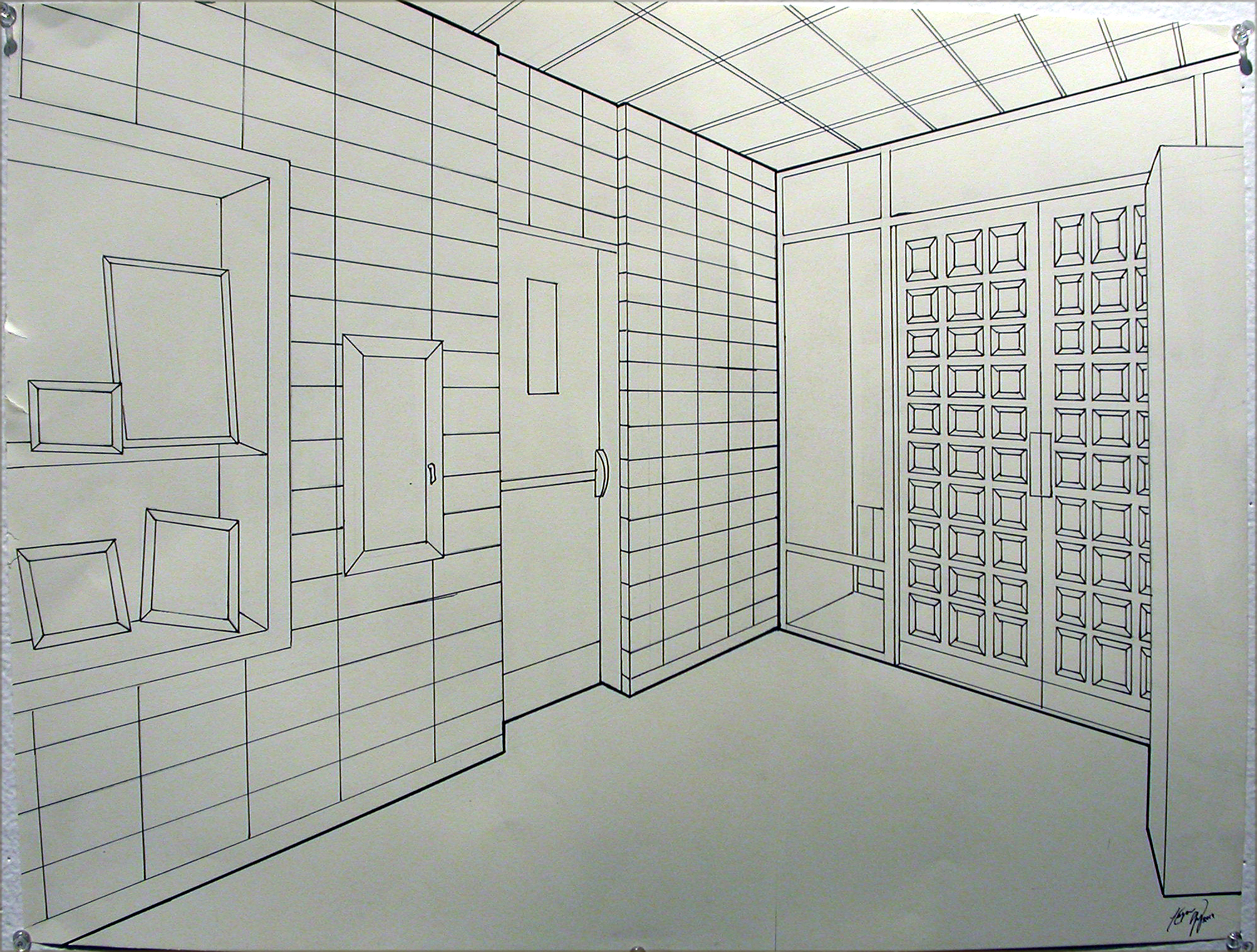
Two-Point Perspective
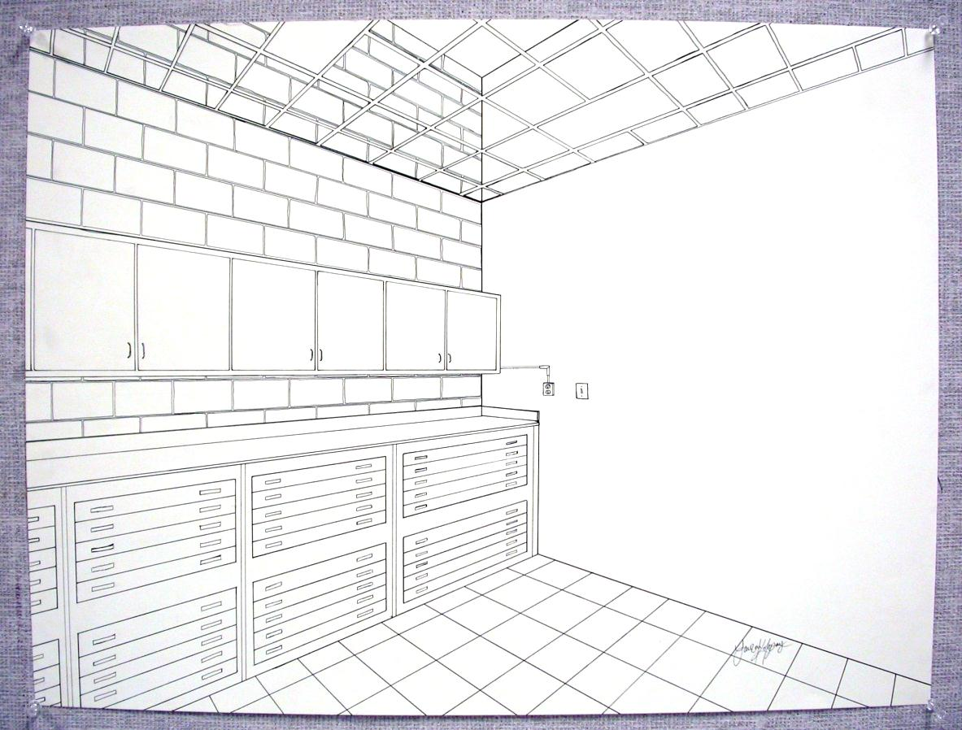
Two-Point Perspective

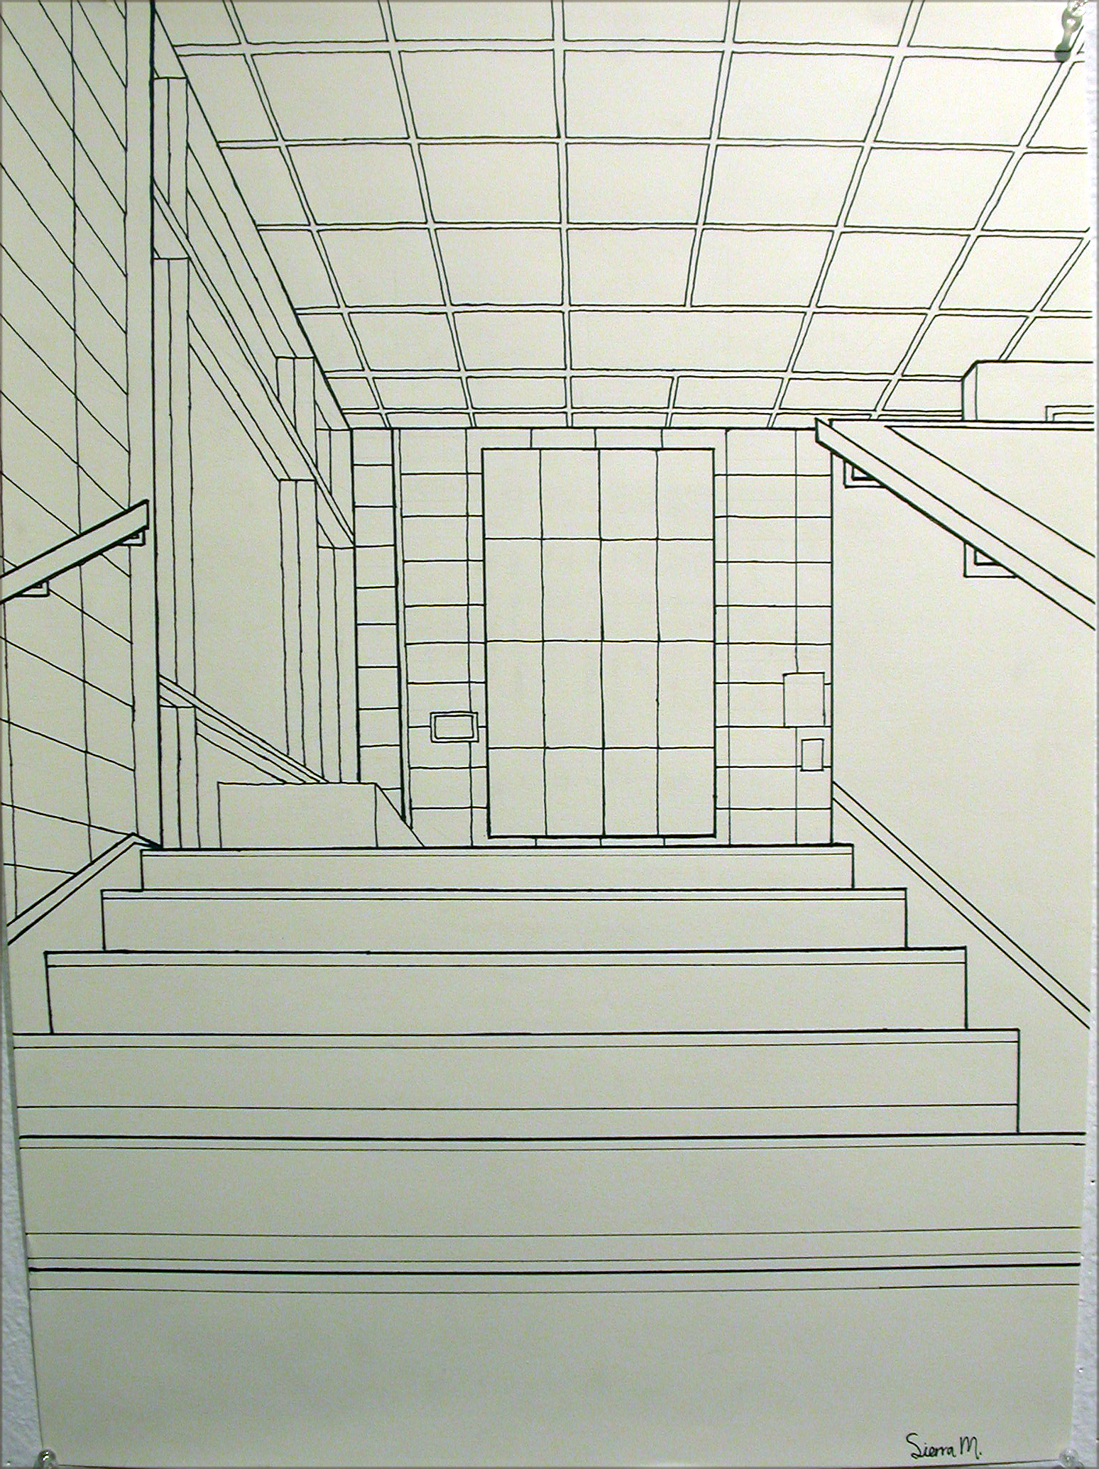
One-Point Perspective

VALDOSTA STATE UNIVERSITY DEPARTMENT OF ART & DESIGN DRAWING I

ART 1010 Drawing I Dr. Selena Nawrocki

Project: Illusionistic Drawing / Perspective

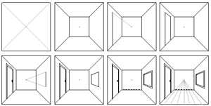

One-Point Perspective Example with Vanishing Point and Horizon Line

