Blind Date- A Drawing + 3D Design Collaboration

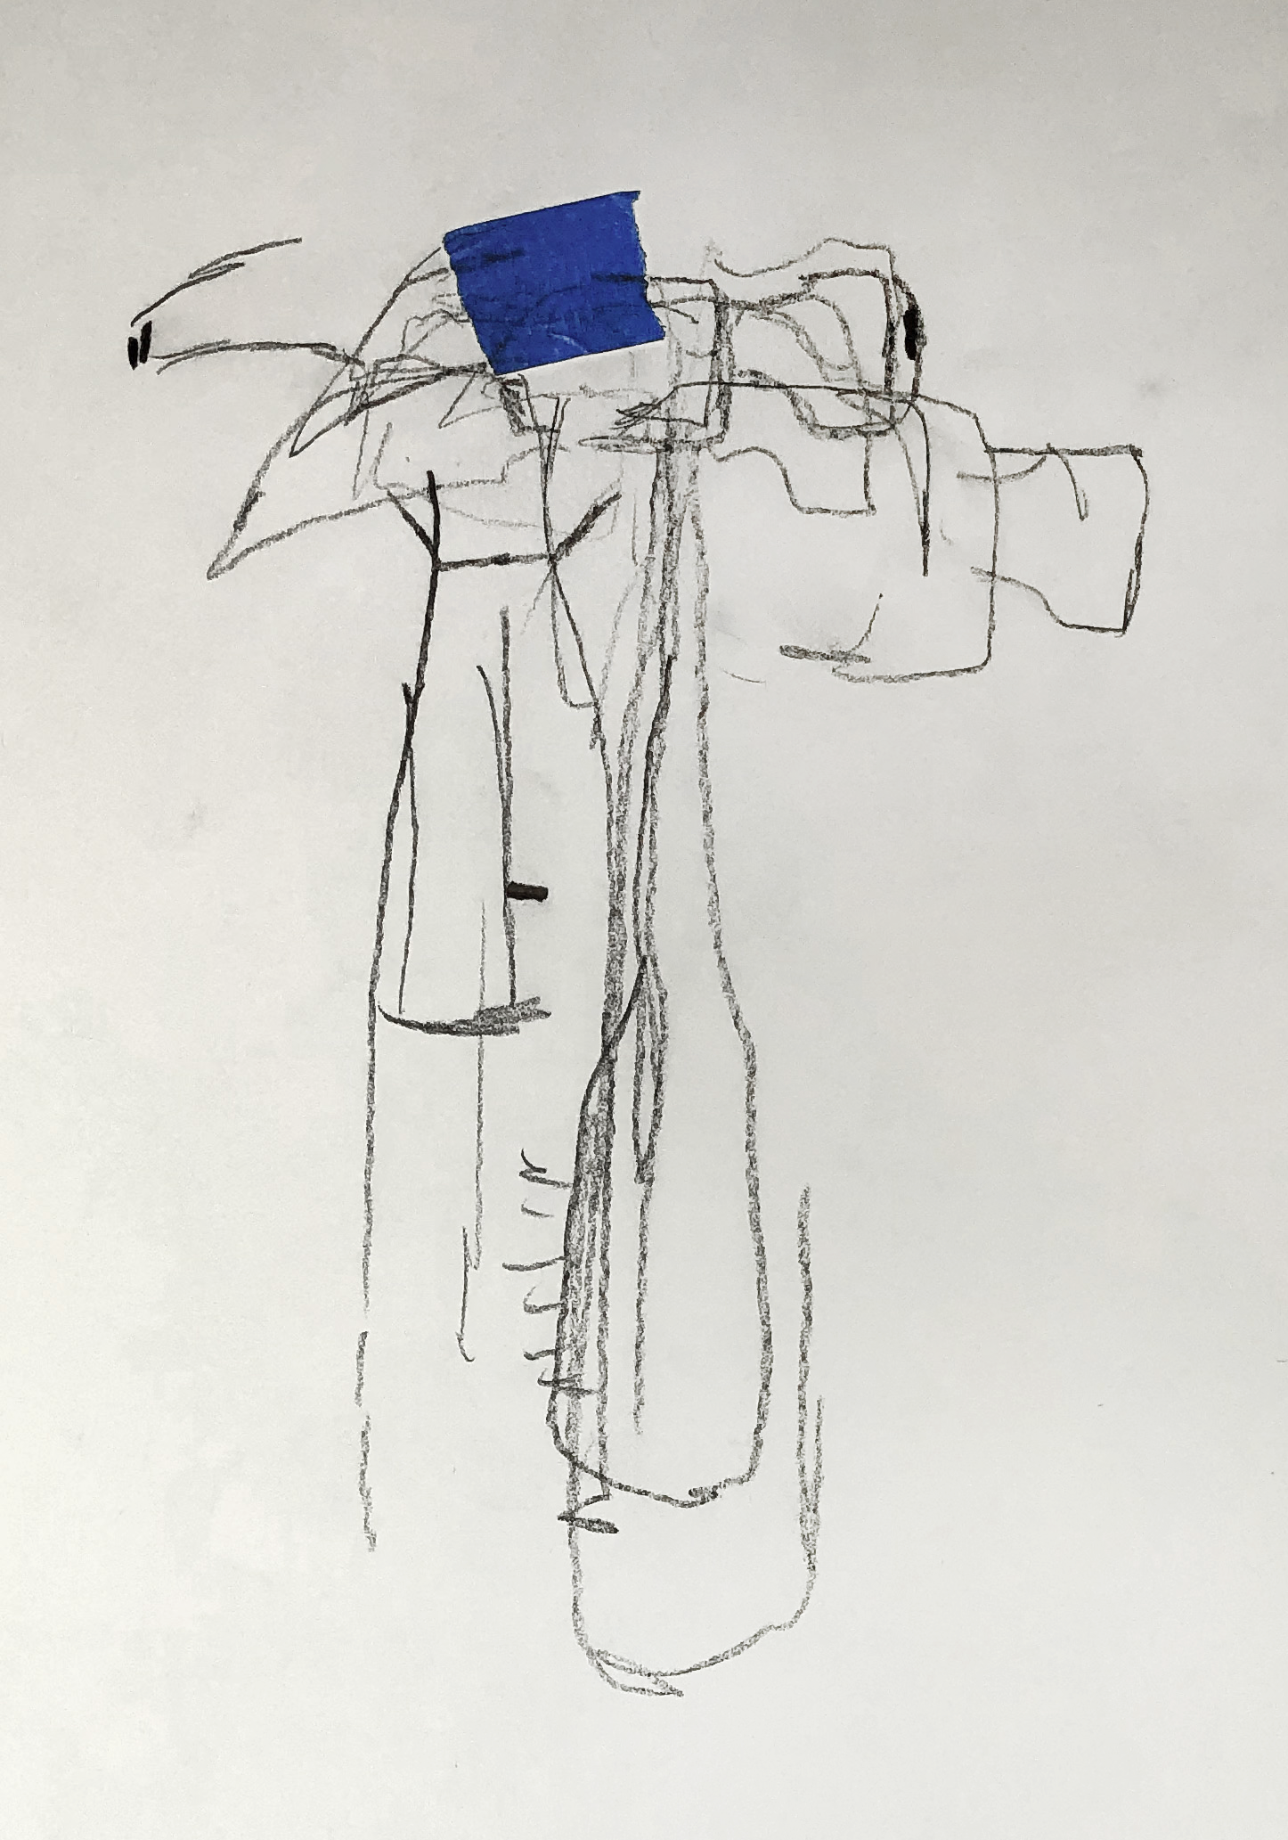
Part 1: Gesture Drawings

For this project we will be working with Professor Hawkins’s drawing class to design sculptures which you will build.

The examples in this handout are from last semester, when we did a similar collaboration using drawings based on objects. This semester we will work together again, but will do our collaboration based on the figure. Professor Hawkins’ class has created gesture drawings of the live models in his figure drawing classes. These drawings attempt to capture the pose, energy, form, and movement of the models.

Part 2: 3D Design
Using those drawings as a reference, we will re-introduce the third dimension- depth, by creating sculptures in wood based upon these drawings. Think of these drawings as the reference photo, design brief, or schematics for the piece you will make.

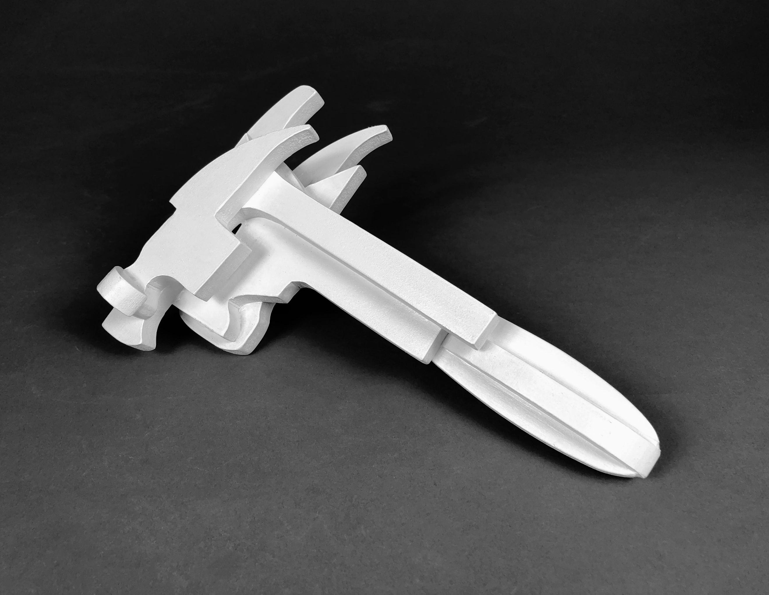
Starting with the drawings, we will sketch 3D sculptures. The aim will not be to recreate the figures as they existed before the drawings, but what these figures would actually look like in 3D if the drawings were accurate. Pay special attention to maintaining the proportions, line quality, and character of the drawings in your plans. Take cues from the drawing you received regarding scale. How does it sit on the paper? Does it appear to be a drawing for a large and weighty sculpture, or small and dainty one? Is it lanky, or squat? Should it be created from thick or thin material, or a combination thereof?

We will be working with ½” and ¼” mdf sheets to create these sculptures, so we’ll not only be going from 2D to 3D with our reference materials, but our building materials as well.

Once you complete your sketches, we will discuss methods of wood joinery, construct small models in cardboard to work out any design kinks, then create these in wood! When the pieces are complete, we will talk a little bit about color theory and then paint the sculptures.

Part 3: Drawings
Once these sculptures are complete, they’ll be given back to the drawing class who will use them as the basis for drawings of our sculptures.

*Don’t worry- you can have your sculptures back once the project is finished

