3D Design Unit 1: Subtractive Carving
Abigail Heuss

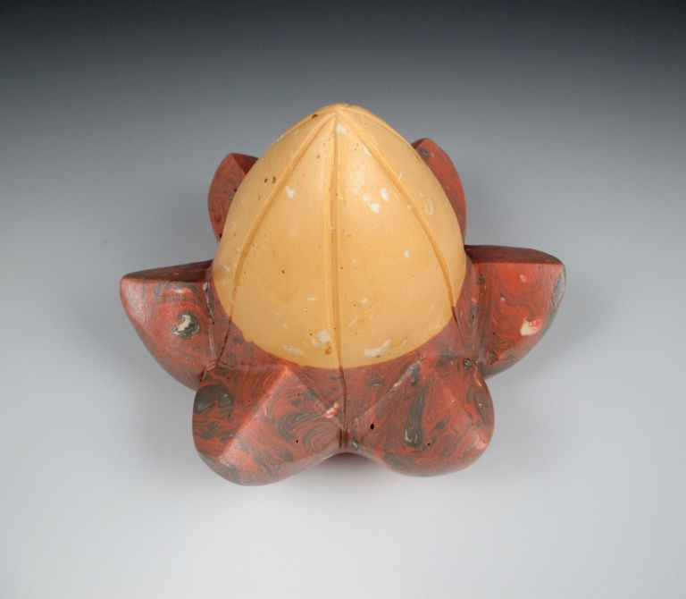

Part 2: Working with Plaster

Now that we have learned about subtractive carving, we’re going to make a sculpture. This week you will each need to collect 5 natural objects that you find interesting. These objects will be the starting point for your plans, so pick things upon which you might like to base your project. They can be things you have around the house, or you can go out into nature to find these things, but I have a few stipulations.

- They must be 5 different things, not 4 pinecones and an acorn.
- Only two of your objects can be: a magnolia seed pod, a pinecone, a stick, or an acorn. These things are beautiful but there are so many more interesting things around! Make sure that at least 3 of your objects are NOT on that list.
- Nothing manufactured or human-made, even if it originally was a natural object. A carved shell or constructed wooden object doesn’t count, but an unaltered shell or a piece of tree bark does.
- If these objects are small, collect them and bring them to class. If they are too large to collect, photograph them from MANY angles all around, so you will have lots of visual information do reference later. You want to record ALL the angles and sides. Choose mostly small things, as working from life is easier than working from photos.

Hint: If you don’t have access to a safe place to go outside and collect from nature, look in your kitchen for natural objects! A nut, vegetable or fruit, whole spices, beans…

