Valdosta State University
SPRING 2022
ARST 1020/Two-Dimensional Design

2D DESIGN
Be Your Own Banksy

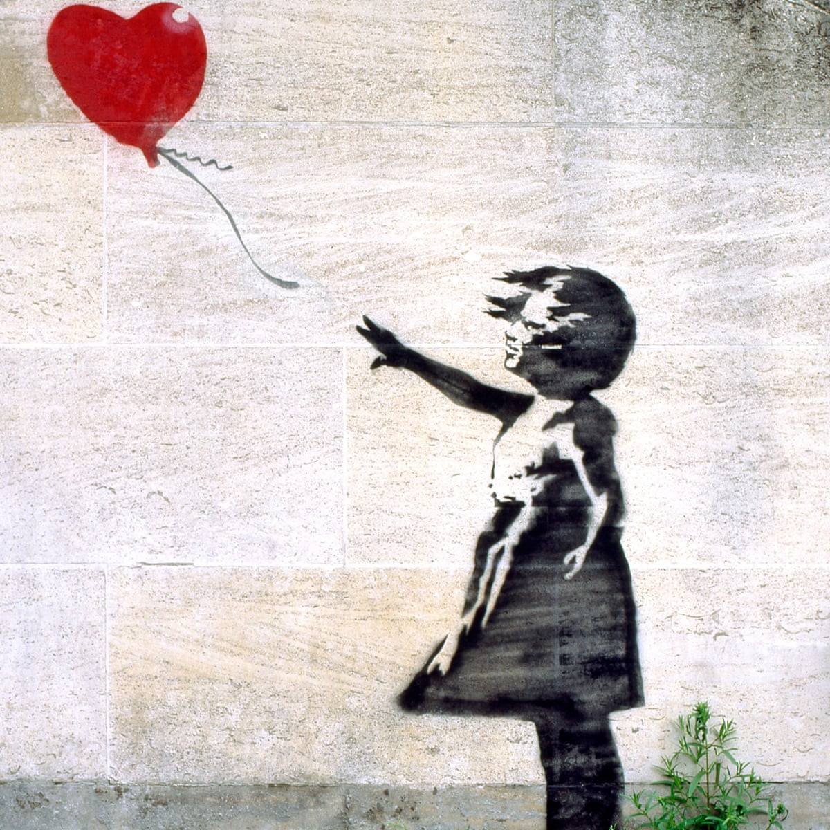

Objective: To create a street artist alter ego and make a stencil to match. This stencil can something based on Emotion, Environment, Future, Humor, Political, and Social Commentary. It can be as conceptual or design based as you wish. This is a chance to explore themes you may not normally get to explore in foundations classes.

Materials: Poster board, pencil, pen, scissors, and Xacto knife.

Process:

- Gather your materials. Please see above for material list.
- Draw. In your sketchbook, draw some ideas down. Feel free to look at images for inspiration. Once you lock-in your idea you’ll transfer to your large piece of poster board.
- Cutting. This stage you’ll need to plan a little more about what pieces need to be cut and what pieces need to stay attached.
- Spray. We will be spraying our designs with spray paint. It takes a light touch to spray images and you don’t need to soak the surface which will lead to runs.

If there’s any questions please don’t hesitate to ask. You can always email me at tshaw@valdosta.edu

