ABSTRACT DIORAMA

Objective: Create a 8.5 x 5.5 drawing on Bristol paper of an abstract still life composed within a 8.5 x 5.5 Priority Mail box. You will create this drawing by layering and color mixing with colored pencil. Chromatic black should be used to depict shadows.

Materials:
11x7 piece of Bristol paper
8.5x 5.5 Priority Mail Box
White artist’s tape
Blue painter’s tape
Various pieces of torn or cut colored paper (plain color, with print pattern, different shapes, painted paper, paper from magazines, etc.)
Set of colored pencils

Instructions:
- On the 11” x 7” Bristol paper provided, measure out a rectangle of 8.5 x 5.5 and mark it with tape so you don’t color out of the lines.
- Using colored paper, cut-outs from magazines, painted paper, patterned paper, tape and glue, create an abstract diorama in the Priority Mail box provided to you. There should be a color for the background and lots of different and interacting layers.
- Once the composition is established you should figure out a way to light your diorama for optimal effect and to create interesting shadows.
- Start drawing. Begin drawing lightly in colored pencil to estimate the position of shapes.
- Continue building layers of colors to create a full value colored drawing that mimics your abstract composition. I would recommend testing colors on a separate piece of paper and comparing until you get a desired result. I would start by lightly layering colors and then building to a more burnished look. There should be no white of your paper left – if there white in your diorama make sure you are coloring it in with white and perhaps adding in some shadows. Pay attention to depth and shadows as this will make your drawing more interesting and less flat.

Artist example: Rachel MacFarlane
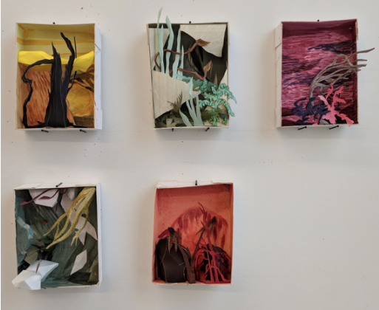

Student Example:
