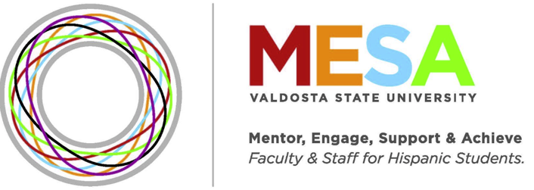

MESA Scholarship Fall 2022

Description:
The $150 MESA scholarship(s) will be awarded for Fall 2022 semester. The deadline to submit fully completed application is April 29, 2022. Applications will be blind-reviewed by MESA Scholarship Committee and award recipients will be announced on May 6, 2022.
Qualifications:
• The student should be a registered Hispanic VSU undergraduate or graduate student per Banner and;
• have a cumulative VSU Institutional GPA of 3.5 or above and;
• have a minimum of 24 earned VSU credit hours by the end of Spring 2022 semester (if undergraduate) or a minimum of 12 VSU credit hours by the end of Spring 2022 semester (if graduate student) and;
• be enrolled for Fall 2022 semester in good standing with the university.
Application Requirements:
• Submit application and personal statement in this form (scroll down).
• Write personal statement of at least 500 words explaining your career plan/goals, how the scholarship will be beneficial to your academic success, and earned achievements/characteristics that distinguish you from other students and;
• Submit one (1) letter of recommendation from a previous professor, instructor or advisor at VSU. The letter should include how student has demonstrated outstanding scholastic achievement and ability. Faculty, instructor or advisor should email letter of recommendation to vsumesa@gmail.com

Once the application is completed, save the document with your first and last name MESA Scholarship Fall 2022 (for example, Regina Suriel MESA Scholarship Fall 2022) and send to vsumesa@gmail.com
Please contact Regina L. Suriel rlsuriel@valdosta.edu should you or your recommenders have any questions.

We look forward to your application!
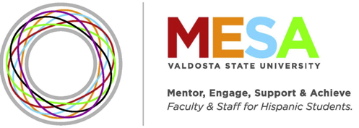

MESA Scholarship Application

Instructions: Please answer the following statements on the space provided.

1. Provide your full name, as listed in Banner.

___________________________________________

2. Provide your Official VSU Email

___________________________________________

3. Provide your cumulative VSU Institutional GPA (per Transcript in Banner) *Please note we will verify this information per your transcript*

___________________________________________

4. Provide earned VSU credit hours by end of Spring 2022 semester (May 2022) *Please note we will verify this information per your transcript*

___________________________________________

5. Please list the name and email of a previous professor/instructor or advisor at VSU who will submit the letter of recommendation to vsumesa@gmail.com. The letter should include how you, the student, has demonstrated outstanding scholastic achievement and ability.

___________________________________________

6. In the space below, provide a personal statement of at least 500 words explaining your career plan/goals, how the scholarship will be beneficial to your academic success and earned achievements/characteristics that distinguish you from other students.
END

