Cancel Absence Request
The below steps are to cancel an absence request as yourself (the employee); the second page are the steps for a Manager to cancel the absence request on behalf of an employee.
Cancelling absence request as Employee Method One:
- Employee Self-Service Time and Absence Absence Request History
- Click the Edit button next to the absence event you want to cancel (if the Edit button is grayed out and you cannot select it, please try the method two below)
- The Cancel Absence box will open, click Cancel Absence
- Confirm cancellation
Cancelling absence request as Employee Method Two:
- Open your timesheet (Self-Service Time & Absence Weekly Timesheet)
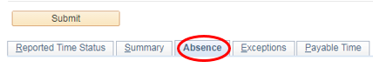
- Click the Absence tab below the Submit button

- Click the Edit button for the absence that needs to be changed
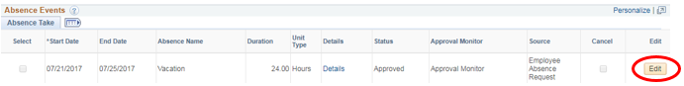

- Click the checkbox under the Cancel column

- Click Submit on the timesheet, click OK to confirm submission

Cancelling absence request as a Manager on behalf of Employee:
- Open the timesheet (Manager Self-Service Team Time Report Time) for the employee that needs the absence request cancelled
- Click the Absence tab below the Submit button

- Click the Edit button for the absence that needs to be changed

- Click the checkbox under the Cancel column

- Click Submit on the timesheet, click OK to confirm submission
- Once back on the timesheet, the approval options should appear for you to approve the change under the Absence tab; select the row next to the absence that was changed and then click Approve
- If the approval options below are not available, please approve through the normal absence approval method (Manager Self-Service Team Time Absence Requests)

