OneUSG Connect Job Aid

Submitting December Absences for 12-Month Faculty & Monthly Staff (Due 12/6/17 by 9AM)

Step | Command | Action
1. | Login to: | OneUSG Connect
2. | Select: | From Employee Self Service, select the Time and Absence tile  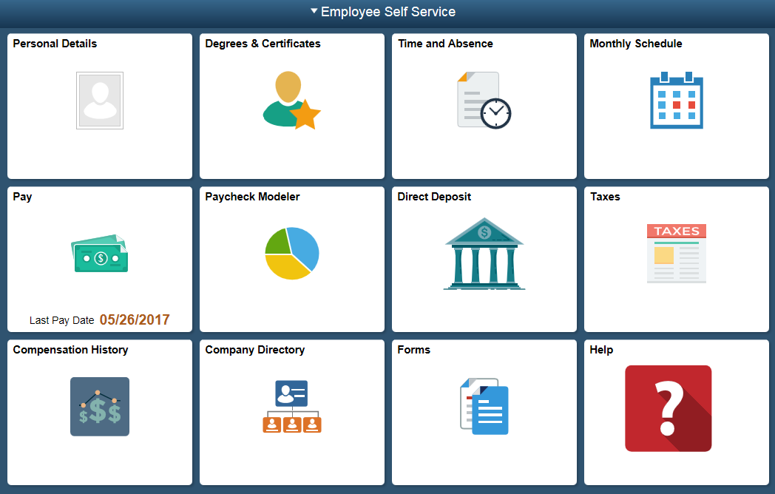
3. | Select: | Click the Request Absence link.
4. | Select: | Under Absence Type, select Vacation.
5. | Select: | Under Absence Name, select Vacation.
6. | Select | The calendar icon to select start date 12/18/17 and end date 12/22/17. Hour duration (40 hours) will populate from your default schedule.  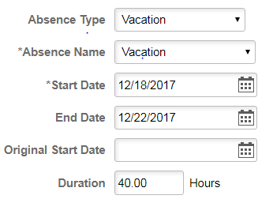
7. | Select: | Click the Submit button in the upper right hand corner.  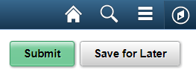
8. | Select: | A confirmation page will display asking if you want to submit. Click Ok.
12. | Select: | Remember to sign out of the application by clicking the Action List icon on the NavBar.  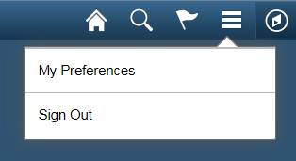
13. | Select: | Click the Sign Out option in the listing.

