Enter Previous Pay Period Hours
Managers can enter hours from a previous pay period for employees; once entered, the hours will need to be approved in payable time and will then be paid on the next normal payroll cycle.
- Manager Self-Service Team Time Report Time
- Select Get Employees
- Click the last name of the employee
- The timesheet will open to the current pay period; change the Date field to the date that hours need to be entered for and click the green refresh arrows or use the Previous Period link to navigate to the correct dates.
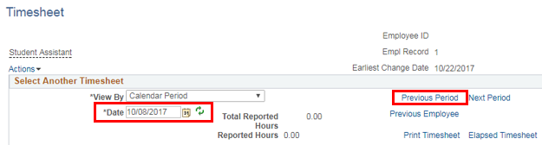
- Enter the hours for the correct dates and click the Submit button
- At the next half-hour, approve these hours under Approve Payable Time (Manager Self-Service Team Time Approve Payable Time)
- These hours will be paid on the next normal payroll cycle

