[Sample Title: The Service-Learning Experiences and Outcomes of Low-Income, First-Generation College Students Utilizing Multivariate Regression Modeling]

A Thesis submitted
to the Graduate School
Valdosta State University

in partial fulfillment of requirements
for the degree of

MASTER OF [PROGRAM]

in [Program]

in the Department of [Department Name]
of the [Full College Name]

[Graduation Month and YEAR]

[NAME]

[Previous Degrees begin with most recent on top]
[e.g., MED, Valdosta State University, 2008]

© Copyright [YEAR] [Name]
All Rights Reserved

This thesis, “[Thesis Title: Long titles that require two lines must keep this section single-spaced],” by [Full Name], is approved by:

Thesis Committee  Chair |  | Jane A. Doe, Ph.D.  Assistant Professor of Higher Education
Committee  Members |  | [Name, Degree]  [Rank & Field]
[Name, Degree]
[Rank & Field]
Associate  Provost for  Graduate  Studies and  Research |  | Becky A. K. da Cruz, Ph.D., J.D.  Professor of Criminal Justice

Defense Date ________________________________
FAIR USE
This thesis is protected by the Copyright Laws of the United States (public Law 94-533, revised in 1976). Consistent with fair use as defined in the Copyright Laws, brief quotations from this material are allowed with proper acknowledgement. Use of the material for financial gain without the author’s expressed written permission is not allowed.

DUPLICATION

I authorize the Head of Interlibrary Loan or the Head of Archives at the Odum Library at Valdosta State University to arrange for duplication of this thesis for educational or scholarly purposes when so requested by a library user. The duplication shall be at the user’s expense.

Signature

I refuse permission for this thesis to be duplicated in whole or in part.

Signature

[NOTE: Be sure to sign one line either authorizing duplication or refusing permission of duplication of your thesis. Most students authorize although that is not a requirement.]
ABSTRACT
[NOTE: The abstract should tell the reader your topic, research methods, and major findings. The abstract is double-spaced and should not exceed one page in length or approximately 250 words.]

TABLE OF CONTENTS
Chapter I: Introduction to the Study 1
Statement of the Problem 1
Purpose of the Study 1
Research Questions 1
Theoretical Framework of the Study 1
Significance of the Study 1
Assumptions, Delimitations, and Limitations 1
Assumptions 1
Delimitations 2
Limitations 2
Definitions 2
Chapter Summary 2
Outline of the Study 2
Heading Level 4. 2
Heading Level 5. 2
Chapter II: Literature Review [Heading Level 1] 3
Major Topic 1 [Level 2 Heading] 3
Heading Level 3 3
Heading Level 4. 3
Heading Level 5. 3
Heading Level 5. 3
Heading Level 4. 3
Heading Level 3 3
Heading Level 4. 3
Heading Level 5. 4
Heading Level 5. 4
Heading Level 4. 4
Major Topic 2 [Level 2 Heading] 4
Heading Level 3 4
Heading Level 4. 4
Heading Level 5. 4
Heading Level 5. 4
Heading Level 4. 4
Heading Level 3 4
Heading Level 4. 4
Heading Level 5. 4
Heading Level 5. 4
Heading Level 4. 5
Major Topic 3 [Level 2 Heading] 5
Heading Level 3 5
Heading Level 4. 5
Heading Level 5. 5
Heading Level 5. 5
Heading Level 4. 5
Heading Level 3 5
Heading Level 4. 5
Heading Level 5. 5
Heading Level 5. 5
Heading Level 4. 5
Chapter III: Methodology 7
Research Design 7
Population and Sample 7
Variables and Instrumentation 7
Procedure 7
Data Analysis 7
Chapter Summary 7
Chapter IV: Findings 8
Overview of the Sample 8
Demographics 8
Instrumentation 9
Analysis of Research Questions 9
Chapter Summary 11
Chapter V: Discussion and Implications 12
Summary of the Study 12
Major Findings 12
Discussion 12
Limitations to the Study 12
Recommendations for Future Research 12
Summary and Conclusion 12
References 13
Appendix A: Title of Appendix 14

[NOTE: You will need to manually delete “Chapter 1” “Chapter 2” etc. and type each manually with a colon “:” on the same line once your table is updated because the actual chapter headers in the document cannot have colons. Use the arrow keys to navigate within the table because clicking will activate the hyperlinks.]

Use Word for Desktop, not Word Online. Learn how to install the desktop version here.

[NOTE: Be sure to include the signed IRB Approval or Exemption Report as an Appendix.]
LIST OF TABLES
Table 1: Sociodemographic Characteristics of Participants at Baseline 8
Table 2: Results of Curve-Fitting Analysis 9
Table 3: Descriptive Statistics and Correlations 10
[NOTE 1: Caption tables using Word’s captioning feature to allow Word to generate a list of tables, figures, and equations automatically. Insert a table using “Insert Table of Figures” on the References ribbon. You will need to manually add a colon “:” and title after each table number once your table is updated. Number and title all tables, figures, and equations. If you have three or more tables/figures/equations, present a list showing their location after your table of contents.]

[NOTE 2: There should be a separate list for Tables, a list for Figures, and one for charts or illustrations if needed. Do not include a list if there are fewer than three tables or figures. (Hint: When using tables, present a brief summary of the contents before the table is presented rather than repeat all statistics in the narrative. Try to limit tables and figures; if there are more than 15 of each, it is permissible to place in the appendices to avoid disrupting the flow of the narrative.) If you must include both a list of tables and a list of figures, put each on its own page using a page break.]

[NOTE 3: All graphs, diagrams and images should be titled as Figures. Tables are commonly used to reflect data from your research findings.]

[NOTE 4: Citations are required for all Figures, Tables, and Charts if the figure, table or chart was borrowed from another. If you created the figure, table, or chart, no citation is needed.]
ACKNOWLEDGEMENTS
[Single space.] [While your thesis or dissertation must be your intellectual property, you could not have written it without the assistance of a number of individuals and institutions. The acknowledgements page provides you with the opportunity to thank those who provided that assistance. You may include as many individuals as you desire. This is also the appropriate place to list permission to quote copyrighted material.]

[NOTE: You may include an optional “DEDICATION” page after your Acknowledgements page. It will be a separate section formatted just like this one. It should be short and to the point. This statement can be one to five sentences but is usually one or two.] [Single space]

Chapter I

Introduction to the Study [Heading Level 1 – Centered, Bold]
In this section, orient the reader to your study as you present the problem statement.

Statement of the Problem [Heading Level 2 – Flush left, bold]
[Normal] body paragraph. This section illustrates the style settings that have been made for this document template. To apply a header style, simply highlight the header text and choose the style (Header 1, Header 2, etc.) that you’d like to apply from the style pane. Using styles is necessary to create an automatically generated table of contents. You may update the existing table of contents by right clicking and selecting “update field,” or you may delete the existing table and create a new one by using “Table of Contents” on the References ribbon. There may be some additional editing required once updated (for instance, combine the headings “Chapter 1” and “Introduction” on the same line in the Table of Contents, but not in the body of the thesis. Also, the first page of each chapter should have a 2” top margin—use two double-spaced returns to create this on the first pages of each chapter). Finally, the following section “Chapter 2” is a truncated sample chapter utilizing the headers illustrated here.

Purpose of the Study [Heading Level 2 – Flush Left, Bold]

Research Questions [Heading Level 2 – Flush Left, Bold]

Theoretical Framework of the Study [Heading Level 2 – Flush Left, Bold]

Significance of the Study [Heading Level 2 – Flush Left, Bold]

Assumptions, Delimitations, and Limitations [Heading Level 2 – Flush Left, Bold]

Assumptions [Heading Level 3 – Flush Left, Bold Italic]

Delimitations [Heading Level 3 – Flush Left, Bold Italic]

Limitations [Heading Level 3 – Flush Left, Bold Italic]

Definitions [Heading Level 2 – Flush Left, Bold]

Chapter Summary [Heading Level 2 – Flush Left, Bold]

Outline of the Study [Heading Level 2 – Flush Left, Bold]
If using Heading Level 4 (after Level 3) and 5 (after Level 4), follow the format below:

Heading Level 4.
[Indented, Bold, Ending with a Period.] Text begins on the same line and continues as a regular paragraph. Use Cntrl+Alt+Return to make a style separator and ensure that Heading 4 style is only applied to the heading so the full paragraph does not display in the Table of Contents.

Heading Level 5.
[Indented, Bold Italic. Ending with a Period.] Text begins on the same line and continues as a regular paragraph. See above note about style separators. This functionality is not available for Mac or Word Online, but you can copy/paste and change the headers in this document or manually update the Table of Contents when you are finished.

Chapter II

Literature Review [Heading Level 1 – Centered, Bold]
In this chapter, the goal is to synthesize relevant literature, and to organize the literature in a logical progression for the reader. Typically, Chapter II addresses elements related to the statement of the problem and your theoretical framework(s). Consult your thesis chair regarding what literature you should address in Chapter II. Below is heading levels 2–5; however, the extent of levels is a function of the depth and breadth of the material addressed.

Major Topic 1 [Heading Level 2 – Flush Left, Bold]

Heading Level 3 [Flush Left, Bold Italic]

Heading Level 4.
[Indented, Bold, Ending with a Period.] Text begins on the same line and continues as a regular paragraph.

Heading Level 5.
[Indented, Bold Italic. Ending with a Period.] Text begins on the same line and continues as a regular paragraph.

Heading Level 5.
[Indented, Bold Italic. Ending with a Period.] Text begins on the same line and continues as a regular paragraph.

Heading Level 4.
[Indented, Bold, Ending with a Period.] Text begins on the same line and continues as a regular paragraph.

Heading Level 3 [Flush Left, Bold Italic]

Heading Level 4.
[Indented, Bold, Ending with a Period.] Text begins on the same line and continues as a regular paragraph.

Heading Level 5.
[Indented, Bold Italic. Ending with a Period.] Text begins on the same line and continues as a regular paragraph.

Heading Level 5.
[Indented, Bold Italic. Ending with a Period.] Text begins on the same line and continues as a regular paragraph.

Heading Level 4.
[Indented, Bold, Ending with a Period.] Text begins on the same line and continues as a regular paragraph.

Major Topic 2 [Heading Level 2 – Flush Left, Bold]

Heading Level 3 [Flush Left, Bold Italic]

Heading Level 4.
[Indented, Bold, Ending with a Period.] Text begins on the same line and continues as a regular paragraph.

Heading Level 5.
[Indented, Bold Italic. Ending with a Period.] Text begins on the same line and continues as a regular paragraph.

Heading Level 5.
[Indented, Bold Italic. Ending with a Period.] Text begins on the same line and continues as a regular paragraph.

Heading Level 4.
[Indented, Bold, Ending with a Period.] Text begins on the same line and continues as a regular paragraph.

Heading Level 3 [Flush Left, Bold Italic]

Heading Level 4.
[Indented, Bold, Ending with a Period.] Text begins on the same line and continues as a regular paragraph.

Heading Level 5.
[Indented, Bold Italic. Ending with a Period.] Text begins on the same line and continues as a regular paragraph.

Heading Level 5.
[Indented, Bold Italic. Ending with a Period.] Text begins on the same line and continues as a regular paragraph.

Heading Level 4.
[Indented, Bold, Ending with a Period.] Text begins on the same line and continues as a regular paragraph.

Major Topic 3 [Heading Level 2 – Flush Left, Bold]

Heading Level 3 [Flush Left, Bold Italic]

Heading Level 4.
[Indented, Bold, Ending with a Period.] Text begins on the same line and continues as a regular paragraph.

Heading Level 5.
[Indented, Bold Italic. Ending with a Period.] Text begins on the same line and continues as a regular paragraph.

Heading Level 5.
[Indented, Bold Italic. Ending with a Period.] Text begins on the same line and continues as a regular paragraph.

Heading Level 4.
[Indented, Bold, Ending with a Period.] Text begins on the same line and continues as a regular paragraph.

Heading Level 3 [Flush Left, Bold Italic]

Heading Level 4.
[Indented, Bold, Ending with a Period.] Text begins on the same line and continues as a regular paragraph.

Heading Level 5.
[Indented, Bold Italic. Ending with a Period.] Text begins on the same line and continues as a regular paragraph.

Heading Level 5.
[Indented, Bold Italic. Ending with a Period.] Text begins on the same line and continues as a regular paragraph.

Heading Level 4.
[Indented, Bold, Ending with a Period.] Text begins on the same line and continues as a regular paragraph.
Chapter Summary [Heading Level 2 – Flush Left, Bold]
In this section provide an overview of what you presented in this chapter. Then, provide an overview of the next chapter.

Chapter III

Methodology [Heading Level 1 – Centered, Bold]
[NOTE: Mention the Institutional Review Board (IRB) approval/exemption in this chapter (Appendix X) – a copy should be included as an appendix.]
In this intro paragraph, provide a short overview of the chapter and identify the progression of the content. Depending on your Chair’s direction, you may restate the purpose statement and remind the reader of the study’s goal(s) as well as the research questions.

Research Design [Heading Level 2 – Flush Left, Bold]

Population and Sample [Heading Level 3 – Flush Left, Bold Italic]

Variables and Instrumentation [Heading Level 3 – Flush Left, Bold Italic]

Procedure [Heading Level 3 – Flush Left, Bold Italic]

Data Analysis [Heading Level 3 – Flush Left, Bold Italic]

Chapter Summary [Heading Level 2 – Flush Left, Bold]
In this section, provide an overview of what you presented in this chapter. Then provide an overview of the next chapter.

Chapter IV

Findings [Heading Level 1 – Centered, Bold]
[NOTE: Always include a space before and after each =, +, <, >, + symbol.]

Overview of the Sample [Heading Level 2 – Flush Left, Bold]

Demographics [Heading Level 2 – Flush Left, Bold]
The following are a list of tables taken from the APA Style Blog. These tables are included to demonstrate table format and have been truncated for space. Insert your table using the Insert>Table function in Word. Right click and insert a caption (e.g., Table 1) to enable an automatic table of contents for tables. You will need to manually change the style of the caption to Times New Roman 12pt, bold, and black font. Use APA 7 guidelines for tables, sections 7.8 to 7.21, unless directed otherwise by your thesis chair.
Table 1
Sociodemographic Characteristics of Participants at Baseline
Baseline characteristic | Guided self-help |  | Unguided self-help |  | Wait-list control |  | Full sample
Baseline characteristic | n | % | n | % | n | % | n | %
Gender
Female | 25 | 50 | 20 | 40 | 23 | 46 | 68 | 45.3
Male | 25 | 50 | 30 | 60 | 27 | 54 | 82 | 54.7
Marital status
Single | 13 | 26 | 11 | 22 | 17 | 34 | 41 | 27.3
Married/partnered | 35 | 70 | 38 | 76 | 28 | 56 | 101 | 67.3
Divorced/widowed | 1 | 2 | 1 | 2 | 4 | 8 | 6 | 4.0
Other | 1 | 1 | 0 | 0 | 1 | 2 | 2 | 1.3
Children | 26 | 52 | 26 | 52 | 22 | 44 | 74 | 49.3
Cohabitating | 37 | 74 | 36 | 72 | 26 | 52 | 99 | 66.0
Highest educational level
Middle school | 0 | 0 | 1 | 2 | 1 | 2 | 2 | 1.3
Tables should be located at the end of a paragraph. Begin the next paragraph of your writing as usual with a 0.5” first-line indent.

Instrumentation [Heading Level 2 – Flush Left, Bold]
Discuss your instruments here. Full instruments and permissions should be included as appendices unless directed otherwise by your thesis chair.

Analyses of Research Questions [Heading Level 2 – Flush Left, Bold]
Analyze your research questions in this section. Two sample tables follow to demonstrate table formatting. Table 2 shows the result of several t tests. Take note of the “note” formatting at the bottom.
Table 2
Results of Curve-Fitting Analysis Examining the Time Course of Fixations to the Target
Logistic parameter | 9-year-olds |  | 16-year-olds |  | t(40) | p | Cohen’s d
Logistic parameter | M | SD | M | SD | t(40) | p | Cohen’s d
Maximum asymptote, proportion | .843 | .135 | .877 | .082 | 0.951 | .347 | 0.302
Crossover, in ms | 759 | 87 | 694 | 42 | 2.877 | .006 | 0.840
Slope, as change in proportion per ms | .001 | .0002 | .002 | .0002 | 2.635 | .012 | 2.078
Note. For each subject, the logistic function was fit to target fixations separately.
Table 3 is a sample correlation table. Remember to use the same font in tables as in the rest of the paper. Do not use vertical borders. You can adjust borders by right clicking on the table, then selecting “Borders and Shading,” or by using the borders icon in the Table ribbon.
Table 3
Descriptive Statistics and Correlations for Study Variables
Variable | n | M | SD | 1 | 2 | 3 | 4 | 5 | 6 | 7
1. Internal–external status ª | 3,697 | 0.43 | 0.49 | —
2. Manager job performance | 2,134 | 3.14 | 0.62 | −.08** | —
3. Starting salary ^{b} | 3,697 | 1.01 | 0.27 | .45** | −.01 | —
4. Subsequent promotion | 3,697 | 0.33 | 0.47 | .08** | −.07** | .04* | —
5. Organizational tenure | 3,697 | 6.45 | 6.62 | −.29** | .09** | .01 | .09** | —
6. Unit service performance ^{c} | 3,505 | 85.00 | 6.98 | −.25** | −.39** | .24** | .08** | .01 | —
7. Unit financial performance ^{c} | 694 | 42.61 | 5.86 | .00 | −.03 | .12* | −.07 | −.02 | .16** | —
ª 0 = internal hires and 1 = external hires.
^{b} A linear transformation was performed on the starting salary values to maintain pay practice confidentiality. The standard deviation (0.27) can be interpreted as 27% of the average starting salary for all managers. Thus, ±1 SD includes a range of starting salaries from 73% (i.e., 1.00 – 0.27) to 127% (i.e., 1.00 + 0.27) of the average starting salaries for all managers.
^{c} Values reflect the average across 3 years of data.
*p < .05. **p < .01.
Take note of the superscript annotations in Table 3, which provide additional information. Insert a superscript using Control, Shift, and the Plus Sign (+) on Windows or Command, Shift, and Plus Sign (+) on a Mac, or use the superscript button in the Home ribbon.

Chapter Summary [Heading Level 2 – Flush Left, Bold]
In this section, provide an overview of what you presented in this chapter. Then provide an overview of the next chapter.

Chapter V

Discussion and Implications [Heading Level 1 – Centered, Bold]

Summary of the Study [Heading Level 2 – Flush Left, Bold]

Major Findings [Heading Level 2 – Flush Left, Bold]

Discussion [Heading Level 2 – Flush Left, Bold]

Limitations to the Study [Heading Level 3 – Flush Left, Bold Italic]

Recommendations for Future Research [Heading Level 3 – Flush Left, Bold Italic]

Summary and Conclusion [Heading Level 2 – Flush Left, Bold]

References
Writing tips for the Reference section:
- Ensure this section is formatted correctly per APA 7th edition manual.
- Cross-reference in-text citations against Reference entries to ensure every citation has a Reference entry. Then, cross-reference Reference entries with citations to ensure every Reference entry has a citation. Note that personal communication, which requires a citation, does not require a References entry.
- If you have multiple entries from an author, enter these in the References section with the oldest publication date (or n.d.) first, and then work in chronological order.
- If you have multiple entries with an author and then an author + co-author (e.g., Brockett, R. G. and Brockett, R. G., & Hiemstra, R.), enter the solo authorship first. The rule is nothing before something.

Appendix A:

Title of Appendix
[NOTE: Supplemental material should be placed in appendices. You need a separate appendix for each type of material presented. Some style manuals allow you to place tables, figures, and other graphical representations in an appendix, rather than dispersed throughout your text. Each appendix should have a cover page that identifies it. Reference the cover sheet page number in the Table of Contents. Center the title on the page. A copy of your IRB or IACUC approval or exemption (if applicable) must be included as an appendix. Be sure to mention the IRB or IACUC in your “Methodology” chapter. Every Appendix must be cited in-text.]

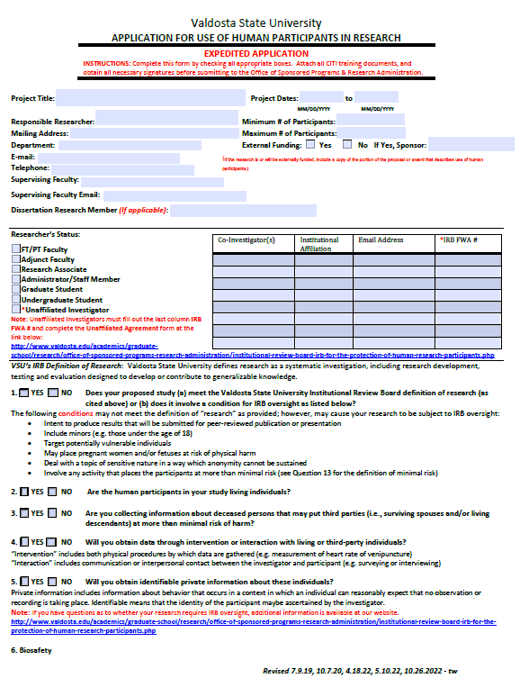

Appendix B:

Title of Appendix

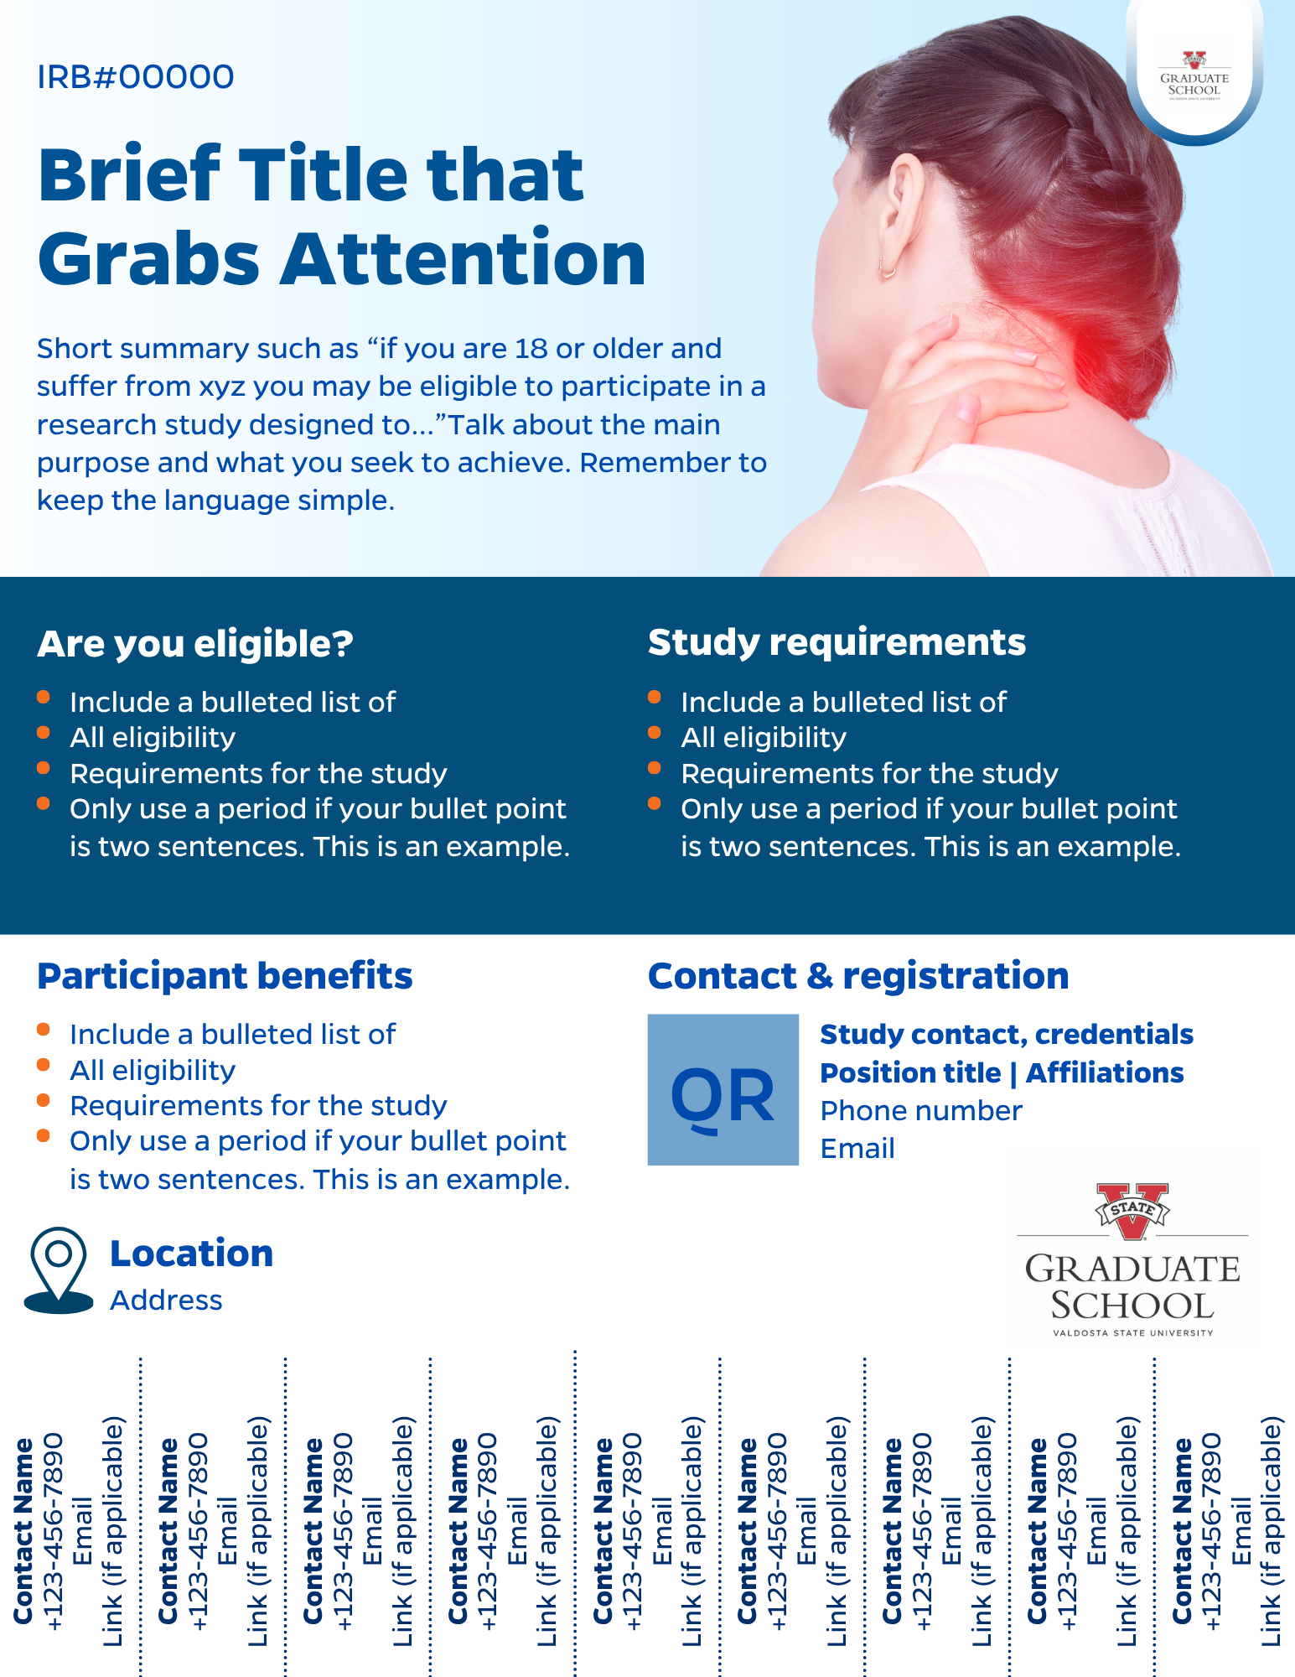

Thesis Writing Tips
Research is an act of persuasion, according to Saldaña (2022). As such, your scholarly responsibility is not only to explicate what you are doing, but also why and how you are engaging in the work. You must build your case and make it accessible in its understanding to the reader who may be unfamiliar with the context, site, population, and theoretical framework(s).
Thesis Formatting Tips
- Use 1” left and right margins unless you plan to have your thesis bound. In that case, you will need to have a 1.5” left margin and 1” right margin.
- The first page of each chapter has a 2” top margin—other pages have a 1” top.
- The bottom margin is 1”.
- Page numbering is bottom center. No running head in this document.
- Set your paragraph settings to double spacing with no extra space between paragraphs.
- Spacing after a period ending a sentence is one space only.
- When centering chapter titles (Chapter I, Chapter II, etc.) at the 2” mark, be sure to use the “center” button on the toolbar rather than the tab key.
- Tables and/or Figures: Only include a list of tables or list of figures if you have three or more each.
- Figures: Place titles underneath the figure. Notes are single spaced; Tables: place titles above the table, with one blank line separating the table and the title. Figures and tables can be in color or black/white.
- For the Table of Contents, use leaders and page numbers (do not include “p.”).
- When using = < > + symbols, place one space before and one space after each. For example, n=45 should read as n = 45; p<.05 should be p < .05.
- Include a copy of your IRB approval or exemption as an appendix (mention it in the Methodology chapter and include it in the Table of Contents).
- When discussing percentages, use either the symbol (%) or the word (percentage). Be consistent with use—don’t interchange!
- Watch out for that pesky quotation mark—be sure all are the same font and style to open quote and end quote.
- Avoid hanging headers by ensuring every heading, regardless of the level, has text following it.
- At the bottom of a page, if a heading does not have at least two lines of text after it, move the section to the next page.
- Use appropriate headings as guideposts particularly in lengthier sections to help the reader stay anchored.

