[Sample Title: Through the Artist’s Lense: A Phenomenological Study of the Lived Experience of Expressive Writing with Former Writer’s Workshop Students]

A Thesis submitted
to the Graduate School
Valdosta State University

in partial fulfillment of requirements
for the degree of

DOCTOR OF [PROGRAM IN ALL CAPS]

in [Program]

in the Department of [Department Name]
of the [Full College Name]

[Graduation Month and YEAR]

[NAME IN ALL CAPS]

[Previous Degrees begin with most recent on top]
[e.g., B.S., Valdosta State University, 2008]

© Copyright [YEAR] [Name]
All Rights Reserved

This thesis, “[Thesis Title: Long titles that require two lines must keep this section single-spaced and aligned left],” by [Full Name], is approved by:

Thesis Committee  Chair |  | Jane A. Doe, Ph.D.  Assistant Professor of Higher Education
Thesis Research Member |  | [Name, Degree]  [Rank & Field]
Committee  Members |  | [Name, Degree]  [Rank & Field]
[Name, Degree]
[Rank & Field]
Associate  Provost for  Graduate  Studies and  Research |  | Becky A. K. da Cruz, Ph.D., J.D.  Professor of Criminal Justice

Defense Date ________________________________
FAIR USE
This thesis is protected by the Copyright Laws of the United States (public Law 94-533, revised in 1976). Consistent with fair use as defined in the Copyright Laws, brief quotations from this material are allowed with proper acknowledgement. Use of the material for financial gain without the author’s expressed written permission is not allowed.

DUPLICATION

I authorize the Head of Interlibrary Loan or the Head of Archives at the Odum Library at Valdosta State University to arrange for duplication of this thesis for educational or scholarly purposes when so requested by a library user. The duplication shall be at the user’s expense.

Signature

I refuse permission for this thesis to be duplicated in whole or in part.

Signature

[NOTE: Be sure to sign one line either authorizing duplication or refusing permission of duplication of your thesis. Most students authorize although that is not a requirement.]
ABSTRACT
[NOTE: The abstract should tell the reader your topic, research methods, and major findings. The abstract is double-spaced and should not exceed one page in length or approximately 250 words.]
Note to fix abstract so that it’s not indented and one paragraph.

TABLE OF CONTENTS
Chapter I: Chapter Title 1
Introduction to the Study [Heading Level 1 – Centered, Bold] 1
Statement of the Problem [Heading Level 2 – Flush Left, Bold] 1
Purpose of the Study [Heading Level 2 – Flush Left, Bold] 1
Research Questions [Heading Level 2 – Flush Left, Bold] 1
Conceptual Framework [Heading Level 2 – Flush Left, Bold] 1
Theoretical Premises [Heading Level 2 – Flush Left, Bold] 1
Epistemological Premises [Heading Level 2 – Flush Left, Bold] 1
Methodological Premises [Heading Level 2 – Flush Left, Bold] 1
Significance of the Study [Heading Level 2 – Flush Left, Bold] 4
Assumptions, Delimitations, and Limitations [Heading Level 2 – Flush Left, Bold] 5
Assumptions [Heading Level 3 – Flush Left, Bold Italic] 5
Delimitations [Heading Level 3 – Flush Left, Bold Italic] 5
Limitations [Heading Level 3 – Flush Left, Bold Italic] 5
Definitions [Heading Level 2 – Flush Left, Bold] 5
Chapter Summary [Heading Level 2 – Flush Left, Bold] 5
Outline of the Study [Heading Level 2 – Flush Left, Bold] 5
Chapter II: Chapter Title 6
Review of the Literature [Heading Level 1 – Centered, Bold] 6
Major Topic 1 [Heading Level 2 – Flush Left, Bold] 6
Sub-topic 1 [Heading Level 3 – Flush Left, Bold Italic] 6
Heading Level 4. 6
Heading Level 5. 6
Heading Level 5. 6
Heading Level 4. 6
Sub-topic 2 [Heading Level 3 – Flush Left, Bold Italic] 7
Heading Level 4. 7
Heading Level 5. 7
Heading Level 5. 7
Major Topic 2 [Heading Level 2 – Flush Left, Bold] 7
Sub-topic 1 [Heading Level 3 – Flush Left, Bold Italic] 7
Heading Level 4. 7
Heading Level 5. 7
Heading Level 5. 7
Heading Level 4. 7
Sub-topic 2 [Heading Level 2 – Flush Left, Bold] 7
Heading Level 4. 7
Heading Level 5. 7
Heading Level 5. 8
Major Topic 3 [Heading Level 2 – Flush Left, Bold] 8
Sub-topic 1 [Heading Level 3 – Flush Left, Bold Italic] 8
Heading Level 4. 8
Heading Level 5. 8
Heading Level 5. 8
Heading Level 4. 8
Sub-topic 2 [Heading Level 3 – Flush Left, Bold Italic] 8
Heading Level 4. 8
Heading Level 5. 8
Heading Level 5. 8
Chapter Summary [Heading Level 2 – Flush Left, Bold] 8
Chapter III: Chapter Title 9
Method [Heading Level 1 – Centered, Bold] 9
Research Design [Heading Level 2 – Flush Left, Bold] 9
Site and Participant Selection [Heading Level 2 – Flush Left, Bold] 9
Data Collection [alternatively Data Generation or Data Gathering] [Heading Level 2 – Flush Left, Bold] 9
Data Analysis [Heading Level 2 – Flush Left, Bold] 9
Trustworthiness [Heading Level 2 – Flush Left, Bold] 9
Ethical Considerations [Heading Level 2 – Flush Left, Bold] 9
Chapter Summary [Heading Level 2 – Flush Left, Bold] 9
Chapter IV: Chapter Title 10
Findings [Heading Level 1 – Centered, Bold] 10
Level 2 Heading [Flush Left, Bold] 10
Level 3 Heading [Flush Left, Bold Italic] 10
Heading Level 4. 10
Heading Level 5. 11
Heading Level 5. 13
Heading Level 4. 14
Level 3 Heading [Flush Left, Bold Italic] 14
Heading Level 4. 14
Heading Level 5. 14
Heading Level 5. 14
Level 2 Heading [Flush Left, Bold] 14
Level 3 Heading [Flush Left, Bold Italic] 14
Heading Level 4. 14
Heading Level 5. 14
Heading Level 5. 14
Heading Level 4. 14
Level 3 Heading [Flush Left, Bold Italic] 14
Heading Level 4. 14
Heading Level 5. 15
Heading Level 5. 15
Chapter Summary [Heading Level 2 – Flush Left, Bold] 15
Chapter V: Chapter Title 16
Discussion [Heading Level 1 – Centered, Bold] 16
Themes [Heading Level 2 – Flush Left, Bold] 16
Implications [Heading Level 2 – Flush Left, Bold] 16
Recommendations for Future Research [Heading Level 2 – Flush Left, Bold] 16
Chapter Summary and Conclusion [Heading Level 2 – Flush Left, Bold] 16
References 17
Appendix A: Appendix Title 18
Appendix B: Appendix Title 18

[NOTE: Right click and select “update field” to update the Table of Contents. You will need to manually delete “Chapter I” “Chapter II” etc. and type each manually with a colon “:” on the same line once your table is updated because the actual chapter headers in the document cannot have colons. Use the arrow keys to navigate within the table because clicking will activate the hyperlinks.]

Use Word for Desktop, not Word Online. Learn how to install the desktop version here.

[NOTE: Be sure to include the signed IRB Approval or Exemption Report as an Appendix. The Appendices will be listed in the order in which they were cited in-text.]
LIST OF FIGURES
Figure 1: Title of First Figure 2
Figure 2: Title of Second Figure 2
Figure 3: Title of Third Figure 4
[NOTE 1: Caption tables using Word’s captioning feature to allow Word to generate a list of tables, figures, and equations automatically. Insert a table using “Insert Table of Figures” on the References ribbon. You will need to manually add a colon “:” and title after each table number once your table is updated. Number and title all tables, figures, and equations. If you have three or more tables/figures/equations, present a list showing their location after your table of contents.]

[NOTE 2: There should be a separate list for Tables, a list for Figures, and one for charts or illustrations if needed. Do not include a list if there are fewer than three tables or figures. (Hint: When using tables, present a brief summary of the contents in the text of the thesis before the table is presented rather than repeat all statistics in the narrative. Try to limit tables and figures; if there are more than 15 of each, it is permissible to place in the appendices to avoid disrupting the flow of the narrative.) If you must include both a list of tables and a list of figures, put each on its own page using a page break.]

[NOTE 3: All graphs, diagrams and images should be titled as Figures. Tables are commonly used to reflect data from your research findings.]

[NOTE 4: Citations are required for all Figures, Tables, and Charts if the figure, table or chart was borrowed from another. If you created the figure, table, or chart, no citation is needed.]

ACKNOWLEDGEMENTS
[Single space. No Indentation] [While your thesis or thesis must be your intellectual property, you could not have written it without the assistance of a number of individuals and institutions.
The acknowledgements page provides you with the opportunity to thank those who provided that assistance. You may include as many individuals as you desire. This is also the appropriate place to list permission to quote copyrighted material.]

[NOTE: You may include an optional “DEDICATION” page after your Acknowledgements page. It will be a separate section formatted just like this one. It should be short and to the point. This statement can be one to five sentences but is usually one or two.] [Single space]

Chapter I

Introduction to the Study [Heading Level 1 – Centered, Bold]
In this section, you orient the reader to your study as you present the problem statement.

Statement of the Problem [Heading Level 2 – Flush Left, Bold]

Purpose of the Study [Heading Level 2 – Flush Left, Bold]

Research Questions [Heading Level 2 – Flush Left, Bold]

Conceptual Framework [Heading Level 2 – Flush Left, Bold]
In this section, you provide your overall approach to engaging in this work. Consult with your thesis chair regarding their preference in what scholar’s approach and readings you should use for your Conceptual Framework. What is presented below is Saldaña’s thinking on the Conceptual Framework.

Theoretical Premises [Heading Level 2 – Flush Left, Bold]

Epistemological Premises [Heading Level 2 – Flush Left, Bold]

Methodological Premises [Heading Level 2 – Flush Left, Bold]
The following is a list of figures taken from the APA Style Blog. These figures are included to demonstrate formatting. Right click and insert a caption (e.g., Figure 1) to enable an automatic table of contents for figures. You will need to manually change the style of the caption to Times New Roman 12pt, bold, and black font. Use APA 7 guidelines for tables, section 7.36, unless directed otherwise by your thesis chair.
Illustrative materials may add a great deal to your thesis or thesis if properly used. These should be placed in your text as closely following your first reference to them as possible. An illustration may share a page with text, as long as it does not take up more than half the page. Photographs are always placed on their own page. Tables, figures, graphs, and photographs should be numbered under separate numbering systems, and a list for each should be provided if you have three or more of one type of graphic. Always refer to a graphic in the text by number. Never write, “As seen in the following figure;” rather state, “As seen in Figure 1. . .”
Figure 1
Title of Figure is Brief, Clear, and Explanatory
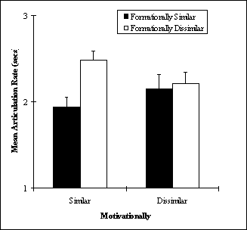
Both tables and figures should be inserted at the end of a paragraph. The subsequent paragraph should begin one double-spaced line below the end of the table or figure. Take note of the “Note” formatting in Figure 2. Notes may be included for clarity.
Figure 2
Examples of Stimuli Used in Experiment 1

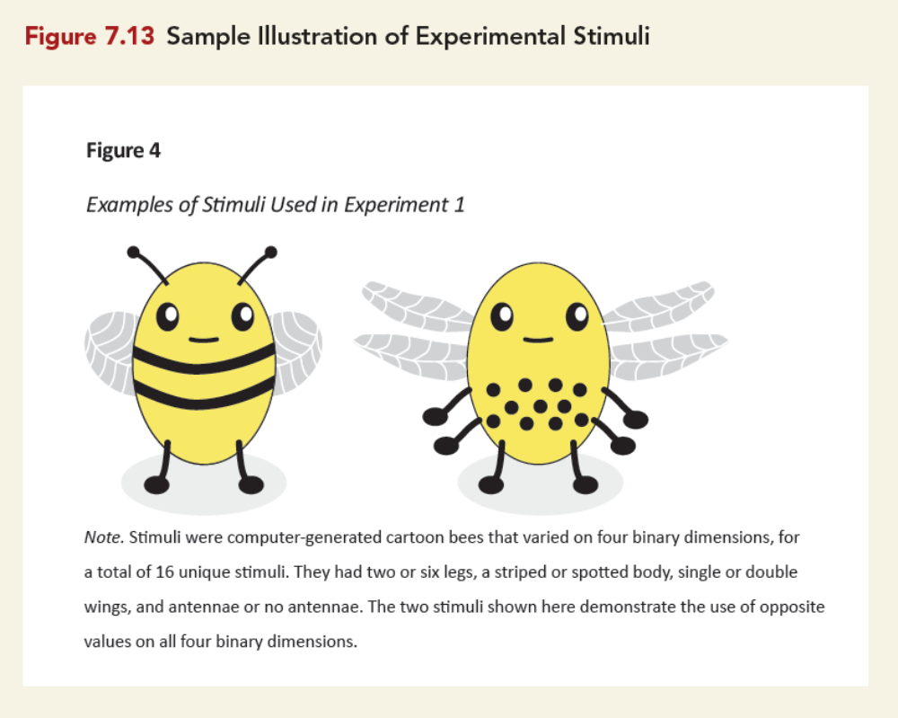
Note. Stimuli were computer-generated cartoon bees that varied on four binary dimensions, for a total of 16 unique stimuli. They had two or six legs, a striped or spotted body, single or double wings, and antennae or no antennae. The two stimuli shown here demonstrate the use of opposite values on all four binary dimensions.
This paragraph is included to demonstrate formatting between figures. Generally, you should discuss a figure in a paragraph before inserting the figure. Explain the relevant details, as you would with a table. There is a page break following this paragraph to ensure that the caption and figure are on the same page. For quotations of more than 40 words, treat it as a block quotation (American Psychological Association, 2020):
Do not use quotation marks to enclose a block quotation. Start a block quotation on a new line and indent the whole block 0.5 in. from the left margin. If there are additional paragraphs within the quotation, indent the first line of each subsequent paragraph an additional 0.5 in. Either (a) cite the source in parentheses after the quotation’s final punctuation or (b) cite the author and year in the narrative before the quotation and place only the page number in the parentheses after the quotation’s final punctuation. Do not add a period after the closing parenthesis in either case. (p. 272)

Figure 3
Poverty Rate in the United States, 2017
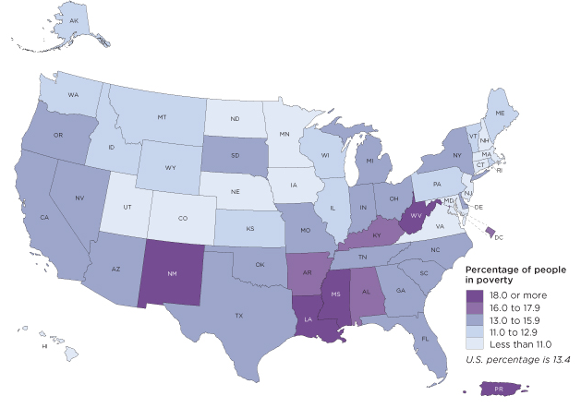
Note. The map does not include data for Puerto Rico. Adapted from 2017 Poverty Rate in the United States, by U.S. Census Bureau, 2017.
[NOTE: If you have three or more figures, you should include a list of figures below your Table of Contents. If you have three or more tables and three or more figures, include both a list of tables and then a list of figures on separate pages.]

Significance of the Study [Heading Level 2 – Flush Left, Bold]
All illustrative materials should be incorporated into the text. Appendices should be reserved for explanatory material (non-essential data), samples of documents, IRB approval, etc. Tables, charts, graphs and the like should all appear with some text included on these pages. If you need to reduce the table or figure, make sure the page number appears in the proper place on the page, e.g. like all the other pages. Also, the title of the chart or graph should appear in the regular size font being used for the rest of the document.
No materials may be pasted into the document. If you have such items, paste each into place and then photocopy the page. This rule applies to photographs. If you need to include photographs, prepare them in black and white half-tone exposure and photocopy the item into the text. Documents that contain pasted items will not be accepted.

Assumptions, Delimitations, and Limitations [Heading Level 2 – Flush Left, Bold]

Assumptions [Heading Level 3 – Flush Left, Bold Italic]

Delimitations [Heading Level 3 – Flush Left, Bold Italic]

Limitations [Heading Level 3 – Flush Left, Bold Italic]

Definitions [Heading Level 2 – Flush Left, Bold]

Chapter Summary [Heading Level 2 – Flush Left, Bold]

Outline of the Study [Heading Level 2 – Flush Left, Bold]

Chapter II

Review of the Literature [Heading Level 1 – Centered, Bold]
In this chapter, the goal is to synthesize relevant literature, and to organize the literature in a logical progression for the reader. Typically, Chapter II addresses elements related to the statement of the problem and your theoretical framework(s). Consult your thesis chair regarding what literature you should address in Chapter II. Below is heading levels 2–5; however, the extent of levels is a function of the depth and breadth of the material addressed.

Major Topic 1 [Heading Level 2 – Flush Left, Bold]

Sub-topic 1 [Heading Level 3 – Flush Left, Bold Italic]
If you use Heading Level 4 (after Level 3) and 5 (after Level 4), follow the format below:

Heading Level 4.
[Indented, Bold, Ending with a Period.] Text begins on the same line and continues as a regular paragraph. Use Cntrl+Alt+Return to make a style separator and ensure that Heading 4 style is only applied to the heading so the full paragraph does not display in the Table of Contents.

Heading Level 5.
[Indented, Bold Italic. Ending with a Period.] Text begins on the same line and continues as a regular paragraph. See above note about style separators. This functionality is not available for Mac or Word Online, but you can copy/paste and change the headers in this document or manually update the Table of Contents when you are finished.

Heading Level 5.
[Indented, Bold Italic. Ending with a Period.] Text begins on the same line and continues as a regular paragraph.

Heading Level 4.
[Indented, Bold, Ending with a Period.] Text begins on the same line and continues as a regular paragraph.

Sub-topic 2 [Heading Level 3 – Flush Left, Bold Italic]

Heading Level 4.
[Indented, Bold, Ending with a Period.] Text begins on the same line and continues as a regular paragraph.

Heading Level 5.
[Indented, Bold, Italic. Ending with a Period.] Text begins on the same line and continues as a regular paragraph.

Heading Level 5.
[Indented, Bold Italic. Ending with a Period.] Text begins on the same line and continues as a regular paragraph.

Major Topic 2 [Heading Level 2 – Flush Left, Bold]

Sub-topic 1 [Heading Level 3 – Flush Left, Bold Italic]

Heading Level 4.
[Indented, Bold, Ending with a Period.] Text begins on the same line and continues as a regular paragraph.

Heading Level 5.
[Indented, Bold Italic. Ending with a Period.] Text begins on the same line and continues as a regular paragraph.

Heading Level 5.
[Indented, Bold Italic. Ending with a Period.] Text begins on the same line and continues as a regular paragraph.

Heading Level 4.
[Indented, Bold, Ending with a Period.] Text begins on the same line and continues as a regular paragraph.

Sub-topic 2 [Heading Level 2 – Flush Left, Bold]

Heading Level 4.
[Indented, Bold, Ending with a Period.] Text begins on the same line and continues as a regular paragraph.

Heading Level 5.
[Indented, Bold Italic. Ending with a Period.] Text begins on the same line and continues as a regular paragraph.

Heading Level 5.
[Indented, Bold Italic. Ending with a Period.] Text begins on the same line and continues as a regular paragraph.

Major Topic 3 [Heading Level 2 – Flush Left, Bold]

Sub-topic 1 [Heading Level 3 – Flush Left, Bold Italic]

Heading Level 4.
[Indented, Bold, Ending with a Period.] Text begins on the same line and continues as a regular paragraph.

Heading Level 5.
[Indented, Bold Italic. Ending with a Period.] Text begins on the same line and continues as a regular paragraph.

Heading Level 5.
[Indented, Bold Italic. Ending with a Period.] Text begins on the same line and continues as a regular paragraph.

Heading Level 4.
[Indented, Bold, Ending with a Period.] Text begins on the same line and continues as a regular paragraph.

Sub-topic 2 [Heading Level 3 – Flush Left, Bold Italic]

Heading Level 4.
[Indented, Bold, Ending with a Period.] Text begins on the same line and continues as a regular paragraph.

Heading Level 5.
[Indented, Bold Italic. Ending with a Period.] Text begins on the same line and continues as a regular paragraph.

Heading Level 5.
[Indented, Bold Italic. Ending with a Period.] Text begins on the same line and continues as a regular paragraph.

Chapter Summary [Heading Level 2 – Flush Left, Bold]
In this section, provide an overview of what you presented in this chapter. Then, provide an overview of the next chapter.

Chapter III

Method [Heading Level 1 – Centered, Bold]
In this intro paragraph, provide a short overview of the chapter and identify the progression of the content. Depending on your Chair’s direction, you may restate the purpose statement and remind the reader of the study’s goal(s) as well as the research questions.

Research Design [Heading Level 2 – Flush Left, Bold]
In this section, explicate the design, including the approach/genre and make the case for why this design is appropriate for the purpose and research questions. Discuss with your thesis chair to confirm their preference regarding placement of theoretical, methodological, and epistemological premises. Also discuss with your thesis chair regarding their preference for the placement of your Reflexivity-Subjectivities statement.

Site and Participant Selection [Heading Level 2 – Flush Left, Bold]

Data Collection [alternatively Data Generation or Data Gathering] [Heading Level 2 – Flush Left, Bold]

Data Analysis [Heading Level 2 – Flush Left, Bold]

Trustworthiness [Heading Level 2 – Flush Left, Bold]

Ethical Considerations [Heading Level 2 – Flush Left, Bold]

Chapter Summary [Heading Level 2 – Flush Left, Bold]
In this section, provide an overview of what you presented in this chapter. Then provide an overview of the next chapter.

Chapter IV

Findings [Heading Level 1 – Centered, Bold]
The purpose of this chapter is to present the findings of your study. The ways in which
the findings are presented is a function of the qualitative paradigm approach/genre used. Consult with your thesis chair regarding their preference in the heading types and organization. Below are listed the headings for formatting.

Level 2 Heading [Flush Left, Bold]
Lorem ipsum dolor sit amet, consectetur adipiscing elit, sed do eiusmod tempor incididunt ut labore et dolore magna aliqua. Ut enim ad minim veniam, quis nostrud exercitation ullamco laboris nisi ut aliquip ex ea commodo consequat. Duis aute irure dolor in reprehenderit in voluptate velit esse cillum dolore eu fugiat nulla pariatur. Excepteur sint occaecat cupidatat non proident, sunt in culpa qui officia deserunt mollit anim id est laborum.

Level 3 Heading [Flush Left, Bold Italic]
Lorem ipsum dolor sit amet, consectetur adipiscing elit, sed do eiusmod tempor incididunt ut labore et dolore magna aliqua. Ut enim ad minim veniam, quis nostrud exercitation ullamco laboris nisi ut aliquip ex ea commodo consequat. Duis aute irure dolor in reprehenderit in voluptate velit esse cillum dolore eu fugiat nulla pariatur. Excepteur sint occaecat cupidatat non proident, sunt in culpa qui officia deserunt mollit anim id est laborum.

Heading Level 4.
[Indented, Bold, Ending with a Period.] Text begins on the same line and continues as a regular paragraph. The following are a list of tables taken from the APA Style Blog. These tables are included to demonstrate table format and have been truncated for space. Insert your table using the Insert>Table function in Word. Right click and insert a caption (e.g., Table 1) to enable an automatic table of contents for tables. You will need to manually change the style of the caption to Times New Roman 12pt, bold, and black font. Use APA 7 guidelines for tables, sections 7.8 to 7.21, unless directed otherwise by your thesis chair.
Table 1
Sociodemographic Characteristics of Participants at Baseline
Baseline characteristic | Guided self-help |  | Unguided self-help |  | Wait-list control |  | Full sample
Baseline characteristic | n | % | n | % | n | % | n | %
Gender
Female | 25 | 50 | 20 | 40 | 23 | 46 | 68 | 45.3
Male | 25 | 50 | 30 | 60 | 27 | 54 | 82 | 54.7
Marital status
Single | 13 | 26 | 11 | 22 | 17 | 34 | 41 | 27.3
Married/partnered | 35 | 70 | 38 | 76 | 28 | 56 | 101 | 67.3
Divorced/widowed | 1 | 2 | 1 | 2 | 4 | 8 | 6 | 4.0
Other | 1 | 1 | 0 | 0 | 1 | 2 | 2 | 1.3
Children | 26 | 52 | 26 | 52 | 22 | 44 | 74 | 49.3
Cohabitating | 37 | 74 | 36 | 72 | 26 | 52 | 99 | 66.0
Highest educational level
Middle school | 0 | 0 | 1 | 2 | 1 | 2 | 2 | 1.3
Tables should be located at the end of a paragraph. Begin the next paragraph of your writing as usual with a 0.5” first-line indent.

Heading Level 5.
[Indented, Bold Italic. Ending with a Period.] Text begins on the same line and continues as a regular paragraph. Two sample tables follow to demonstrate table formatting. Table 2 shows the result of several t tests. Take note of the “note” formatting at the bottom. Lorem ipsum dolor sit amet, consectetur adipiscing elit, sed do eiusmod tempor incididunt ut labore et dolore magna aliqua. Ut enim ad minim veniam, quis nostrud exercitation ullamco laboris nisi ut aliquip ex ea commodo consequat. Duis aute irure dolor in reprehenderit in voluptate velit esse cillum dolore eu fugiat nulla pariatur. Excepteur sint occaecat cupidatat non proident, sunt in culpa qui officia deserunt mollit anim id est laborum.
Table 2
Results of Curve-Fitting Analysis Examining the Time Course of Fixations to the Target
Logistic parameter | 9-year-olds |  | 16-year-olds |  | t(40) | p | Cohen’s d
Logistic parameter | M | SD | M | SD | t(40) | p | Cohen’s d
Maximum asymptote, proportion | .843 | .135 | .877 | .082 | 0.951 | .347 | 0.302
Crossover, in ms | 759 | 87 | 694 | 42 | 2.877 | .006 | 0.840
Slope, as change in proportion per ms | .001 | .0002 | .002 | .0002 | 2.635 | .012 | 2.078
Note. For each subject, the logistic function was fit to target fixations separately.
Table 3 is a sample correlation table. Remember to use the same font in tables as in the rest of the paper. Do not use vertical borders. You can adjust borders by right clicking on the table, then selecting “Borders and Shading,” or by using the borders icon in the Table ribbon. Lorem ipsum dolor sit amet, consectetur adipiscing elit, sed do eiusmod tempor incididunt ut labore et dolore magna aliqua. Ut enim ad minim veniam, quis nostrud exercitation ullamco laboris nisi ut aliquip ex ea commodo consequat. Duis aute irure dolor in reprehenderit in voluptate velit esse cillum dolore eu fugiat nulla pariatur. Excepteur sint occaecat cupidatat non proident, sunt in culpa qui officia deserunt mollit anim id est laborum.
Table 3
Descriptive Statistics and Correlations for Study Variables
Variable | n | M | SD | 1 | 2 | 3 | 4 | 5 | 6 | 7
1. Internal–external status ª | 3,697 | 0.43 | 0.49 | —
2. Manager job performance | 2,134 | 3.14 | 0.62 | −.08** | —
3. Starting salary ^{b} | 3,697 | 1.01 | 0.27 | .45** | −.01 | —
4. Subsequent promotion | 3,697 | 0.33 | 0.47 | .08** | −.07** | .04* | —
5. Organizational tenure | 3,697 | 6.45 | 6.62 | −.29** | .09** | .01 | .09** | —
6. Unit service performance ^{c} | 3,505 | 85.00 | 6.98 | −.25** | −.39** | .24** | .08** | .01 | —
7. Unit financial performance ^{c} | 694 | 42.61 | 5.86 | .00 | −.03 | .12* | −.07 | −.02 | .16** | —
ª 0 = internal hires and 1 = external hires.
^{b} A linear transformation was performed on the starting salary values to maintain pay practice confidentiality. The standard deviation (0.27) can be interpreted as 27% of the average starting salary for all managers. Thus, ±1 SD includes a range of starting salaries from 73% (i.e., 1.00 – 0.27) to 127% (i.e., 1.00 + 0.27) of the average starting salaries for all managers.
^{c} Values reflect the average across 3 years of data.
*p < .05. **p < .01.
Take note of the superscript annotations in Table 3, which provide additional information. Insert a superscript using Control, Shift, and the Plus Sign (+) on Windows or Command, Shift, and Plus Sign (+) on a Mac, or use the superscript button in the Home ribbon.

Heading Level 5.
[Indented, Bold Italic. Ending with a Period.] Text begins on the same line and continues as a regular paragraph.

Heading Level 4.
[Indented, Bold, Ending with a Period.] Text begins on the same line and continues as a regular paragraph.

Level 3 Heading [Flush Left, Bold Italic]

Heading Level 4.
[Indented, Bold, Ending with a Period.] Text begins on the same line and continues as a regular paragraph.

Heading Level 5.
[Indented, Bold Italic. Ending with a Period.] Text begins on the same line and continues as a regular paragraph.

Heading Level 5.
[Indented, Bold Italic. Ending with a Period.] Text begins on the same line and continues as a regular paragraph.

Level 2 Heading [Flush Left, Bold]

Level 3 Heading [Flush Left, Bold Italic]

Heading Level 4.
[Indented, Bold, Ending with a Period.] Text begins on the same line and continues as a regular paragraph.

Heading Level 5.
[Indented, Bold Italic. Ending with a Period.] Text begins on the same line and continues as a regular paragraph.

Heading Level 5.
[Indented, Bold Italic. Ending with a Period.] Text begins on the same line and continues as a regular paragraph.

Heading Level 4.
[Indented, Bold, Ending with a Period.] Text begins on the same line and continues as a regular paragraph.

Level 3 Heading [Flush Left, Bold Italic]

Heading Level 4.
[Indented, Bold, Ending with a Period.] Text begins on the same line and continues as a regular paragraph.

Heading Level 5.
[Indented, Bold Italic. Ending with a Period.] Text begins on the same line and continues as a regular paragraph.

Heading Level 5.
[Indented, Bold Italic. Ending with a Period.] Text begins on the same line and continues as a regular paragraph.

Chapter Summary [Heading Level 2 – Flush Left, Bold]
In this section, provide an overview of the findings presented in the chapter. Also provide an introduction for the following chapter.

Chapter V

Discussion [Heading Level 1 – Centered, Bold]
In this section, introduce the chapter and provide an overview of your study and what you will be presenting in this chapter.

Themes [Heading Level 2 – Flush Left, Bold]
[Consult your thesis chair regarding preferred and appropriate heading titles.]

Implications [Heading Level 2 – Flush Left, Bold]

Recommendations for Future Research [Heading Level 2 – Flush Left, Bold]

Chapter Summary and Conclusion [Heading Level 2 – Flush Left, Bold]

References
Writing tips for the Reference section:
- Ensure this section is formatted correctly per APA 7th Edition manual.
- Cross-reference in-text citations against Reference entries to ensure every citation has a Reference entry. Then, cross-reference Reference entries with citations to ensure every Reference entry has a citation. Note that personal communication, which requires a citation, does not require a References entry.
- If you have multiple entries from an author, enter these in the References section with the oldest publication date (or n.d.) first, and then work in chronological order.
- If you have multiple entries with an author and then an author + co-author (e.g., Brockett, R. G. and Brockett, R. G., & Hiemstra, R.), enter the solo authorship first. The rule is nothing before something.

Appendix A:

Title of Appendix
[NOTE: Supplemental material should be placed in appendices. You need a separate appendix for each type of material presented. Some style manuals allow you to place tables, figures, and other graphical representations in an appendix, rather than dispersed throughout your text. Each appendix should have a cover page that identifies it. Reference the cover sheet page number in the Table of Contents. Center the title on the page. A copy of your IRB or IACUC approval or exemption (if applicable) must be included as an appendix. Be sure to mention the IRB or IACUC in your “Methodology” chapter. Every Appendix must be cited in-text (see Appendix A).]

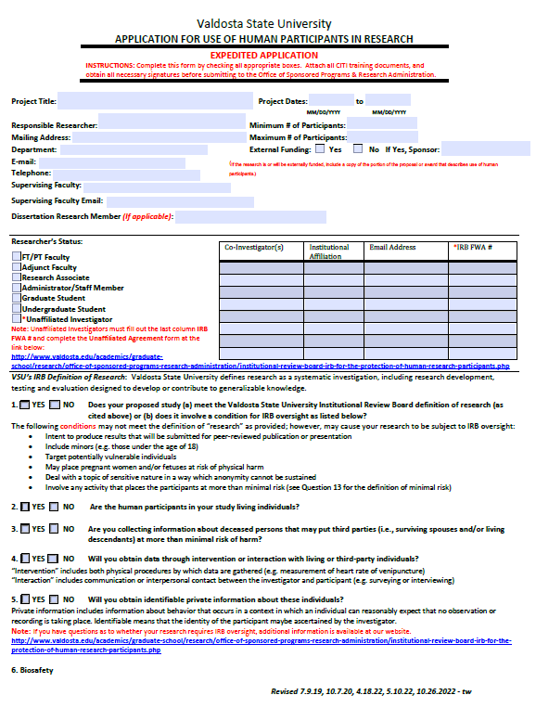

Appendix B:

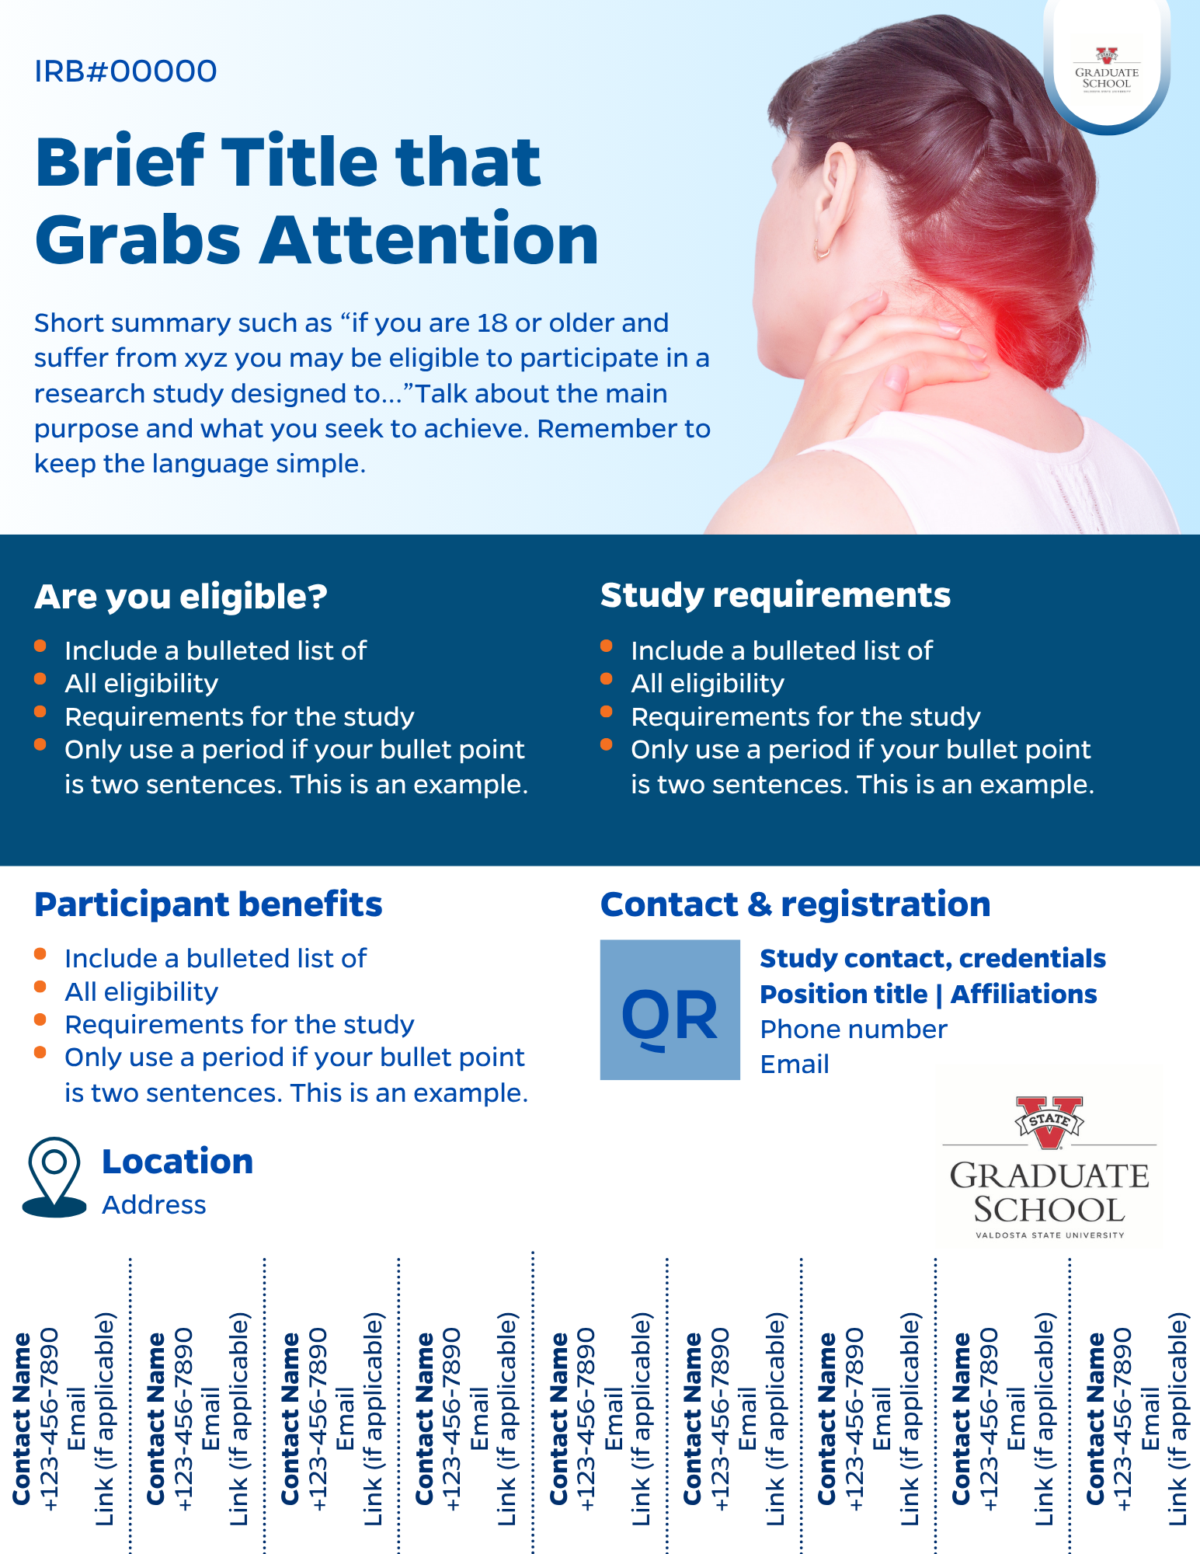
Title of Appendix

