WileyPLUS Integration Instructions

**From your WileyPLUS account, choose Chapters and Sections to integrate into D2L and click Next Step:**

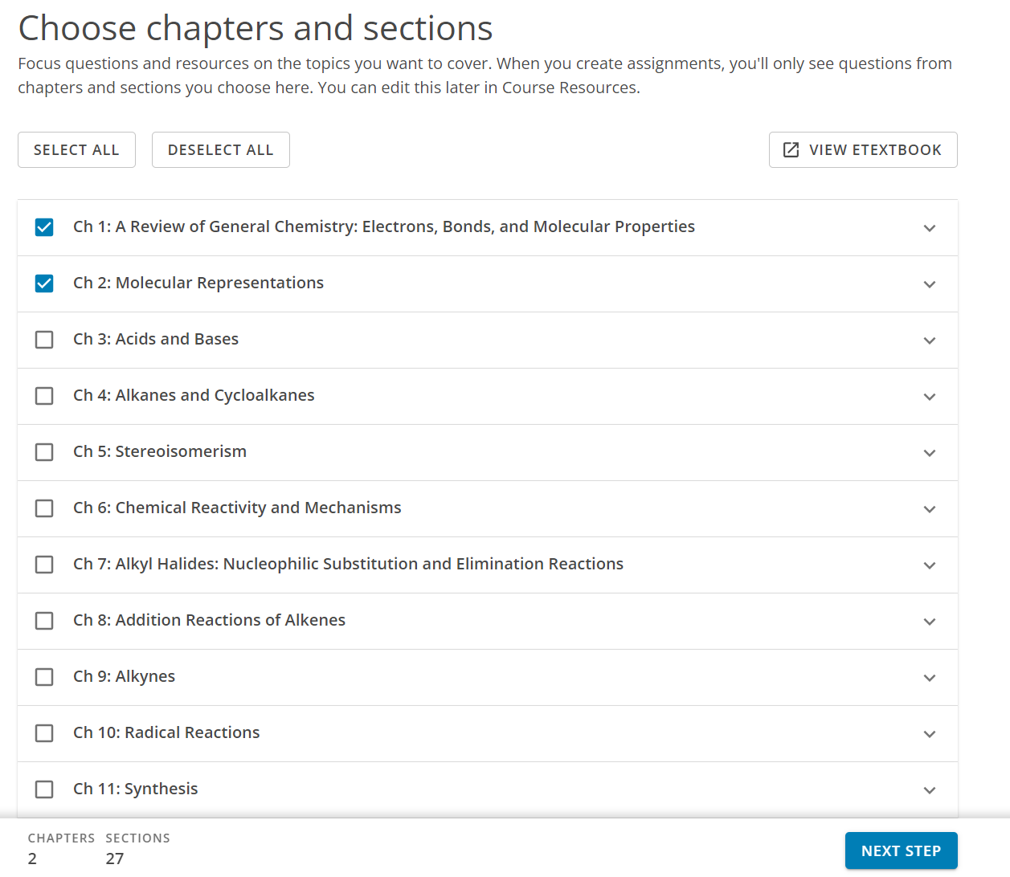

**Select Yes under the My Students will Access WileyPLUS content and resources though an LMS set up through Valdosta State University.**

**Then Select D2L as the LMS.**

**Click the Complete button.**

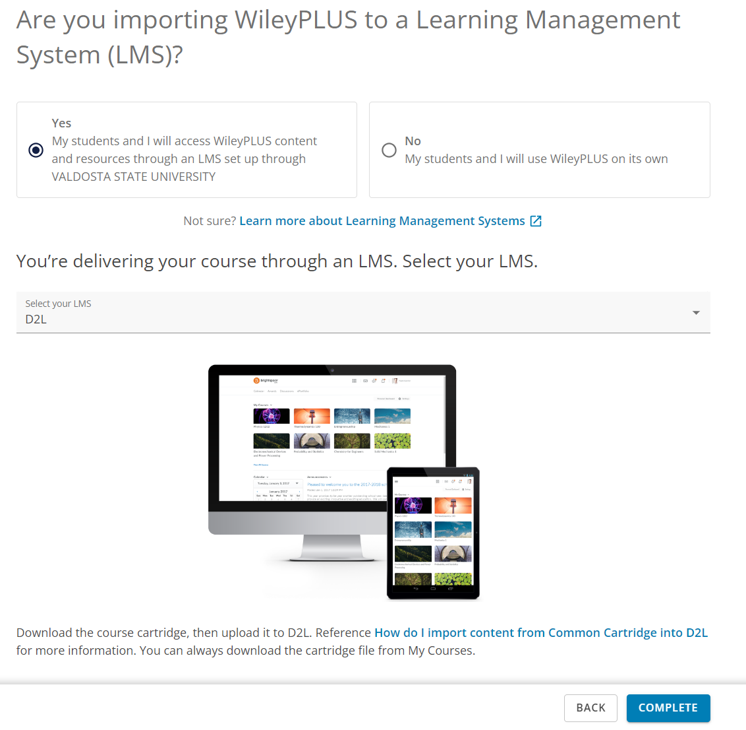

**You will receive a confirmation message:**

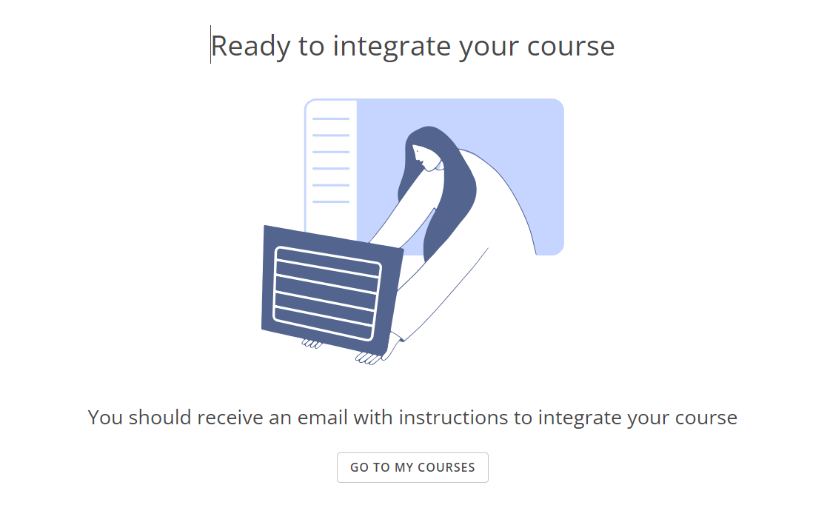

**Check your Inbox for an email from WileyPLUS with the Integration Code and instructions for adding in BlazeVIEW.**

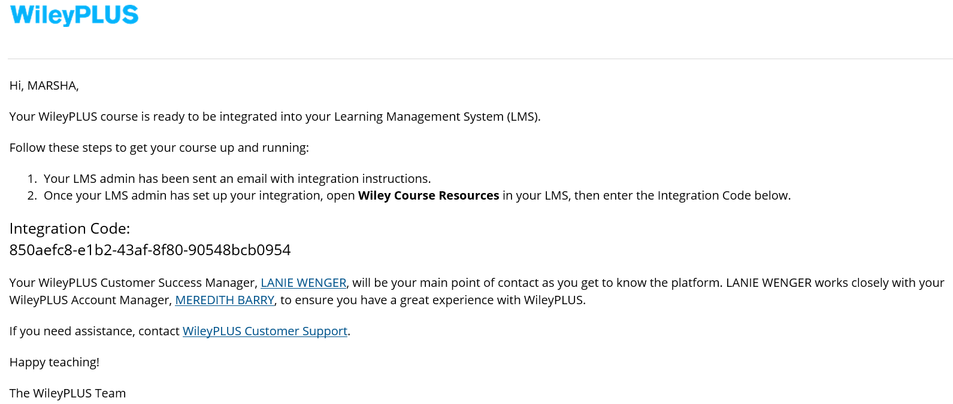

**From BlazeVIEW, go to the module where you want to link the WileyPLUS content.**

**From Existing Activities, select Wiley Assignments 1.3.**

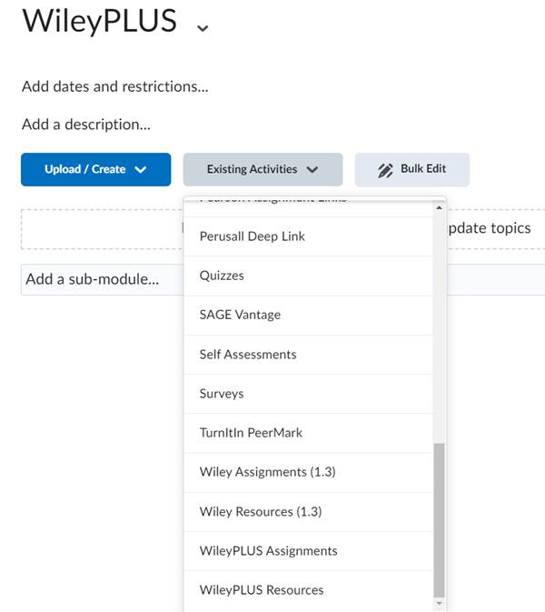

**Enter the Integration Code from your email and click PAIR COURSE:**

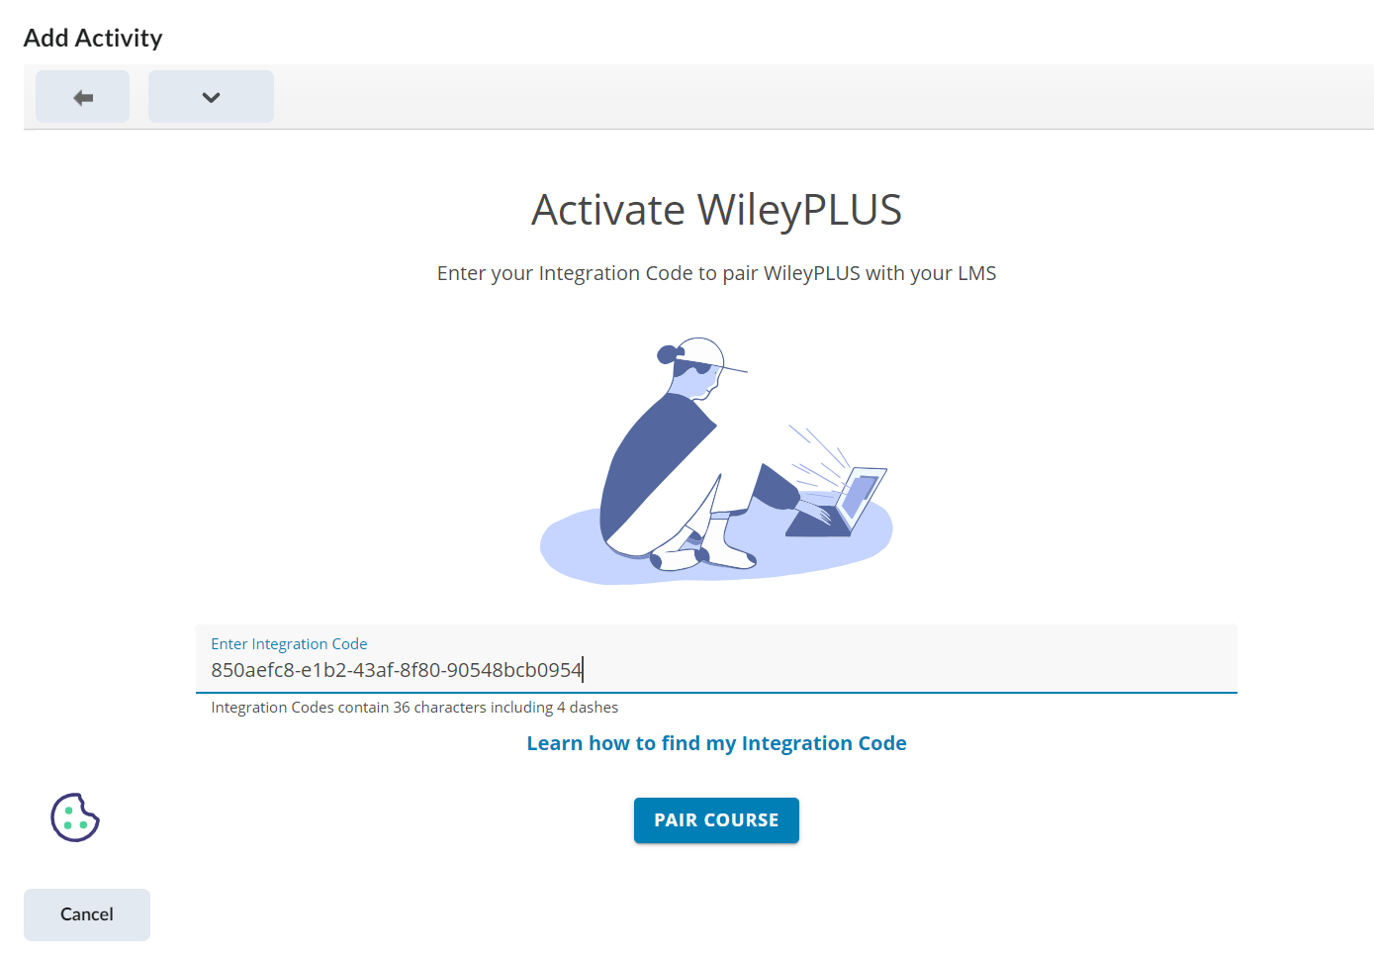

**Click the Confirm button to confirm the course you want to add:**

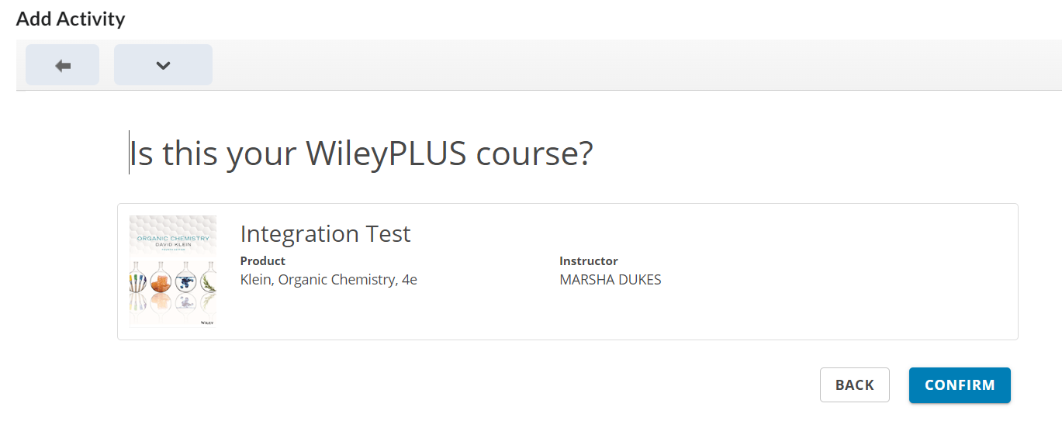

**Select the Login to an Existing Account button to log in to your WileyPLUS account.**

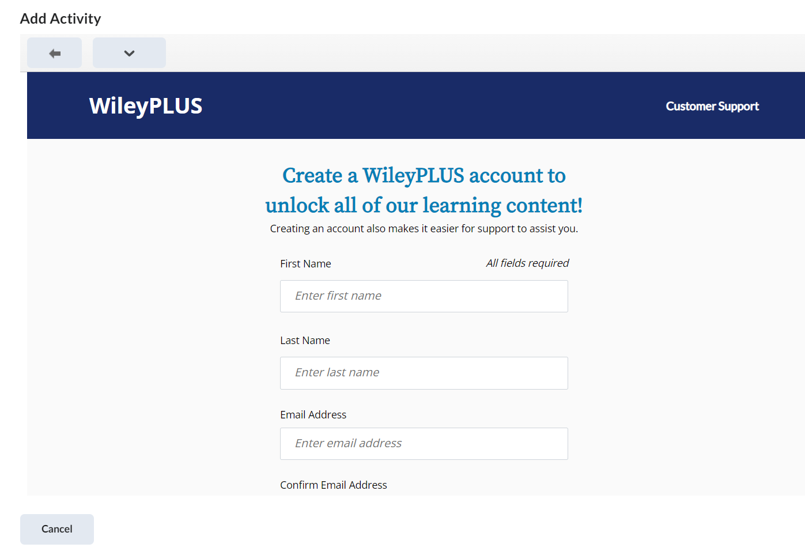

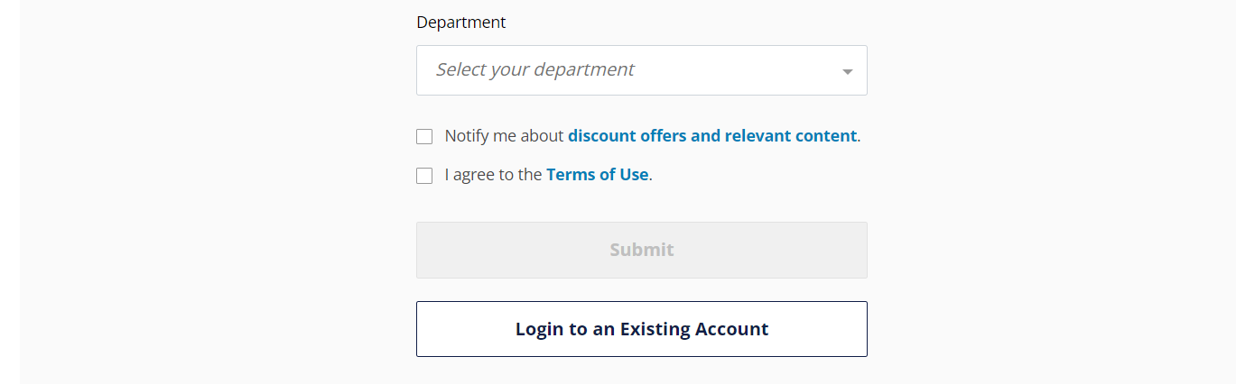

**Enter your email address and WileyPLUS password:**

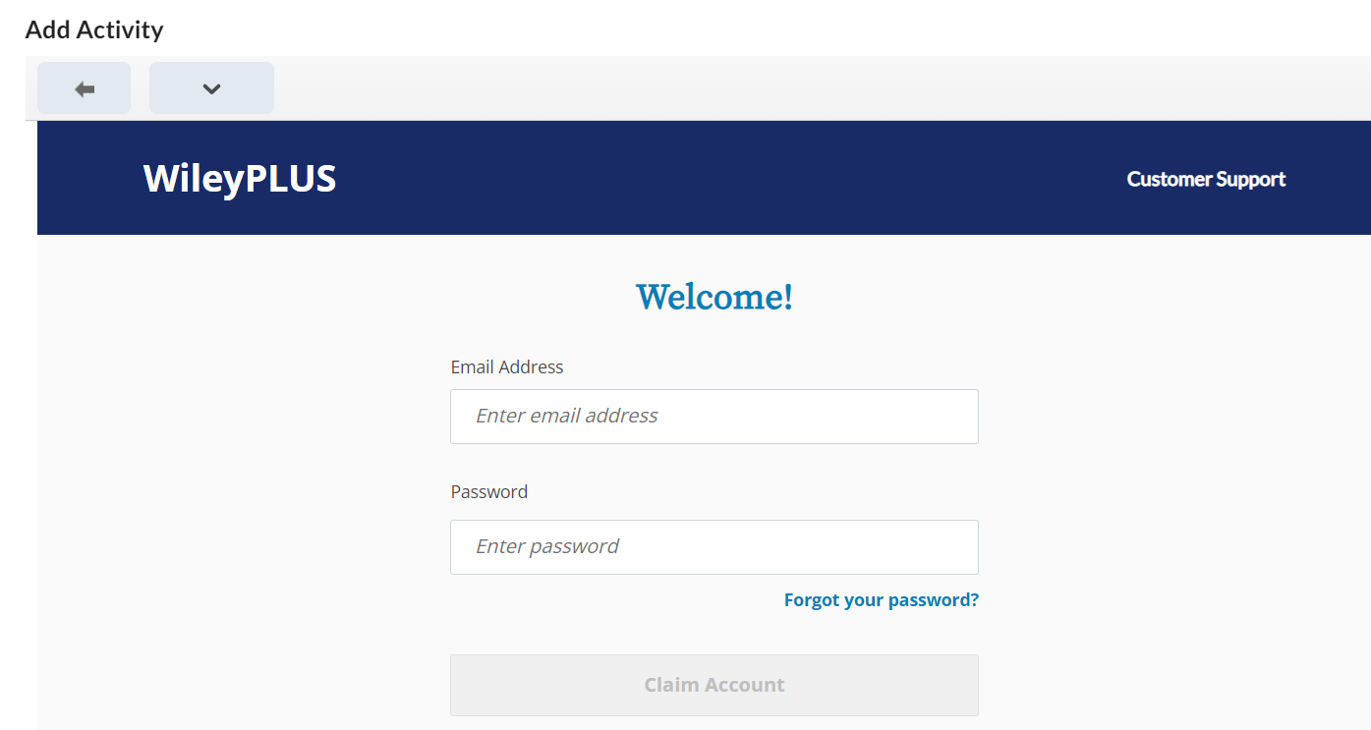

**Click Continue at the account confirmation page:**

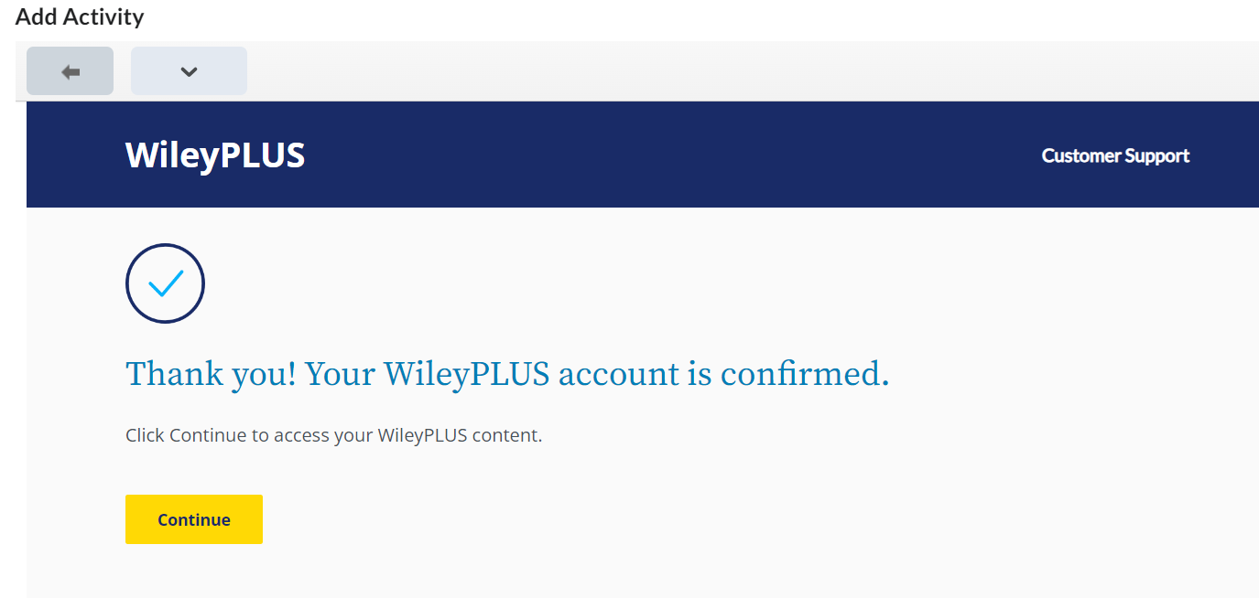

**Use the Options in Select a Question set to add your content. This will vary per course.**

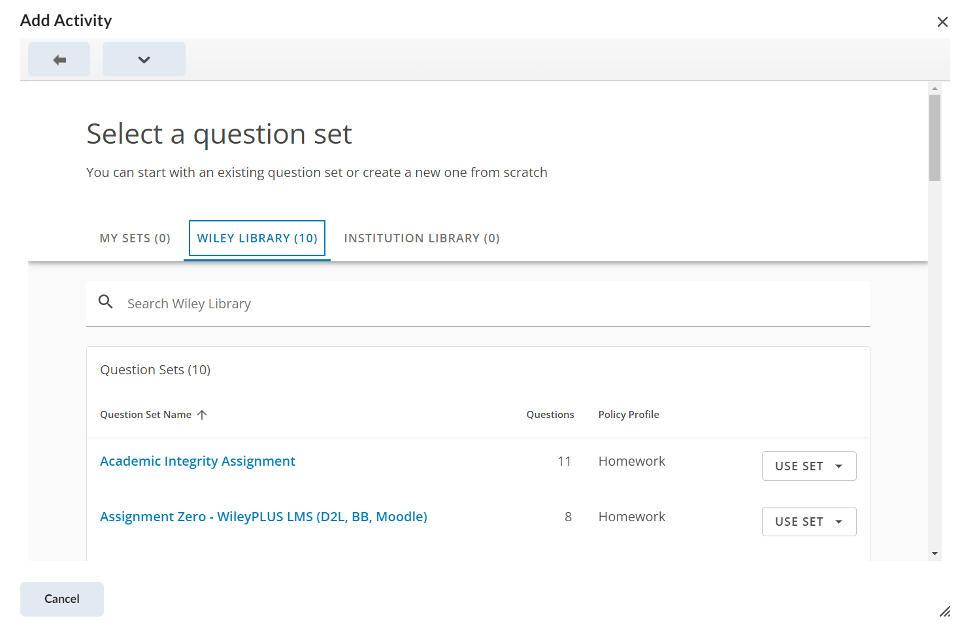

**Select Use to add to the BlazeVIEW course.**

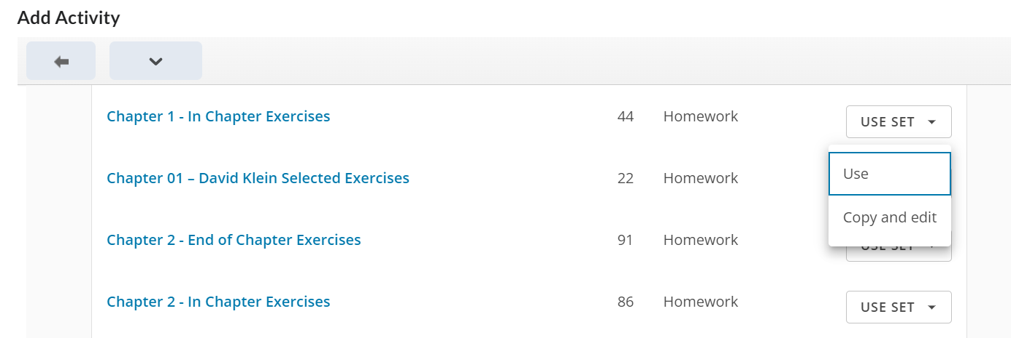

**Optional: Set the Due date and availability. Click Save to add to the Module in BlazeVIEW**

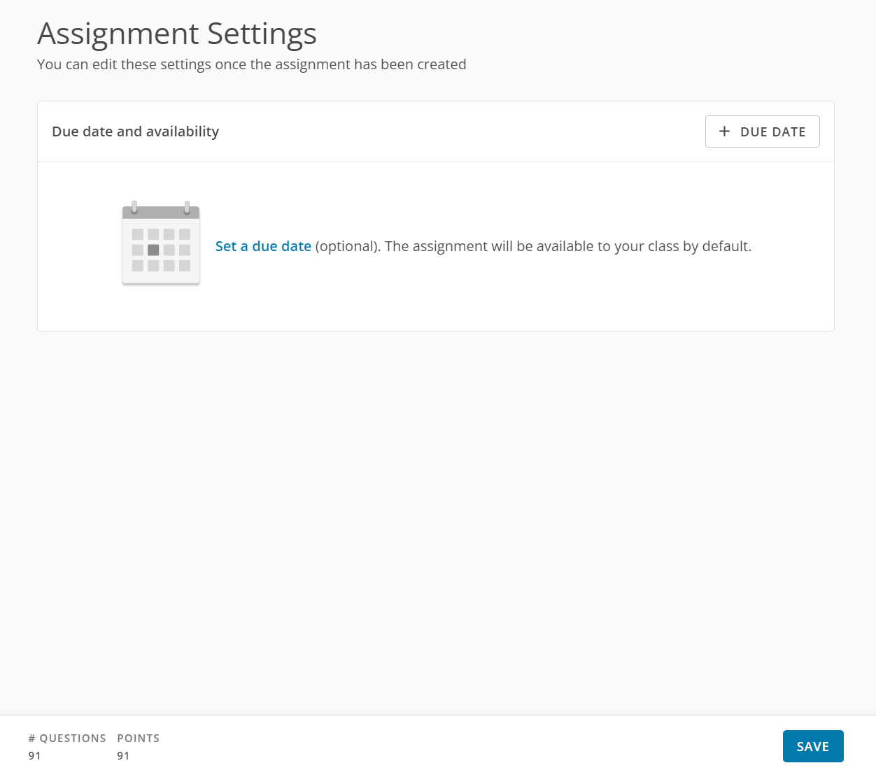

**The activity will be listed in the Module where the link was added:**

