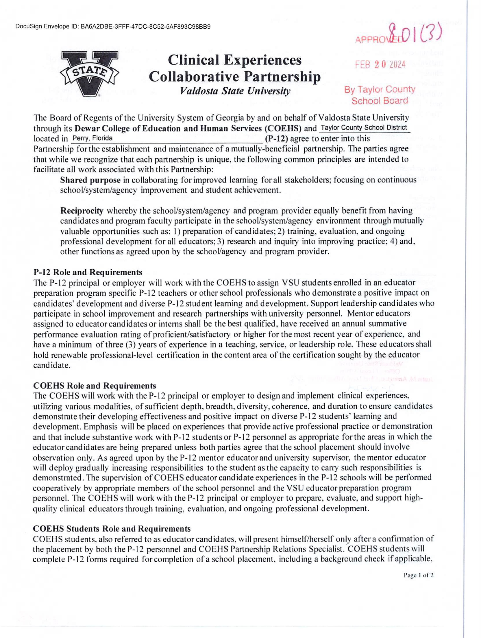

DocuSign Envelope ID: 40B860F3-FC5C-45E3-B893-CAFFEBA01215

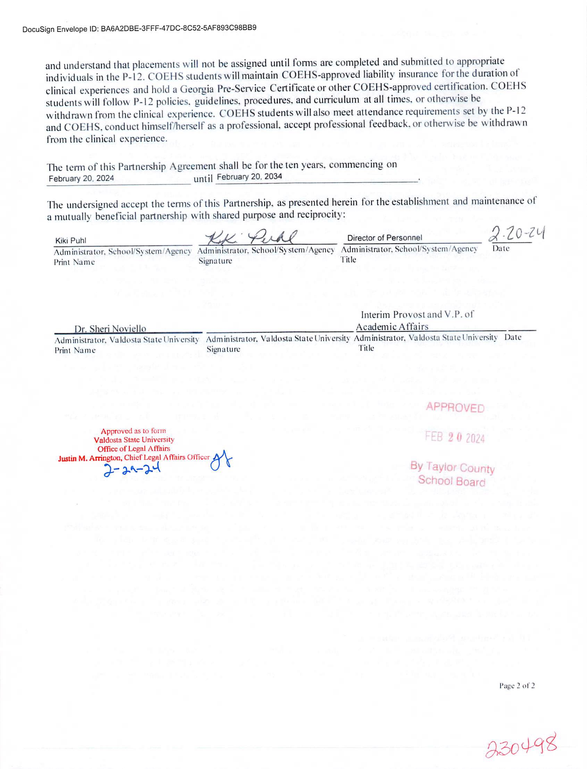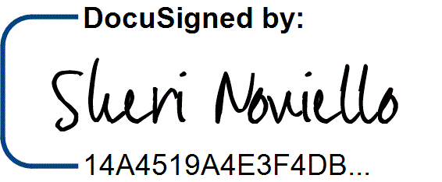

DocuSign Envelope ID: 40B860F3-FC5C-45E3-B893-CAFFEBA01215

3/2/2024 | 2:45 AM E