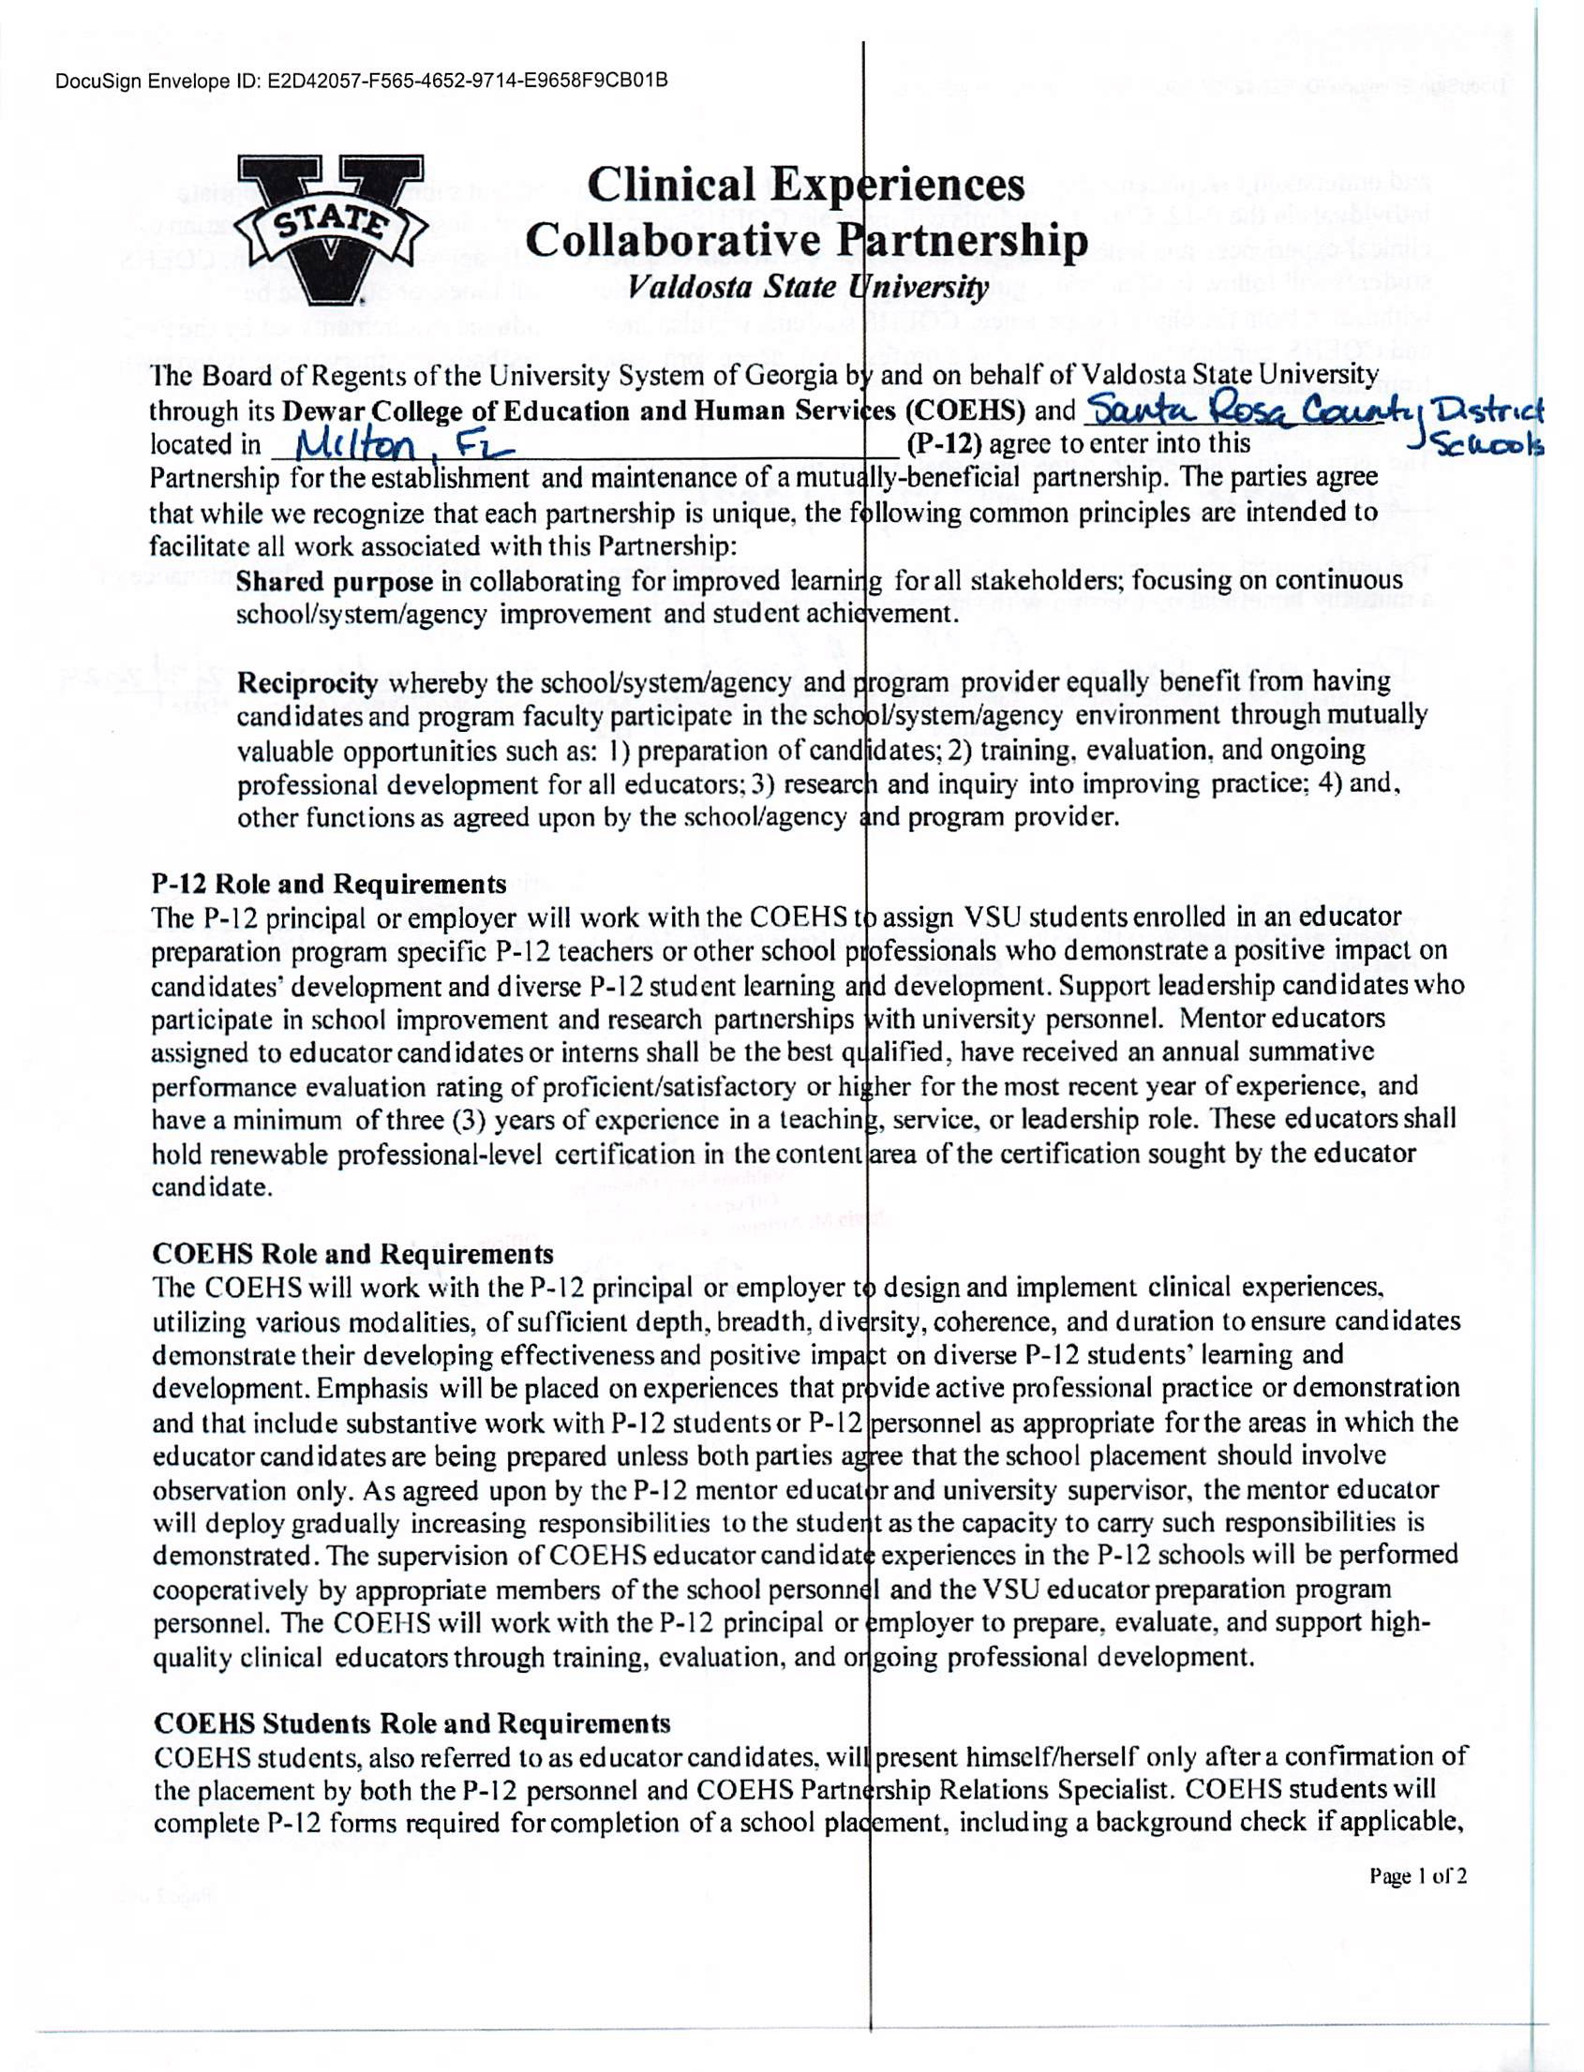

DocuSign Envelope ID: 1DE5BC26-4E0C-4860-8A9F-C409CF78B827

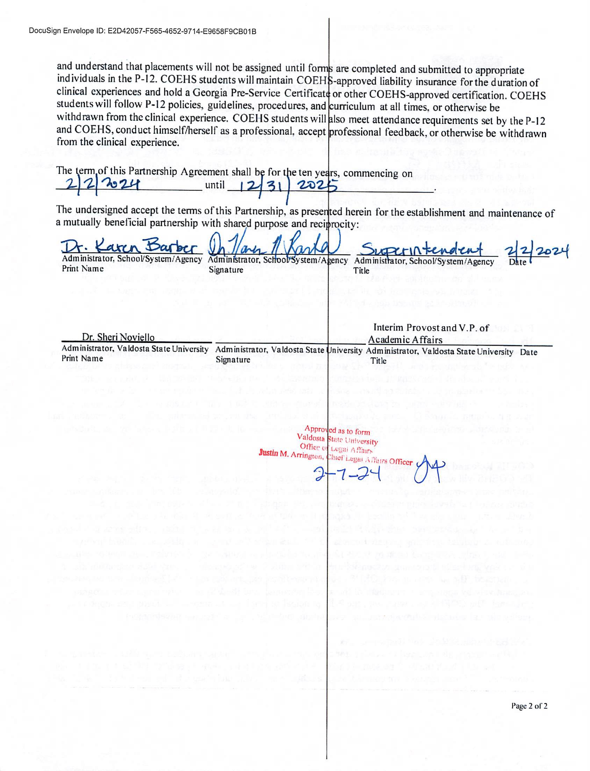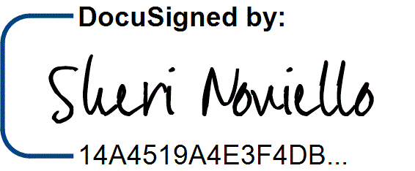

DocuSign Envelope ID: 1DE5BC26-4E0C-4860-8A9F-C409CF78B827

2/8/2024 | 8:03 AM E