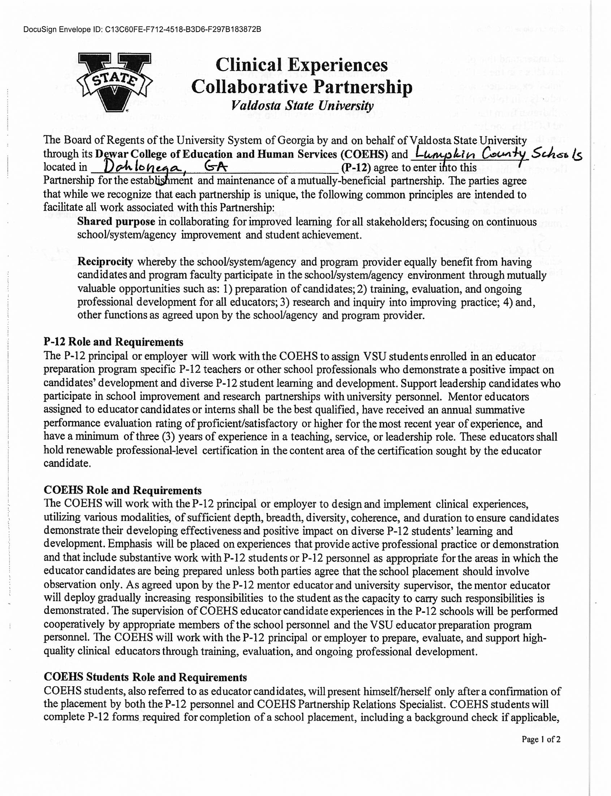

DocuSign Envelope ID: 51E99412-8AE0-4A68-946A-D817706E6B29

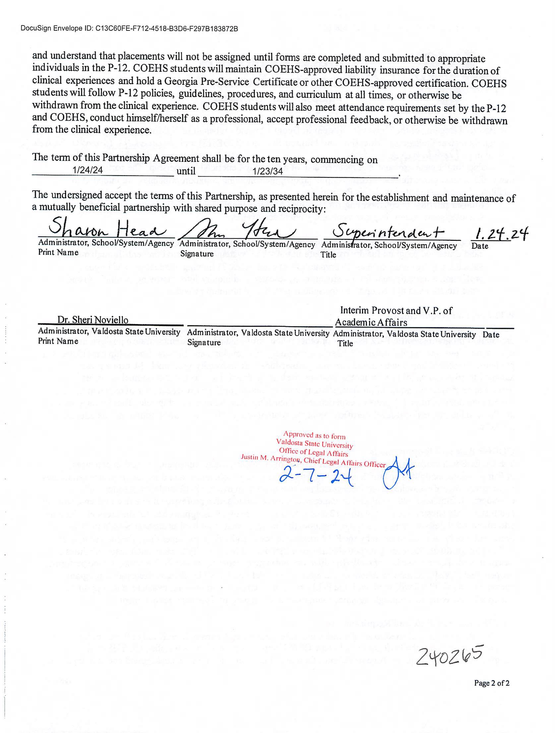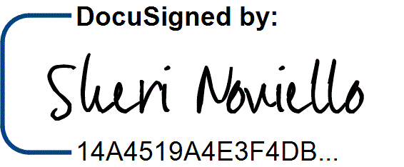

DocuSign Envelope ID: 51E99412-8AE0-4A68-946A-D817706E6B29

2/8/2024 | 8:05 AM