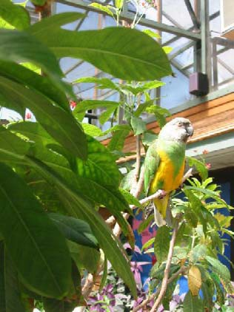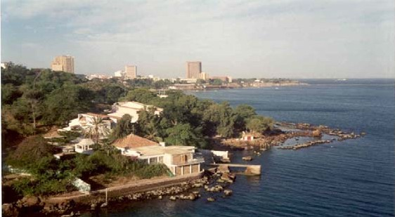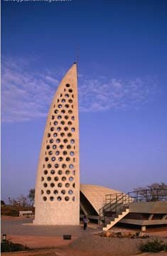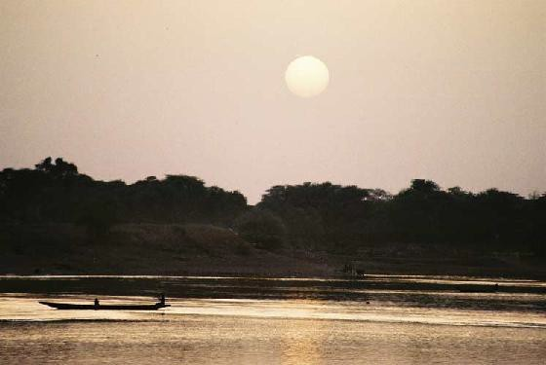Intensive French
Language in Senegal

$4,500+tuition

Spend one month in Senegal immersed in the French language and Senegalese culture. Get six hours of credit while experiencing Africa! The program fee includes stay with a host family, excursions, most meals, and airfare.

Duration / Location: 3 weeks/ Dakar, Senegal.

May 31—June 22

Contact:

Dr. Babacar Mboup (229) 333-5948 bmboup@valdosta.edu
Irina McClellan (CIP) (229)333-7410
ibmcclel@valdosta.edu

APPLICATION

